Name:

Please answer true or false and explain your reasoning!

There are five for you to complete. You can type into the text box or you can write your answers on a printed copy.

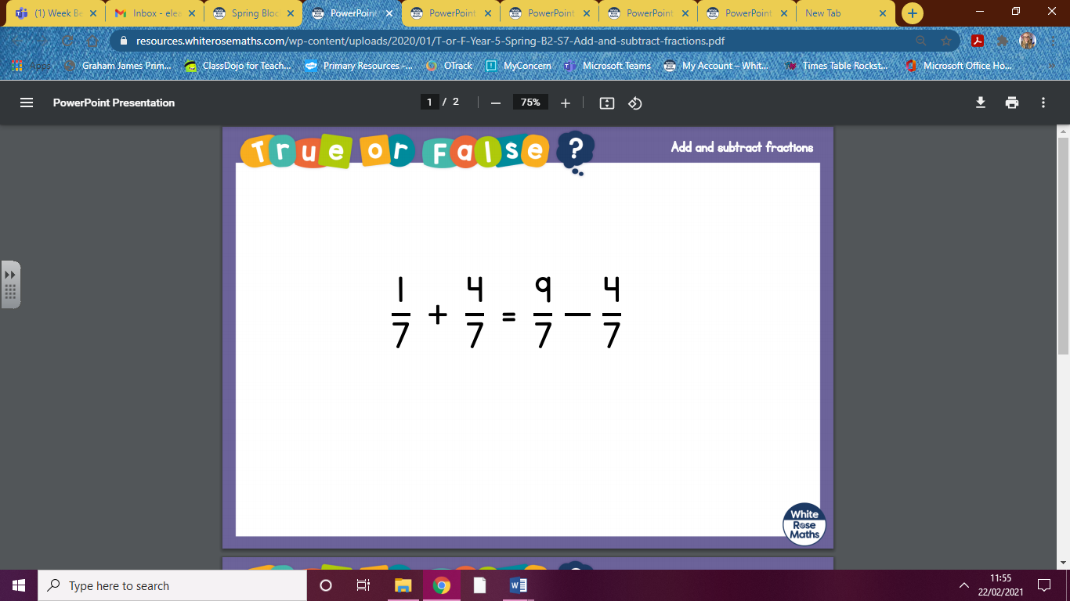

Answer:

Explain:

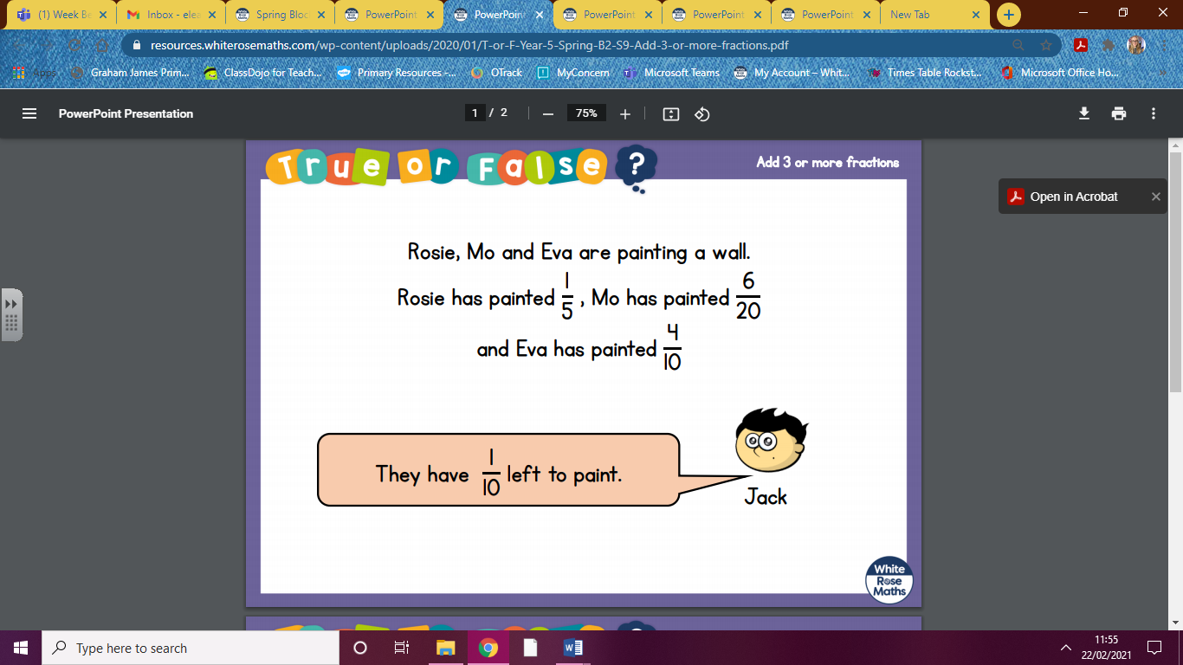

Answer:

Explain:

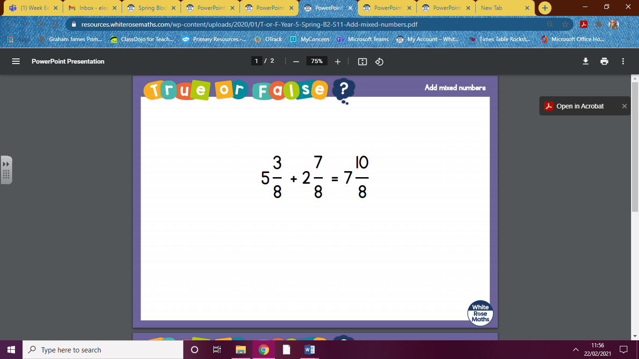

Answer:

Explain:

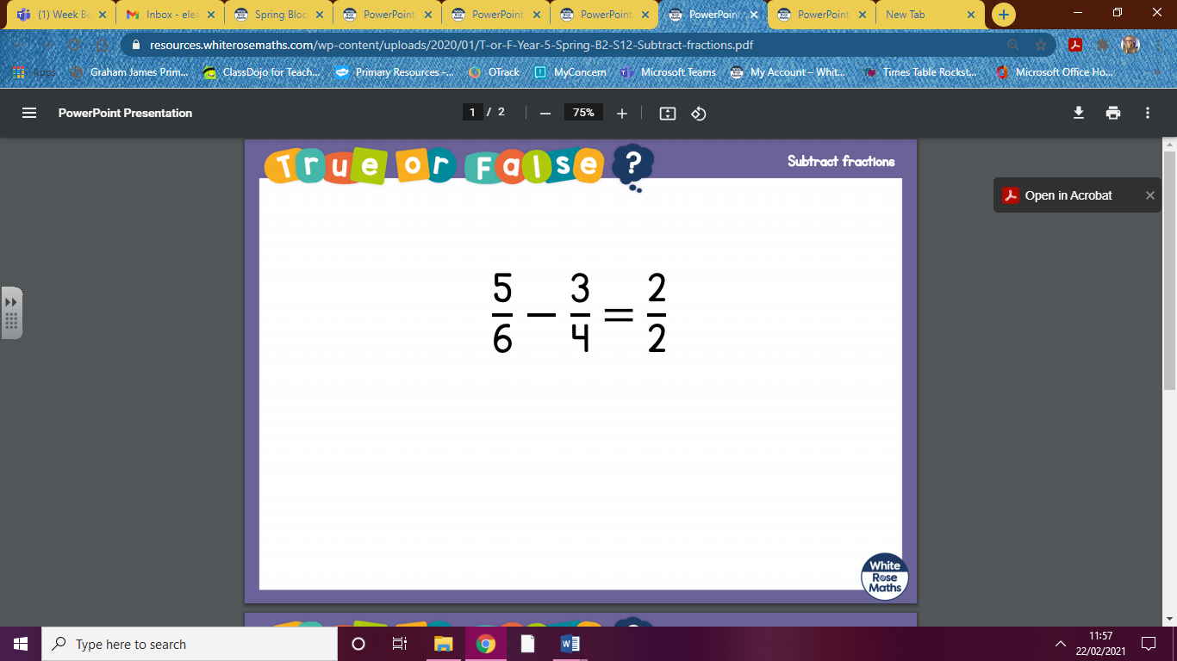

Answer:

Explain:

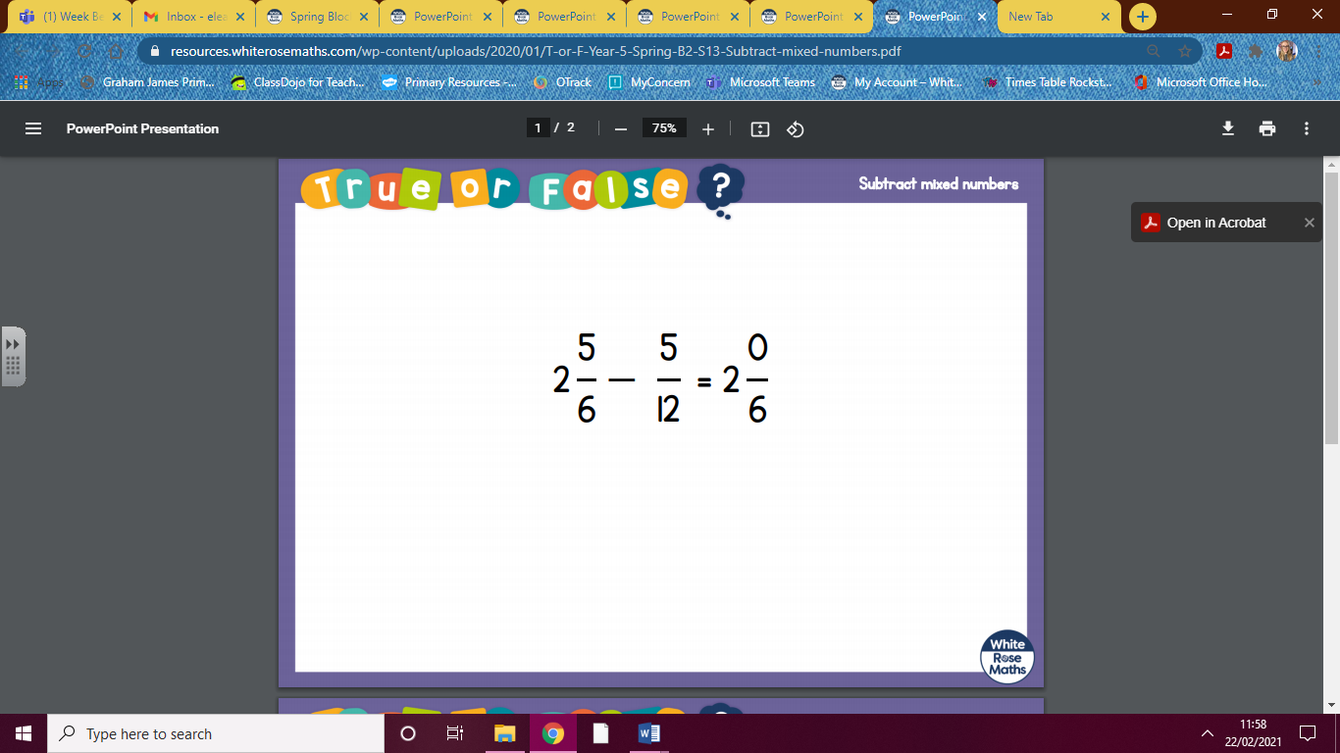

Answer:

Explain: