 | KS3 Stepping stones  The Circle of Life  Week commencing 01.03.2021 |  | 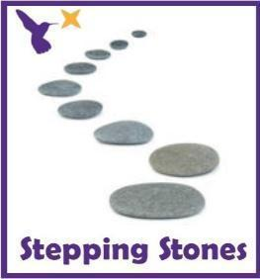
Classes in each pathway-
Woodhouse: Magpie
Boston Spa: Pipit and Wagtail
All about our projects this term:
The Circle of Life project will be delving deep into the world of animal life cycles. The ‘Tadpole’s Promise’ book will be the focus text and you can guide pupils using the Talk for Writing process but adding information text links to develop pupil’s understanding of the caterpillars, tadpoles, frogs and butterflies. During science, we will explore the lives of the human body with the focus of ‘Teeth and Eating’ and ‘Health and Growth’. By the end of term, we would aim for our pupils to be able to show an awareness of the different elements that make a healthy body and diet. In Humanities, we will be exploring what we can see from the window and learn how to describe our immediate environment using Geographical language.
Maths (Time) |  | English (World Book Week!)
This week in Maths we will begin to look at Time. The main skills we will be focusing on is the use of time language and vocabulary e.g. days of the week, now, later, tomorrow, today,  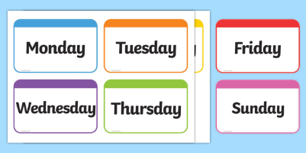  Days of the week  Read through the Jasper’s Beanstalk story on YouTube. Point out the different days of the week and practise the signs.  https://www.youtube.com/watch?v=jemrWJX7xJo  Days of the week signs:  https://www.youtube.com/watch?v=bYIQWWpZm08  Can you order the days of the week in the correct order?  *See ‘Days of the Week Cards’ on the school website*  Timers  Provide a range of timers (physical or YouTube timers) that measure different lengths of time. Pupils can choose a timer and then see what they can do in that period of time. E.g. How many star jumps can you do in 30 seconds? How many bean bags can you throw into the hoop in one minute?  https://www.youtube.com/watch?v=COcc7SZsRyQ  Set up a circuit of different activities around the room or garden. See how many of each activity you can do in one minute. E.g. How many bean bags can they throw into the hoop? How many skittles can they knock down? How many bricks can they build into the tower? Provide timers to show how long it has taken.  *Challenge: Can you guess how long it will take before you start?  Maths related stories and songs:  - Jasper’s Beanstalk - Nick Butterworth  https://www.youtube.com/watch?v=Da6lxY_8jmU  - Mr Wolf’s Week – Colin Hawkins |  | 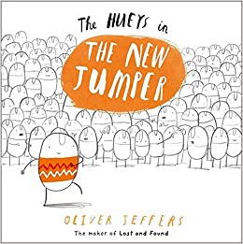  Monday (Huey’s new jumper):  Read ‘Huey’s New Jumper’ story using the link. Design your own jumper and explore different fabrics and fabric paints. https://www.worldbookday.com/videos/the-hueys-in-the-new-jumper/  Tuesday (My Presents):  Read the ‘My Presents’ story and see the attached resources on the link. Wrap and unwrap presents and play pass the parcel altogether.  https://www.worldbookday.com/videos/my-presents/  Wednesday:  Read the ‘Ketchup on your Cornflakes’ story online-  https://www.youtube.com/watch?v=BD_1Sup6Su8  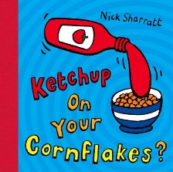  Can you mix some sill ingredients together into a bowl and make your own mixtures from the book?  Thursday:  Today is World Book Day! Can you take part in some cooking tasks linked to a book that you know?  Look at the Gruffalo cooking recipes online and share what you make on Dojo or Twitter!  https://www.worldbookday.com/resources/cooking/  Friday (Oh Dear):  Read ‘Max Won’t go to Bed’ story and see the attached resources on the link. https://www.worldbookday.com/videos/max-and-the-wont-go-to-bed-show/
Science |  | Physical activities
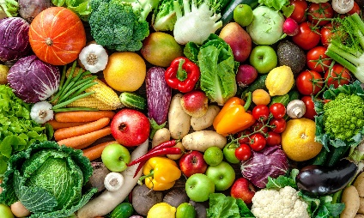  This term, we will be learning about what our bodies need to keep healthy. This week we are going to take a deeper look into what fruit and vegetables are and what they are like, using all of the senses.  What do they taste and smell like?  Can you taste and smell some new fruits and vegetables? Refer to the eatwell plate and food symbols.  *See ‘Eatwell Plate and Symbols’ on the school website*  What do they look like?  Can you draw some observational drawings and do some printing tasks using the different fruit and vegetables.  What do they feel like?  Can you cut up some fruit examples, mash them up and explore how they change when chopped, mashed, whole, cooked or raw.  Extension:  Can you collect some information for a chosen fruit or vegetable. Which fruit was soft? Which vegetables had seeds? |  | Go noodle wake up shake challenges:  Pizza Song  https://www.youtube.com/watch?v=4rm0LYLz1Wg  Fitness Challenges  https://www.youtube.com/watch?v=K4DnPhR9_mo  Kidz Bop Dances  https://www.youtube.com/watch?v=sNog54ovi8Q  ‘Down in the Jungle’ finger exercises- (YouTube)  You might want to do some finger warm up exercises before you start your English work. Get some playdough and join along with the exercises.  https://www.youtube.com/watch?v=o9D5lfqZF3oh  PE bingo card challenges:  Can you choose a few challenges on the bingo cards for each day and see if you can complete them all by the end of the week?  *See ‘PE Bingo Cards’ on the school website*  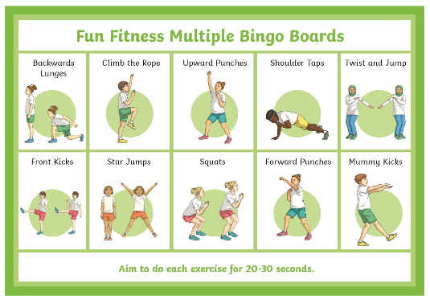
RE
In RE we will continue looking at symbols linked to Judaism.
This week move onto pupils learning to identify the Menorah and name it as ‘Menorah’.
Can you label the Menorah shape as ‘Menorah’ using symbols or words?
*See ‘Menorah Labelling Worksheet’ on the school website*
Can you draw or print a Menorah shape that looks like the Menorah symbol?
*See ‘Menorah Shape Drawing Worksheet’ on school website*

PSHE:
This week in PSHE, we will be learning about Friendship and turn taking.

Friendship work:
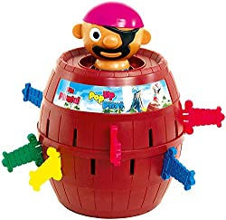
Collect some photos at home of picture or family and friends. Can you name them? Can you find your favourite person? Can you sign their name? Can you draw or produce a self-portrait of your favourite person or friend?

Turn taking:
Set up some activities that will encourage turn taking with another person for example boards games, interactive games on a tablet or computer and cooking activities.

Enrichment activities:
Humanities
This half term we will be learning about our immediate environment and what features are visible from our windows. Read or watch to the story ‘Window’ by Jeannie Baker.
- Drawings and paintings of key features on the windows in your house or garden windows (tree, car, garden, kitchen, field)
- ‘Real’ window (frame and curtains) to put different scene behind and reveal to pupils’ different windows from school
- Take photos of window in your house or on a walk to see different shop windows, house windows, car windows.
- Explore windows in the book and identify some things you see?
- Play a game of ‘What can you see?’ bingo through the window?
*See ‘Window ALD’ on the school website to support language*

DT and Art
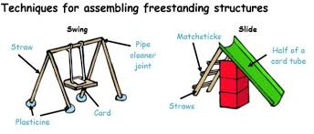
In DT, we are going to learning about freestanding structures.
Collect lots of different boxes (card, paper, plastic, metal) and see if you can place different objects onto top. What things made it fall over or crush?
Can you make your own using paper, card, straws, lollipop sticks, any wooden dowels and see which one is strongest?
Key questions about the materials:
Are they able to join the materials together?
Can they make a structure that stands up?
What technical vocabulary are they able to use or understand? (long, short, strong, weak, heavy, light).
Take photographs of your structures and send them to your teacher to see!

Music
In Music, we will be learning about how music can be related to our emotions. Look at the symbols for each emotion and practise saying and signing that feeling. Listen to the different music clips and when listening to each song starts exploring the feelings symbol and choose which word describes the music best for you.
https://www.youtube.com/watch?v=AkBLnEqmkqU
https://www.youtube.com/watch?v=oxBakn2fMW4
https://www.youtube.com/watch?v=ZbZSe6N_BXs&list=RDQMhH0aPyrY-R0&start_radio=1
https://www.youtube.com/watch?v=80lKLqLm16I
Try to help them understand that the same piece of music can make different people have different feelings.

Sing and sign challenges:
You’ve got a friend in me
https://www.youtube.com/watch?v=TvHmuQHOANc

Extra information
- We would recommend a short work session for each area listed above for up to 30 minutes per day or as much as each individual pupil would manage at home.
- Feel free to share photos and achievements via class Dojo and the school Twitter page.
- Email me directly with any home learning or curriculum issues or questions: elisha.stokes@westoaksschool.co.uk

