 | KS2 Stepping stones  Down on the Farm  Week commencing 01.03.2021 |  | 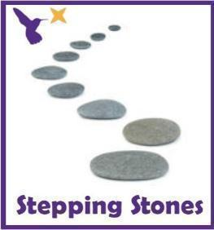
Classes in each pathway-
Woodhouse: Barn Owl, Swan and Starling
Boston Spa: Swift, Finch and Skylark
All about our projects this term:
It’s time to visit the farm! What animals will you see? What sounds will you hear? What does it feel like?
In English, we will explore the farm through the ‘Little Red Hen’. Will you help the Little Red Hen to grow the corn and bake the bread? We will learn the story through the Talk for Writing approach but also develop reading and writing skills through some simple instructions. Continue to focus on our ‘Farm’ topic in art using pencil control and farmyard illustrations and make a farmyard lever books in DT! In Humanities, we will be exploring what we can see from the window and learn how to describe our immediate environment using Geographical language.
Maths (Time) |  | English (World Book Week)
This week in Maths we will begin to look at Time. The main skills we will be focusing on is the use of time language and vocabulary e.g. days of the week, now, later, tomorrow, today,  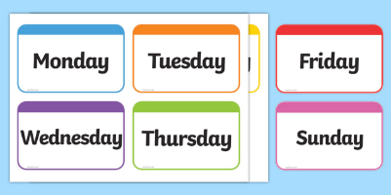  Days of the week  Read through the Jasper’s Beanstalk story on YouTube. Point out the different days of the week and practise the signs.  https://www.youtube.com/watch?v=jemrWJX7xJo  Days of the week signs:  https://www.youtube.com/watch?v=bYIQWWpZm08  Can you order the days of the week in the correct order?  *See ‘Days of the Week Cards’ on the school website*  Timers  Provide a range of timers (physical or YouTube timers) that measure different lengths of time. Pupils can choose a timer and then see what they can do in that period of time. E.g. How many star jumps can you do in 30 seconds? How many bean bags can you throw into the hoop in one minute?  https://www.youtube.com/watch?v=COcc7SZsRyQ  Set up a circuit of different activities around the room or garden. See how many of each activity you can do in one minute. E.g. How many bean bags can they throw into the hoop? How many skittles can they knock down? How many bricks can they build into the tower? Provide timers to show how long it has taken.  *Challenge: Can you guess how long it will take before you start?  Maths related stories and songs:  - Jasper’s Beanstalk - Nick Butterworth  https://www.youtube.com/watch?v=Da6lxY_8jmU  - Mr Wolf’s Week – Colin Hawkins  - 5 Minutes Peace – Jill Murphy Days of the Week Song |  | Monday (Gingerbread man):  Read the Gingerbread story using the link. Make your own gingerbread biscuits! https://www.worldbookday.com/videos/the-gingerbread-man/  Tuesday (Postman Bear):  Read the Postman Bear story using the link. Make your own postman hat to wear when reading the story.  https://www.worldbookday.com/videos/acorn-wood-postman-bear/  *See ‘Postman Hat Template’ on the school website*  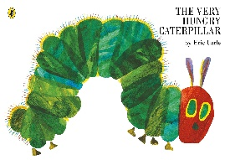  Wednesday:  Read the Hungry Caterpillar story online or using a book you have.  https://www.youtube.com/watch?v=75NQK-Sm1YY  Can you use fruit printing to make your own hungry caterpillar?  Can you taste some of the foods from the Hungry Caterpillar?  Thursday:  Today is World book day! Can you take part in some cooking tasks linked to a book that you know?  Look at the Gruffalo cooking recipes online and share what you make on Dojo or Twitter!  https://www.worldbookday.com/resources/cooking/  Friday (Oh Dear):  Read the ‘Oh Dear’ story and see the attached resources on the link.  https://www.worldbookday.com/videos/oh-dear/
Science |  | Physical activities
This term, we will be learning about what our bodies need to keep healthy. This week we are going to take a deeper look into what fruit and vegetables are and what they are like, using all of the senses.  What do they taste and smell like?  Can you taste and smell some new fruits and vegetables? Refer to the Eatwell plate and food symbols.  *See ‘Eatwell Plate and Symbols’ on the school website*  What do they look like?  Can you draw some observational drawings and do some printing tasks using the different fruit and vegetables.  What do they feel like?  Can you cut up some fruit examples, mash them up and explore how they change when chopped, mashed, whole, cooked or raw.  Extension:  Can you collect some information for a chosen fruit or vegetable? Which fruit was soft? Which vegetables had seeds? |  | Wake up shake up songs:  Wake Up song.  https://www.youtube.com/watch?v=1gUbdNbu6ak  Lazy Town exercises  https://www.youtube.com/watch?v=eD7zbsGjFo4  Dinosaur Stomp  https://www.youtube.com/watch?v=Imhi98dHa5w  ‘Down in the Jungle’ finger exercises- (YouTube)  You might want to do some finger warm up exercises before you start your English work. Get some playdough and join along with the exercises.  https://www.youtube.com/watch?v=o9D5lfqZF3oh  PE bingo card challenges:  Can you choose a few challenges on the bingo cards for each day and see if you can complete them all by the end of the week?  *See ‘PE Bingo Cards’ on the school website*  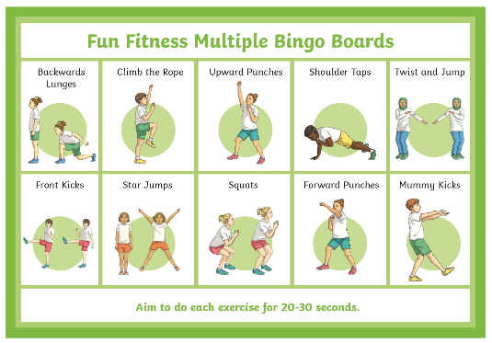
RE
In RE we will continue looking at symbols linked to Christianity.
This week move pupils learning onto identifying the fish and name it as ‘fish’.
Can you label the fish as ‘fish’ using symbols or words?
Can you draw or print a fish shape that looks like the fish symbol?
*See ‘Fish Worksheets’ on the school website*

PSHE:
This week in PSHE, we will be learning about Friendship and turn taking.

Friendship work:
Collect some photos at home of picture of family and friends. Can you name them? Can you find your favourite person? Can you sign their name? Can you draw or produce a self-portrait of your favourite person or friend?

Turn taking:
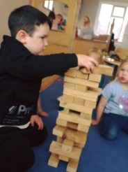
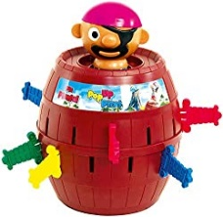
Set up some activities which will encourage turn taking with another person for example boards games, interactive games on a tablet/ computers and cooking activities.
Use the visuals to identify whose turn it currently is and who is waiting.
*See ‘Turn Taking Visuals’ on the school website*

Creative projects
Humanities
This half term we will be learning about our immediate environment and what features are visible from our windows. Read or watch to the story ‘Window’ by Jeannie Baker.
- Drawings and paintings of key features on the windows in your house or garden windows (tree, car, garden, kitchen, field)
- ‘Real’ window (frame and curtains) to put different scene behind and reveal to pupils’ different windows from school
- Take photos of windows in your house or on a walk to see different shop windows, house windows, car windows.
- Explore windows in the book and identify some things you see?
- Play ‘what can you see’ bingo through the window?

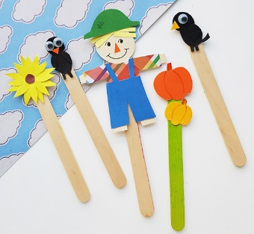
DT and Art
This week we will explore levers in more depth. Look at levers in moving picture books and how they move. This week have a go at making a moving puppet or character linked to your story focus or a pop up book you have at home. Try attaching it to a lollipop stick, straw or spoon and place between a slit in paper and card to use as your background. Let pupils explore it moving up and down or side to side like you can in the book.
https://www.youtube.com/watch?v=PsZ-VTk98Ec
https://www.youtube.com/watch?v=x00f-rcsBYk
*See ‘Example Puppet Templates’ on the school website*
Over the term, for our DT project you will need:
- Scissors
- Glue
- Card and paper
- Straws or lollipop sticks
- Pens, pencils or paints
Music
In Music start with the animal sounds song linked to our topic. Encourage the pupils to join in with some of the animal sounds..
https://www.youtube.com/watch?v=RmFpOP7Z2ww or play listening game 4 https://www.youtube.com/watch?v=o3MJ1tFNYE0
Next, play a game of musical statues, asking the pupils to use their bodies to move around the space and ‘freeze’ when the music stops. Choose a wide range of music to play. Try to include a mixture of pop, folk, country, classical. Change the length of time the music plays and see how the genre and speed of the music affect the children’s movements.
*See ‘Musical Bumps Symbols’ on the school website*
Extra information
-We would recommend a short work session for each area listed above for up to 30 minutes per day or as much as each individual pupil would manage at home.
-Please share your express week photos, work and achievements via my email address, class Dojo and the school Twitter page.
-Email me directly with any home learning or curriculum issues or questions: elisha.stokes@westoaksschool.co.uk
-Education city log in:
Username- 383westoaks
Password: 555637

