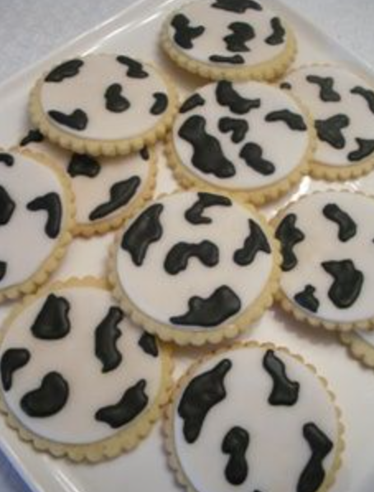
Cow pattern biscuit decoration

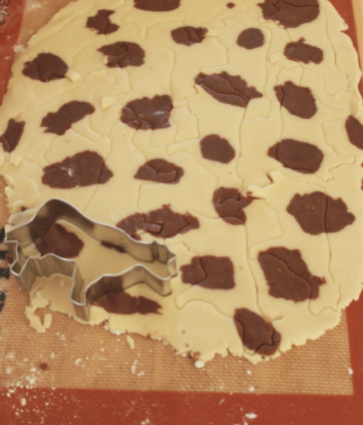
Cow pattern cookies
http://sweetfromtheheart.blogspot.com/2014/06/cow-patterned-cow-cookies.html?m=1

Gluten and dairy free biscuit recipe
https://thewoodlandwife.co.uk/dairy-and-gluten-free-biscuits/

