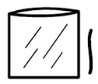
- Find the plastic wallet. | 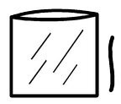
- Open the plastic wallet. | 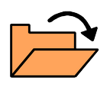
- Find the white wool. | 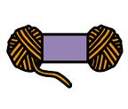
- Put the white wool in the plastic wallet. | 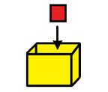
- Find the black wool.

- Put the black wool in the plastic wallet.

- Close the plastic wallet. | 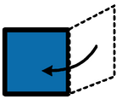
Can you make a cow sensory bag?

- Find the plastic wallet.

- Open the plastic wallet.
- Find the white paint.

- Put the white paint in the plastic wallet.

- Find the black paint.

- Put the black paint in the plastic wallet.

- Close the plastic wallet.
Can you make a cow sensory bag?

ake a cow sensory bag?

