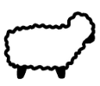

Can you shear the sheep?

