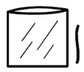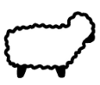

|  |  |
| --- | --- |
| 1. Find the plastic wallet. |  |
| 1. Open the plastic wallet. |  |
| 1. Find the white pom poms. |  |
| 1. Put the white pom poms in the plastic wallet. |  |
| 1. Find the white wool. |  |
| 1. Put the white wool in the plastic wallet. |  |
| 1. Find the white pipe cleaners. |  |
| 1. Put the white pipe cleaners in the plastic wallet. |  |
| 1. Close the plastic wallet. |  |

Can you make a sheep sensory bag?