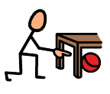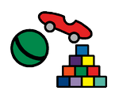

Can you find the toys?

|  |  |
| --- | --- |
| book |  |
| jigsaw |  |
| rubber duck |  |
| trains |  |
| paintbrush |  |