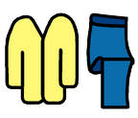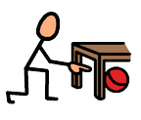

Can you find all the clothes?

|  |  |
| --- | --- |
| Hat |  |
| Scarf |  |
| Wellies |  |
| Gloves |  |
| Coat |  |