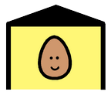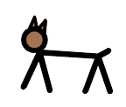

Where do these animals live?

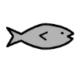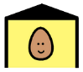

1. The fish lives in

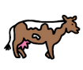

1. The cow lives on a

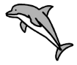



1. The dolphin lives in



1. The pig lives on a



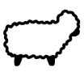

1. The sheep lives on a



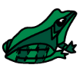

1. The frog lives in

water water water



water

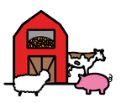farm farm farm

farm