 | Week commencing: 1/3/21  Unit theme: How does it grow?  Story: First the Egg  Weekly theme: Sheep |  | 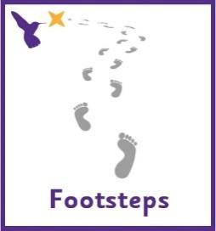
Wren (Boston Spa Learning)
World book day
Thursday 4th March is World Book Day. We will be celebrating in school by reading lots of our favourite stories and making our own books using photos of ourselves and pictures of our favourite things. You could make your own photo scrapbook at home with pictures of friends and family. There are lots of lovely animated stories on the following link https://www.worldbookday.com/share-a-story-corner/
Communication activities |  | Cognition (Maths-based) activities
Help your child to engage with fun stories and musical activities through actions and signs  This half term, our focus skill is: Following instructions.  The learning intention is:  To be able to listen to communicative partners  To be able to process information and respond  Activity ideas  - Reading  Read the story ‘First the Egg’ (See ‘First the Egg Story’ PowerPoint on the school website). Encourage your child to follow instructions to turn the page (if printed) or click onto the next slide (if reading on a computer). Support them to point out characters in the story and to copy the Makaton signs – See ‘First the Egg Makaton Signs’ and ‘First the Egg Story Symbols’ resources on the school website.  - Tactile  Support your child to follow the instructions on the ‘Sheep Sensory Bag’ resource on the school website, to make a lovely tactile resource.  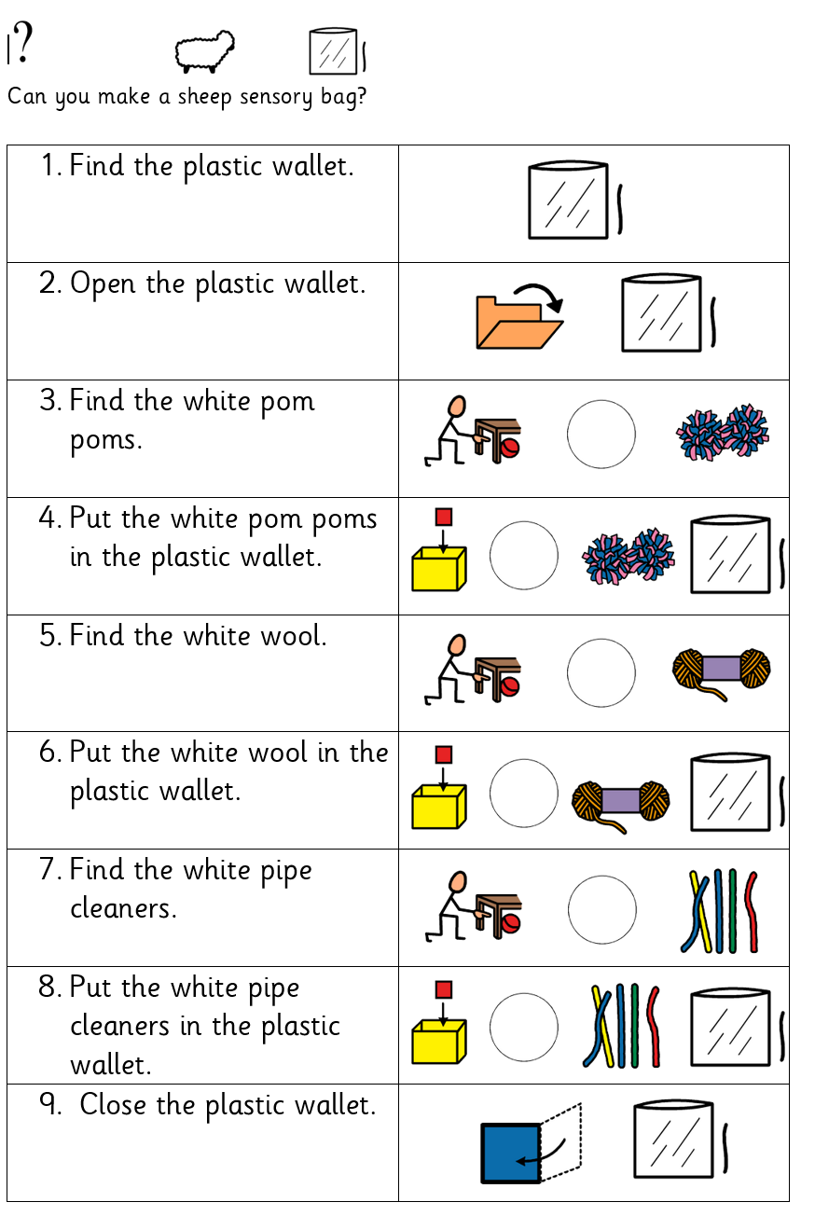  - Craft  Using the ‘Sheep Shearing Craft’ resource on the school website, decorate your sheep with brightly coloured wool, tissue or any other material you have at home, then remove each colour to shear the sheep! |  | There are lots of ways to learn about maths around the house. Doing puzzles, playing games and exploring house equipment are all great ways to practise maths skills.  This half term, our focus skill is: Object permanence.  The learning intention is:  To develop a wider understanding of the world around us by making links between past learning and immediate experiences.  Activity ideas  - Finding missing objects needed for a task  Using the ‘Finding Clothes’ resource on the school website, encourage your child to find woolly clothes to dress up in. This could be taken from central box or from their usual place, e.g. in a wardrobe or cupboard.  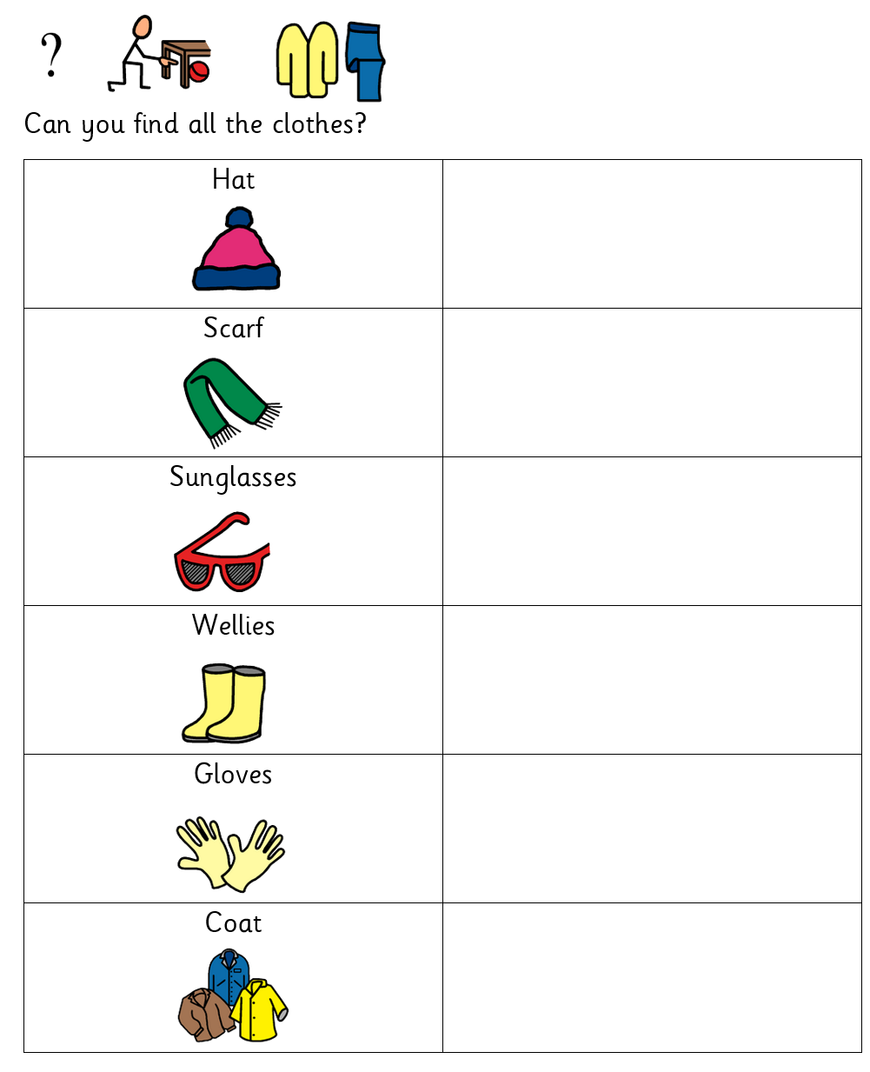  - Sorting  Using the ‘Animal Sorting’ resource on the school website, encourage your child to sort the animals – do they live on the farm or in the water? You could do this with the printable worksheet or with toys if you have them.  - Locating objects around the room  Using the ‘Finding Toys’ resource on the school website, encourage your child to find toys to play with. This could be taken from central box or from their usual place, e.g. in a cupboard. You can edit the list based on your child’s preferences, please contact school if you need any symbols emailing to you to support this.
Sensory activities |  | Physical activities
Sensory activities can be extremely motivating, develop attention skills and help your child to self-regulate.  Activity ideas  - Cooking  Skill: Tasting different food  Make some tasty edible sheep! See ‘Sheep Cooking’ resource on the school website for ideas, including cupcake or rice cake decorating and pretzel and marshmallow sheep.  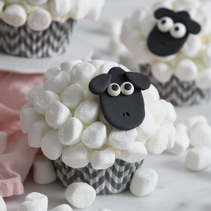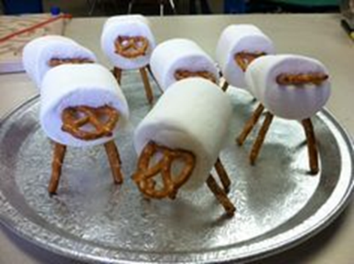  - Tactile  Skill: Fine motor movements  Make a farm sensory bin and encourage your child to develop their fine motor skills by using their fingers to pick up small object, post and thread. This could include building a pen for the animals out of Duplo, or  cleaning the muddy animals – roll in paint and clean with soapy water.  https://learningforlittles.com/how-to-create-a-farm-themed-sensory-table/  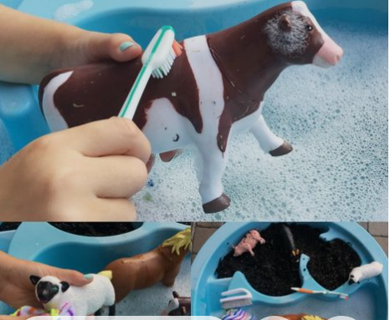  - Art  Skill: Exploring shapes  Make your own sheep from playdough - see ‘Playdough sheep’ resource on the school website. Follow the link below for a recipe to make taste-safe playdough https://www.pinterest.co.uk/pin/5840674504572923/ |  | Physical activity is great to keep our minds active and burn lots of energy!  Activity ideas  - Gross motor  Skill: Proprioception/Body awareness  Giving proprioceptive input can be great for calming and regulating children with sensory processing issues, see website below for more information.  https://www.theottoolbox.com/proprioception-sensory-activities/  You could try activities such as wheelbarrow walking or a heavy lifting relay race to give lots of input to the body.  - Ball skills  Skill: Throwing underarm  Encourage your child to throw a ball or beanbag towards you or at a target, e.g. at a wall or into a bucket.  - Jumping  Skill: Body awareness  Encourage your child to jump on the spot, forwards, backwards and sideways! See printable resource ‘Jumping Visuals’ on the website.  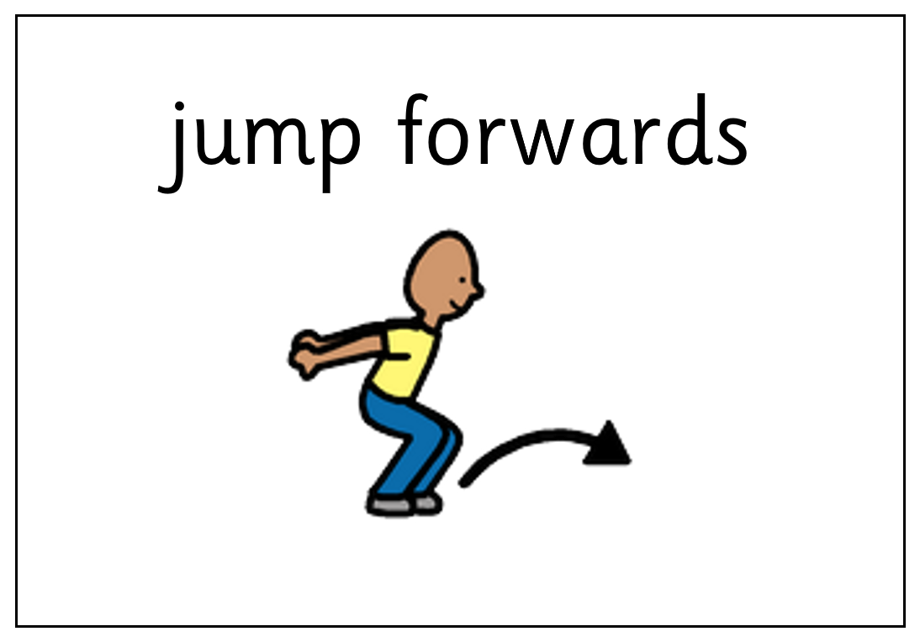  - Dance  Skill: Gross motor movements  Listen to songs about the farming! Encourage your child to choose which song to listen to by clicking on the pictures in the ‘Farm Songs’ PowerPoint on the school website, or print off the symbols on the first page to use for PECS.  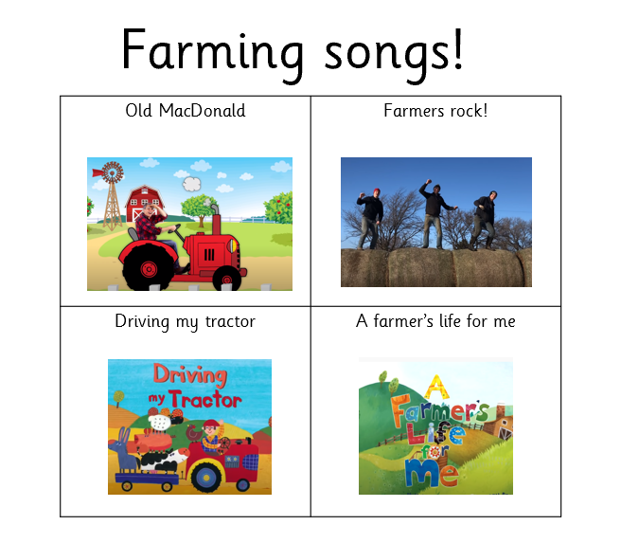
Additional learning links
- Start the day with a ‘Good Morning’ routine – See example PowerPoint on the school website (Click ‘enable content’ when opening the PowerPoint to ensure videos will open)
- Search on YouTube for educational songs, e.g. ‘Barefoot Books’ or ‘The Learning Station’
- Cbeebies.com – games, TV shows and songs. ‘Something Special’ is great for teaching children (and the rest of the family!) Makaton signs.
- TACPAC – See information sheet and example PowerPoint on the school website. Click on the musical notes symbol for links to songs.
- Follow ‘Gina Davies Autism Centre’ on Facebook to find out more about the Attention Autism programme that we use in school and get tips on how you could replicate this at home, either by watching the videos with your child or creating your own session https://www.facebook.com/ginadaviesautism/posts/
- Yoga/relaxation session – See PowerPoint on the school website
Other information
- We have put together an example timetable to help you structure your day – See ‘Footsteps Daily Routine Example’ on the school website. Please adapt this for your child and include as much or as little of the content as you feel appropriate. Symbols can be printed out and used with the ‘Now and next’ board to support your child to understand their routine.
- Please feel free to share any photos or achievements on Dojo or the school Twitter page.
- If you need any further information, or would like a pack of these resources delivered to your home, you can email me at jessica.arnold@westoaksschool.co.uk

