 | Week commencing: 1/3/21  Unit theme: How does it grow?  Story: The Tiny Seed  Weekly theme: The sun |  | 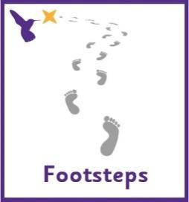
Kingfisher (Boston Spa Learning)
Sandpiper (Woodhouse Learning)
World book day
Thursday 4th March is World Book Day. We will be celebrating in school by reading lots of our favourite stories and making our own books using photos of ourselves and pictures of our favourite things. You could make your own photo scrapbook at home with pictures of friends and family. There are lots of lovely animated stories on the following link https://www.worldbookday.com/share-a-story-corner/
Communication activities |  | Cognition (Maths-based) activities
Help your child to engage with fun stories and musical activities through actions and signs  This half term, our focus skill is: Making choices.  The learning intention is:  To be able to communicate preferences.  Activity ideas  - Reading  Read the story ‘The Tiny Seed’ (See PowerPoint on the school website). Encourage your child to follow instructions to turn the page (if printed) or click onto the next slide (if reading on a computer). Support them to point out characters/objects in the story and to copy the Makaton signs – see ‘Tiny Seed Makaton Signs’ resource on the school website.  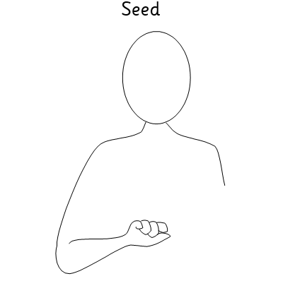  - Music  Listen to songs about the sunshine! Encourage your child to choose which song to listen to by clicking on the pictures in the ‘Sun Songs’ PowerPoint on the school website, or print off the symbols on the first page to use for PECS.  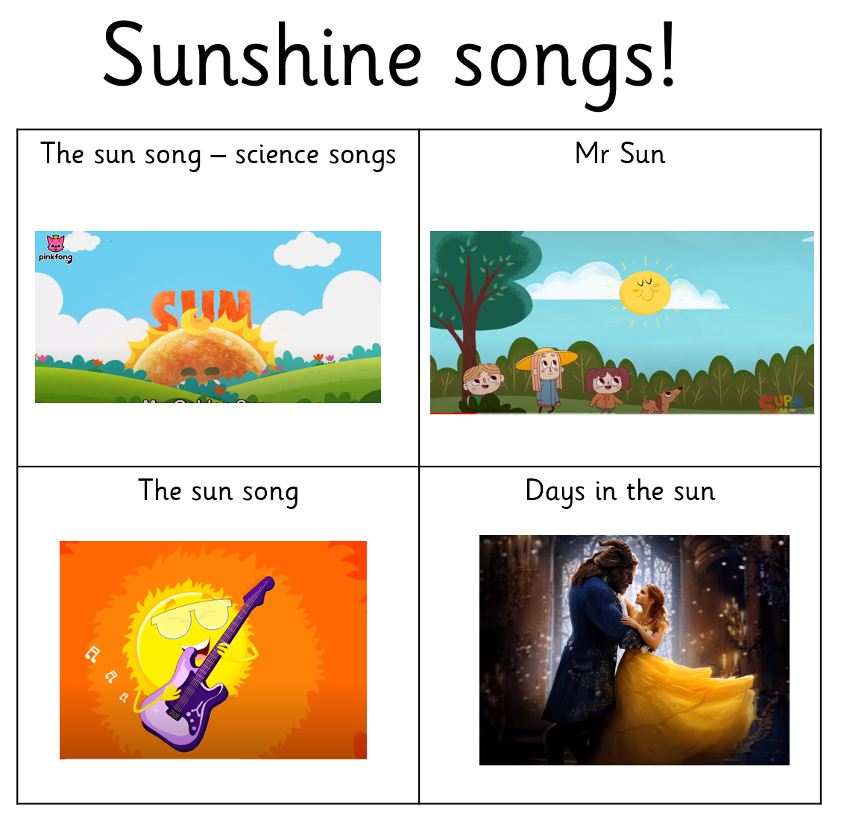  - Tastes and smells  Taste and smell food that makes you think of sunshine! This might be smelling a variety of spices from hot countries or tasting yellow and orange foods that resembles the sun. Encourage your child to make choices between different options and to communicate their preferences. See ‘Preferences Symbols’ resource on the school website.  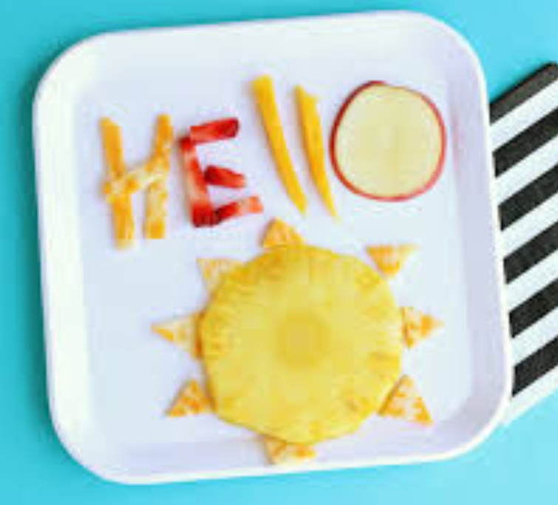 |  | There are lots of ways to learn about maths around the house. Doing puzzles, playing games and exploring house equipment are all great ways to practise maths skills.  This half term, our focus skill is: Measure – Capacity.  The learning intention is:  To be able to make comparisons between objects.  Activity ideas  - Cooking  Cooking can also be a great way to engage children with exploring objects of different shapes and sizes. Encourage your child to fill up different sized containers, e.g. with ice cream to make this cool sunny treat!  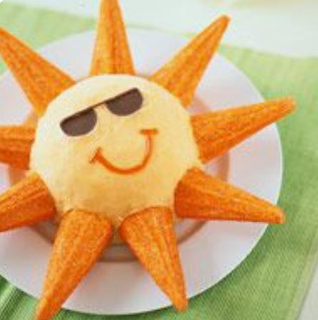  - Art  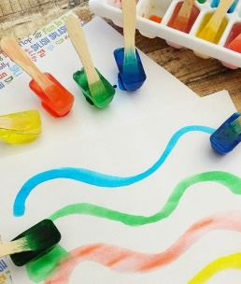  Try making your own frozen paints for sun-themed art by freezing water and food colouring in ice cube trays. Encourage your child to experiment with adding different amounts of the liquids – Can you make a brighter colour by adding more food colouring? Can you find a container to make a bigger paint stick? You will need to make the paints the day before you want to use them for art.  - Water play  Water play can be very motivating for our pupils and great way to support them to explore capacity. Use any outdoor space you have to get really messy, or you could incorporate water play into bath/shower time by having a range of different containers to fill with water. If you have the resources/space to plant some real seeds then this is a great activity to explore different containers, such as watering cans, jugs, cups, bottles, etc.  Key vocabulary to focus on: full, empty, more, less.
Sensory activities |  | Physical activities
Sensory activities can be extremely motivating, develop attention skills and help your child to self-regulate.  - Cooking  Skill: Spreading  Spread yellow icing onto biscuits to make a cute edible sunshine!  - Art  Skill: Using a paintbrush  Encourage your child to use a paintbrush in different ways to paint a sunny scene. They could use yellow for the sun, blue for sky and then experiment with mixing the two together to make green for grass. Follow the link below for a recipe to make taste-safe paint.  https://rainydaymum.co.uk/baby-play-finger-painting/  See printable resource on the school website – ‘Sunny Scene Colouring’  - Tactile  Skill: Fine motor movements  Make a sunshine sensory bin and encourage your child to develop their fine motor skills by using their fingers to pick up small object, post and thread.  https://mrsplemonskindergarten.com/2018/05/baby-bins-summer.html  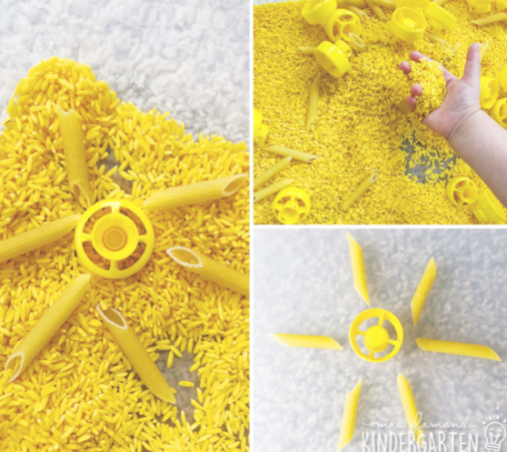 |  | Physical activity is great to keep our minds active and burn lots of energy!  - Dance  Skill: Gross motor movements  Encourage your child to copy the actions to this fun insect dance! Search on YouTube for ‘Learn to Dance: Can you Plant a Bean’ https://www.youtube.com/watch?v=LCKEdDEr82k  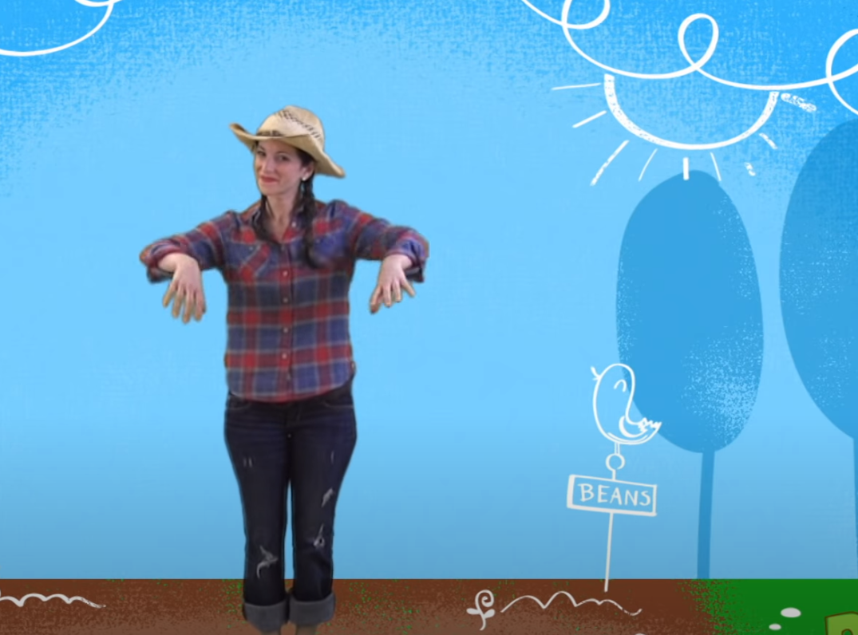  - Ball skills  Skill: Throwing underarm  Encourage your child to throw a ball or beanbag towards you or at a target, e.g. at a wall or into a bucket.  - Jumping  Skill: Body awareness  Encourage your child to jump on the spot, forwards, backwards and sideways! See printable resource ‘Jumping Visuals’ on the school website.  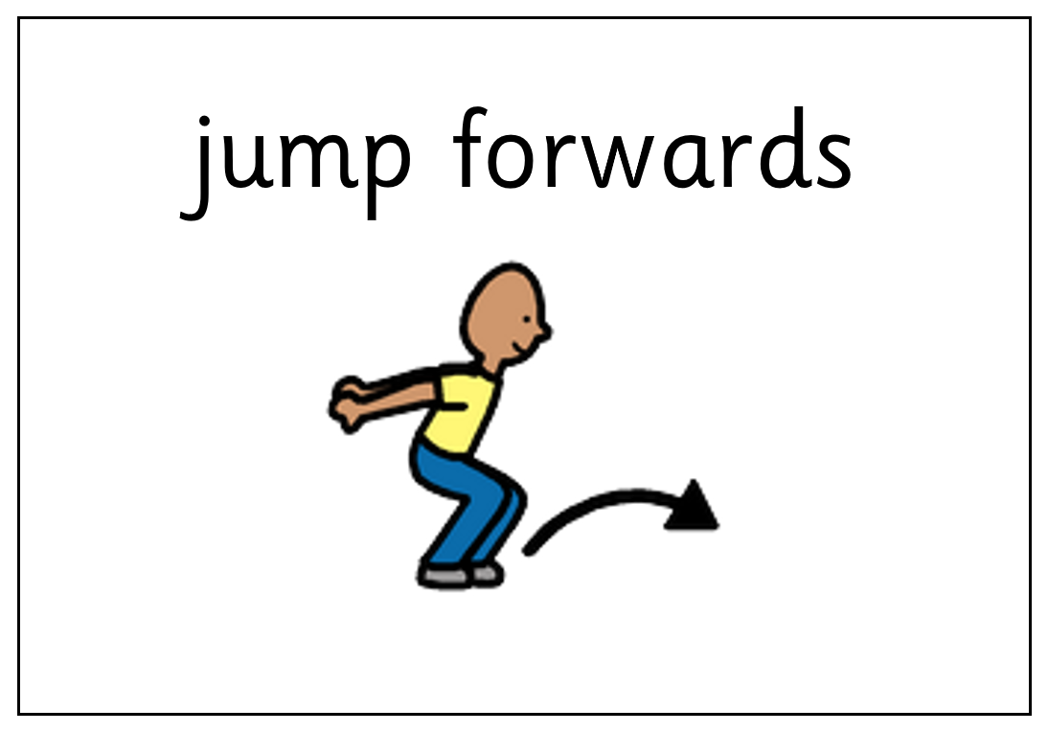
Additional learning links
- Start the day with a ‘Good Morning’ routine – See example PowerPoint on the school website (Click ‘enable content’ when opening the PowerPoint to ensure videos will open)
- Search on YouTube for educational songs, e.g. ‘Barefoot Books’ or ‘The Learning Station’
- Cbeebies.com – games, TV shows and songs. ‘Something Special’ is great for teaching children (and the rest of the family!) Makaton signs.
- TACPAC – See information sheet and example PowerPoint on the school website. Click on the musical notes symbol for links to songs.
- Follow ‘Gina Davies Autism Centre’ on Facebook to find out more about the Attention Autism programme that we use in school and get tips on how you could replicate this at home, either by watching the videos with your child or creating your own session https://www.facebook.com/ginadaviesautism/posts/
- Yoga/relaxation session – See PowerPoint on the school website
Other information
- We have put together an example timetable to help you structure your day – See ‘Footsteps Daily Routine Example’ on the school website. Please adapt this for your child and include as much or as little of the content as you feel appropriate. Symbols can be printed out and used with the ‘Now and next’ board to support your child to understand their routine.
- Please feel free to share any photos or achievements on Dojo or the school Twitter page.
- If you need any further information, or would like a pack of these resources delivered to your home, you can email me at jessica.arnold@westoaksschool.co.uk

