 | Week commencing: 1/3/21  Unit theme: How does it Grow?  Story: The Cautious Caterpillar  Weekly theme: Ladybirds |  | 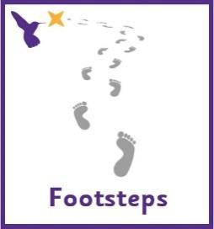
Dove (Boston Spa Learning)
World book day
Thursday 4th March is World Book Day. We will be celebrating in school by reading lots of our favourite stories and making our own books using photos of ourselves and pictures of our favourite things. You could make your own photo scrapbook at home with pictures of friends and family. There are lots of lovely, animated stories on the following link https://www.worldbookday.com/share-a-story-corner/
Communication activities |  | Cognition (Maths-based) activities
Help your child to engage with fun stories and musical activities through actions and signs  This half term, our focus skill is: Following instructions.  The learning intention is:  To be able to listen to communicative partners  To be able to process information and respond  Activity ideas  - Reading  Read the story ‘The Cautious Caterpillar’ (See PowerPoint on the website). Encourage your child to follow instructions to turn the page (if printed) or click onto the next slide (if reading on a computer). Support them to point out characters in the story and to copy the Makaton signs - search for ‘Singing Hands Minibeasts’ on YouTube or see the ‘Cautious caterpillar Makaton Signs’ resource on the school website.  - Simon says  Following a sequence of actions. Encourage your child to copy actions (see printable resource on the website - ‘Simon Says Visuals’). You could make this easier by giving physical support, or trickier by making a sequence of 2 or 3 actions in a row.  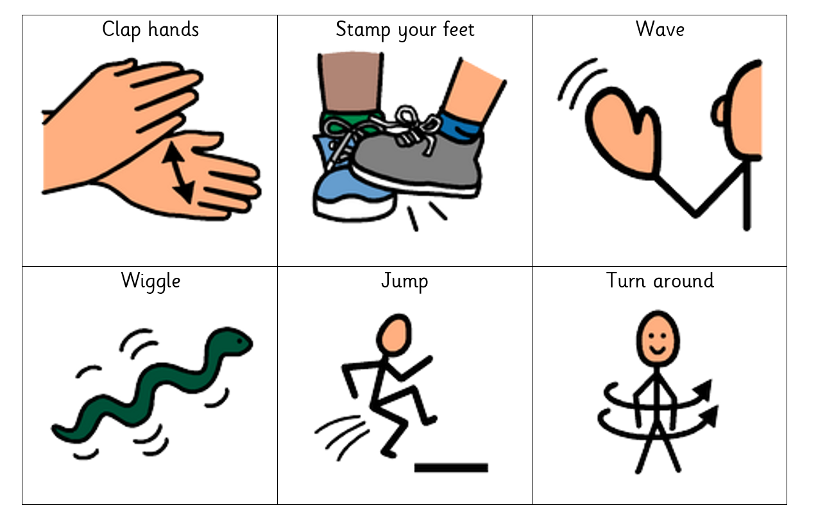  - Tactile  Can you make it fly like a ladybird? Encourage your child to follow instructions to keep objects in the air, e.g. throwing and catching, using a fan to blow objects, making paper aeroplanes decorated with ladybird spots. Vocabulary to focus on: ‘ready, steady, go’, ‘up’, ‘down’ and ‘throw’. |  | There are lots of ways to learn about maths around the house. Doing puzzles, playing games and exploring house equipment are all great ways to practise early maths skills.  This half term, our focus skill is: Object permanence.  The learning intention is:  To develop a wider understanding of the world around us by making links between past learning and immediate experiences.  Activity ideas  - Art – finding the correct colours  Encourage your child to find red playdough from a choice of different colours and use this to make little ladybirds with different amounts of spots. Follow the link below for a recipe to make taste-safe playdough: https://www.pinterest.co.uk/pin/5840674504572923/  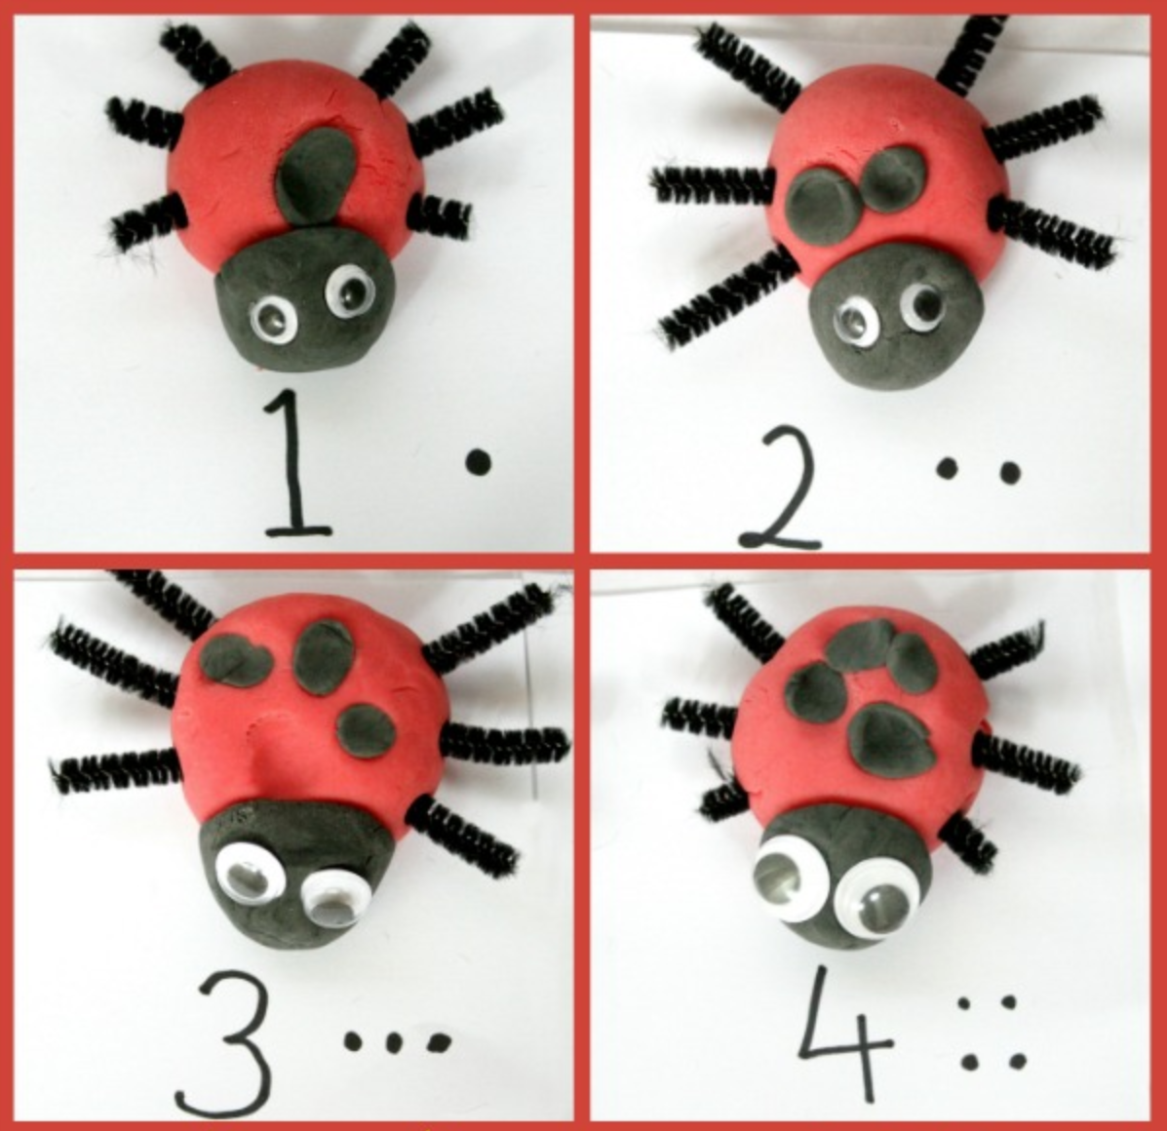  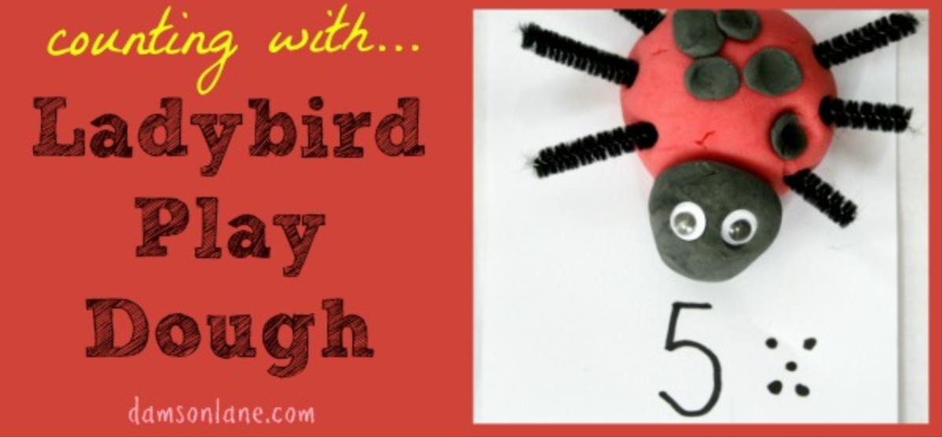  - Number songs – finding the ladybird  Sing the song ‘5 Little Ladybirds’ (See printable visuals on the website). Encourage your child to find each ladybird and make them fly away after each verse.  - Food – knowing the location of kitchen equipment  Make strawberry ladybirds. Encourage your child to locate equipment in the kitchen, e.g. by getting a knife from the drawer or fruit from the fridge. Cut strawberries in half and decorate using chocolate drops for spots.  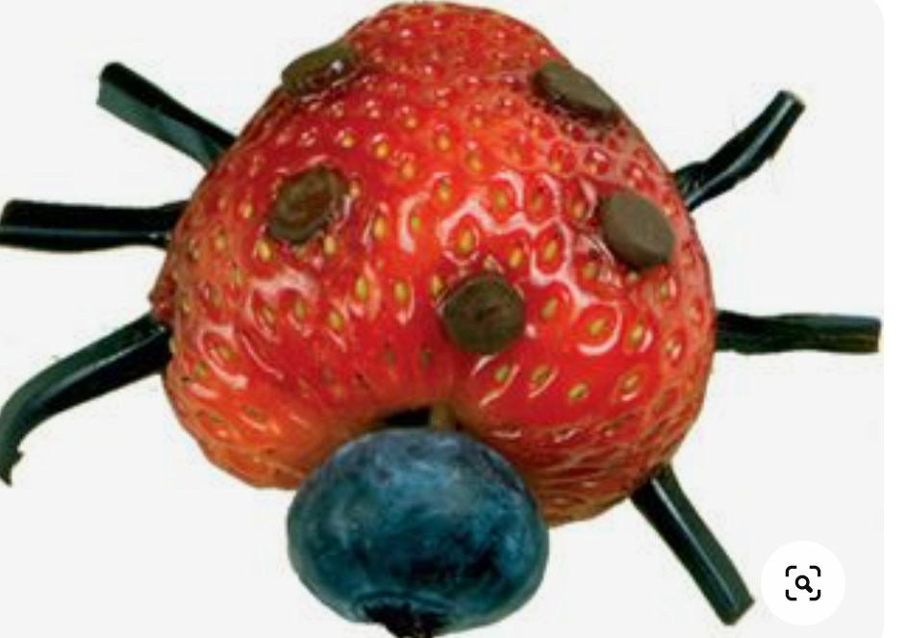
Sensory activities |  | Physical activities
Sensory activities can be extremely motivating, develop attention skills and help your child to self-regulate.  - Cooking  Skill: Spreading  Spread red icing onto biscuits to make cute edible ladybirds!  - Art  Skill: Using a paintbrush  Encourage your child to use a paintbrush in different ways to paint a ladybird. Use long strokes for the main body and make little circles for the spots. Follow the link below for a recipe to make taste-safe paint.  https://rainydaymum.co.uk/baby-play-finger-painting/  See printable resource on the school website – ‘Ladybird Colouring Template’.  - Tactile  Skill: Fine motor movements  Make a ladybird sensory bin and encourage your child to develop their fine motor skills by using their fingers to pick up small object, post and thread.  https://www.pinterest.co.uk/pin/721209327818202183/  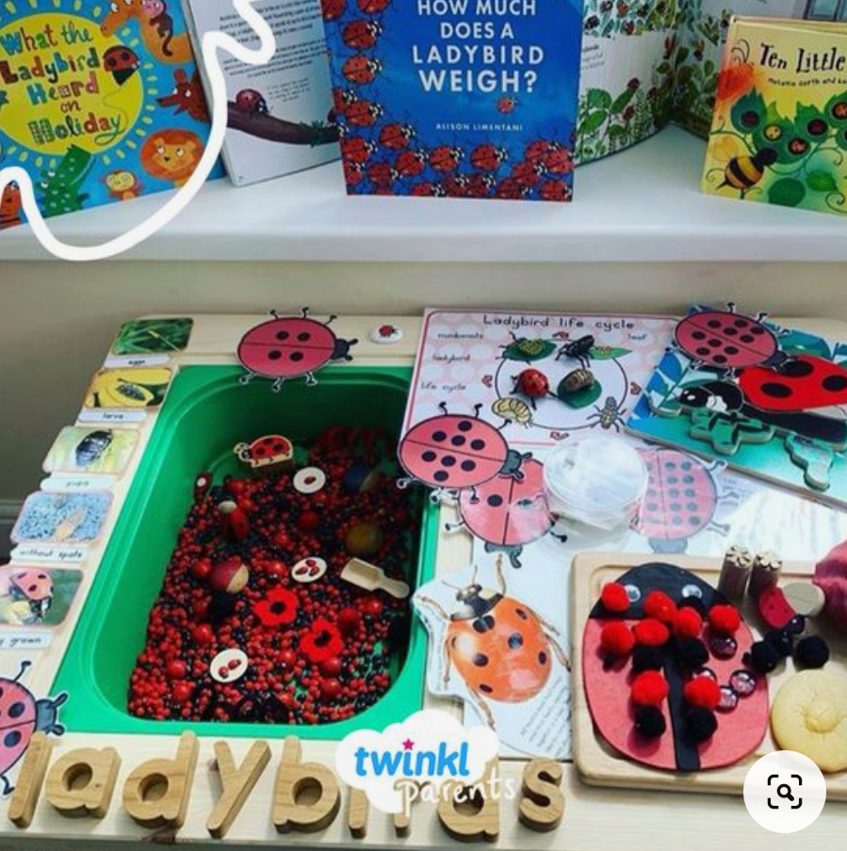 |  | Physical activity is great to keep our minds active and burn lots of energy!  - Dance  Skill: Gross motor movements  Encourage your child to copy the actions to this fun insect dance! Search on YouTube for ‘Learn to Dance: Bugs and Crawly Things’ https://www.youtube.com/watch?v=hUbYq93cYdE  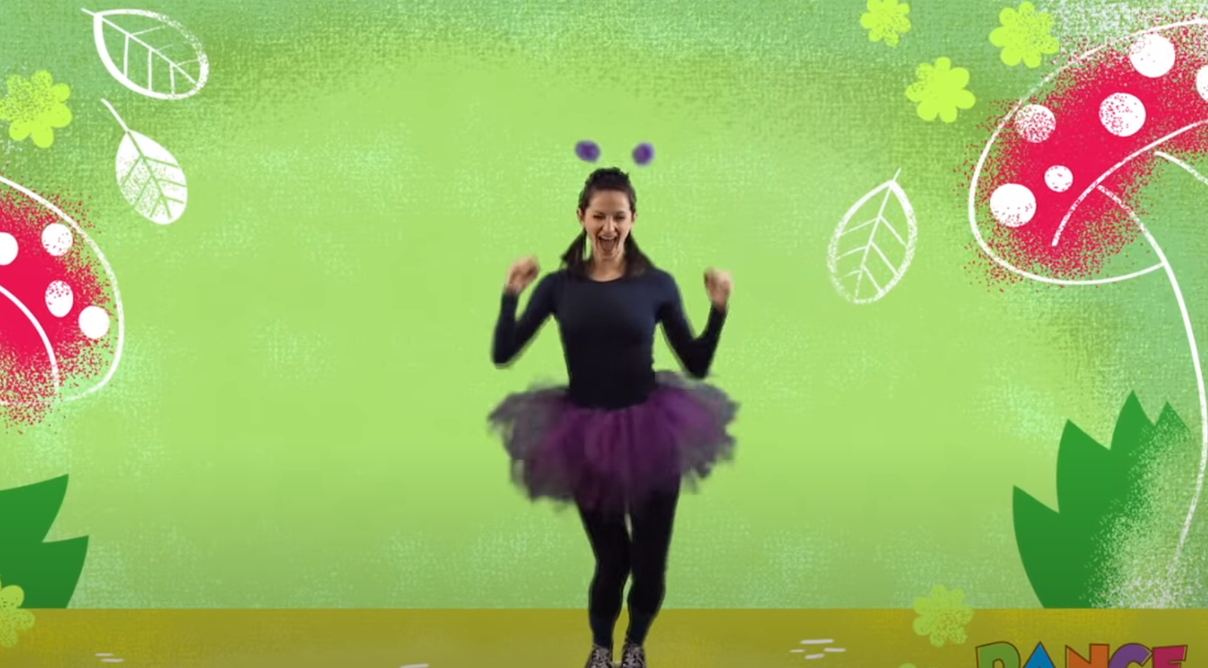  - Ball skills  Skill: Throwing underarm  Encourage your child to throw a ball or beanbag towards you or at a target, e.g. at a wall or into a bucket.  - Jumping  Skill: Body awareness  Encourage your child to jump on the spot, forwards, backwards and sideways! See printable resource ‘Jumping Visuals’ on the website.  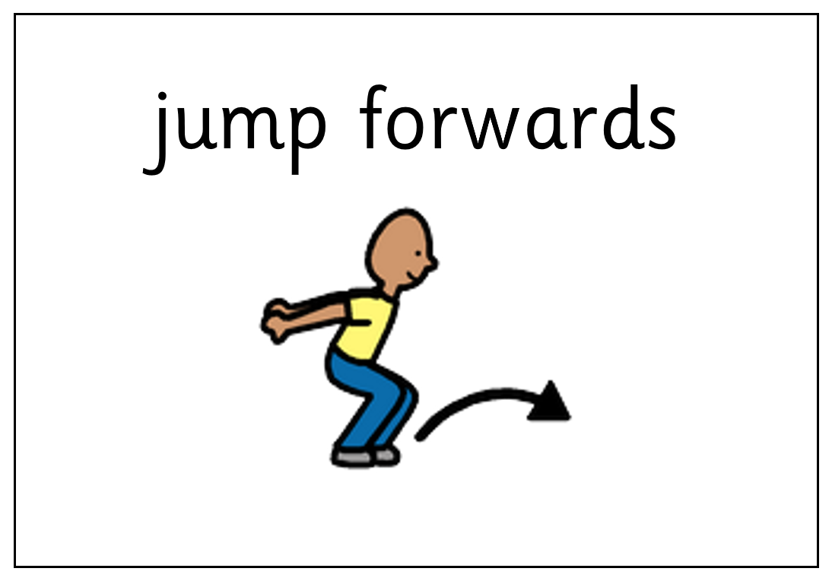
Additional learning links
- Start the day with a ‘good morning’ routine – See example PowerPoint on the school website (Click ‘enable content’ when opening the PowerPoint to ensure videos will open)
- Search on YouTube for educational songs, e.g. ‘Barefoot Books’ or ‘The Learning Station’
- Cbeebies.com – games, TV shows and songs. ‘Something Special’ is great for teaching children (and the rest of the family!) Makaton signs.
- TACPAC – See information sheet and example PowerPoint on the school website. Click on the musical notes symbol for links to songs.
- Follow ‘Gina Davies Autism Centre’ on Facebook to find out more about the Attention Autism programme that we use in school and get tips on how you could replicate this at home, either by watching the videos with your child or creating your own session https://www.facebook.com/ginadaviesautism/posts/
- Yoga/relaxation session – See PowerPoint on the school website
Other information
- We have put together an example timetable to help you structure your day – See ‘Footsteps Daily Routine Example’ on the school website. Please adapt this for your child and include as much or as little of the content as you feel appropriate. Symbols can be printed out and used with the ‘Now and next’ board to support your child to understand their routine.
- Please feel free to share any photos or achievements on Dojo or the school Twitter page.
- If you need any further information, or would like a pack of these resources delivered to your home, you can email me at jessica.arnold@westoaksschool.co.uk

