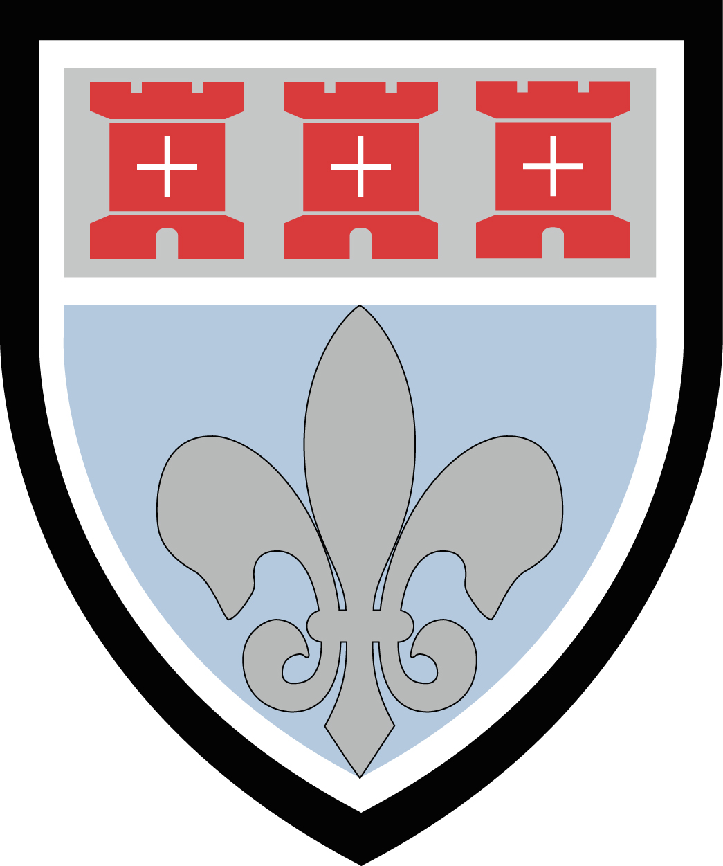
St Mary’s Catholic Sixth Form
Application for Entry 2021: External Students Only
Benton Park Road, Newcastle upon Tyne, NE7 7PE
Your details

Surname |  | Date of Birth
Forename(s) |  | M/F
Home Address  Postcode |  | Home tel
Parent |  | Mobile
Parent email
Present school  Postcode | Named school referee & position held  Tel  Email
Personal Statement

Please write a statement about your reasons for applying to St Mary’s Sixth Form. This can be handwritten or attached as a word processed document. This should be completed by the student wishing to attend the Sixth Form.

Signature of student | Date
Signature of parent/carer | Date

Please return your form to Mr McKeating, Assistant Headteacher, by email at admin@st-marys.newcastle.sch.uk or via post

What are your predicted GCSE grades?

Subject | Predicted Grade

What subjects would you like to study in the Sixth Form?
- Students should pick 3 subjects
- Students should pick subjects where they are likely to meet the entry requirements
- Students can only pick 1 subject per block
- If students wish to study double award vocationals (in Business or Health and Social Care), this counts as 2 subjects. Students should select the subject in the single column and also in the column where double award is noted.

Deadline for Applications is 12th March 2021

