26.2.21 Reading comprehension
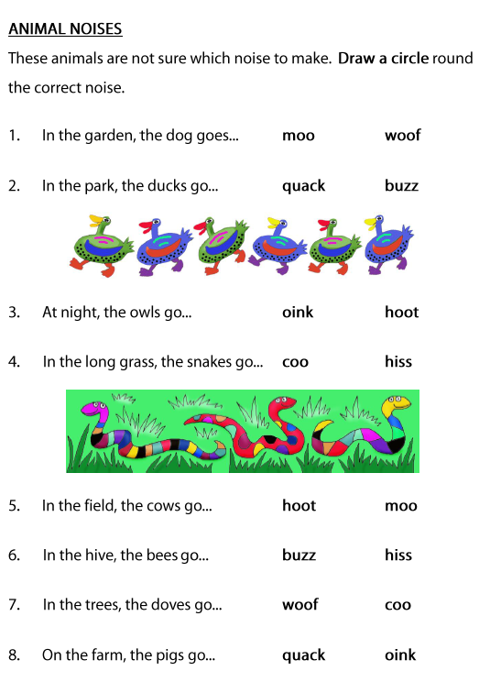
Read the sentences and select the correct word to finish them off.

