 | Week commencing: 22/2/21  Unit theme: How does it Grow?  Story: First the Egg  Weekly theme: The Farm |  | 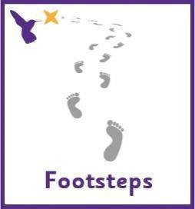
Wren (Boston Spa Learning)
Communication activities |  | Cognition (Maths-based) activities
Help your child to engage with fun stories and musical activities through actions and signs  This half term, our focus skill is: Following instructions.  The learning intention is:  To be able to listen to communicative partners  To be able to process information and respond  Activity ideas  - Reading  Read the story ‘First the Egg’ (See ‘First the Egg Story’ PowerPoint on the school website). Encourage your child to follow instructions to turn the page (if printed) or click onto the next slide (if reading on a computer). Support them to point out characters in the story and to copy the Makaton signs – See ‘First the Egg Makaton Signs’ and ‘First the Egg Story Symbols’ resources on the school website.  The sign of the week is ‘farm’.  - Simon says  Encouraging your child to copy your actions is a great way to develop attention and communication skills. The ‘Movement – First the Egg’ resource on the school website can give some ideas and visual supports.  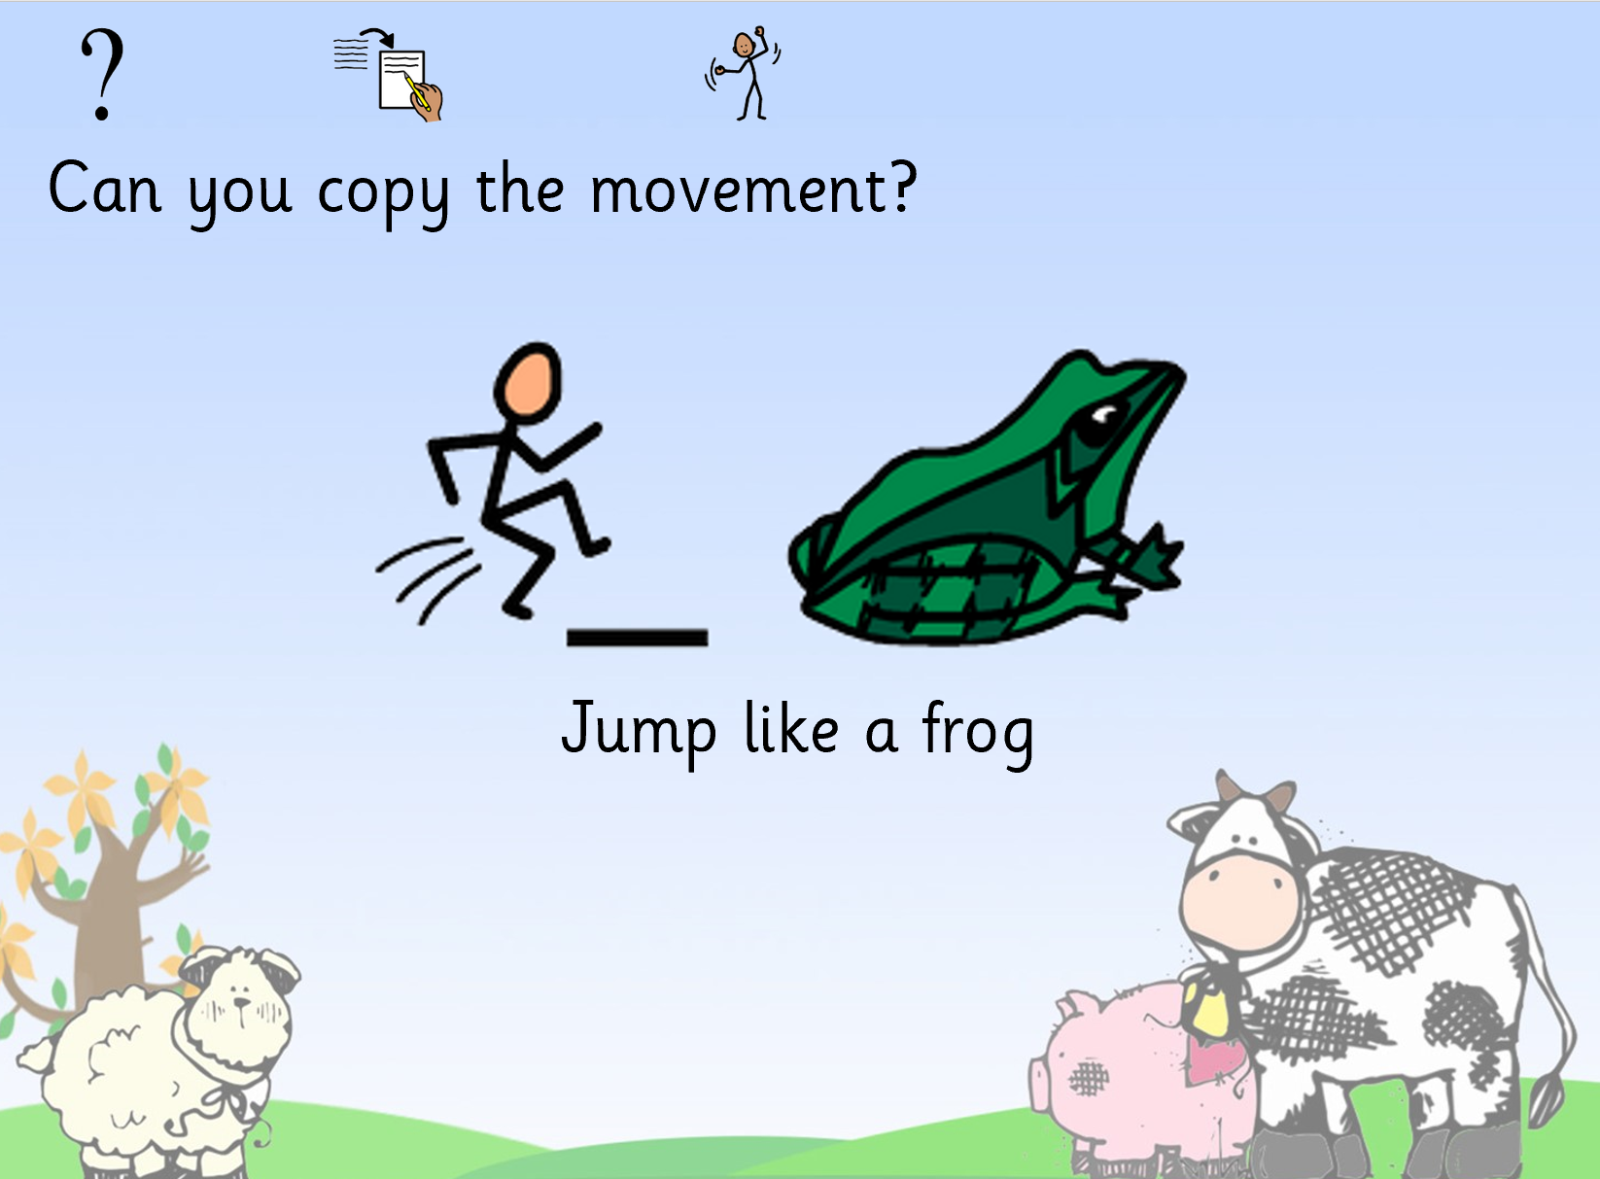  - Sensory  Support your child to choose resources to make a sensory bottle. See ‘Farm sensory bottle’ resource n the school website for ideas.  Sensory bottles are simple and effective in helping children to be calm and focus their attention. Adding resources to the bottle (use any transparent bottle) can be fantastic fine motor skills practice – you can use your finger, tweezers, scoop with a spoon, pour with a jug, etc.  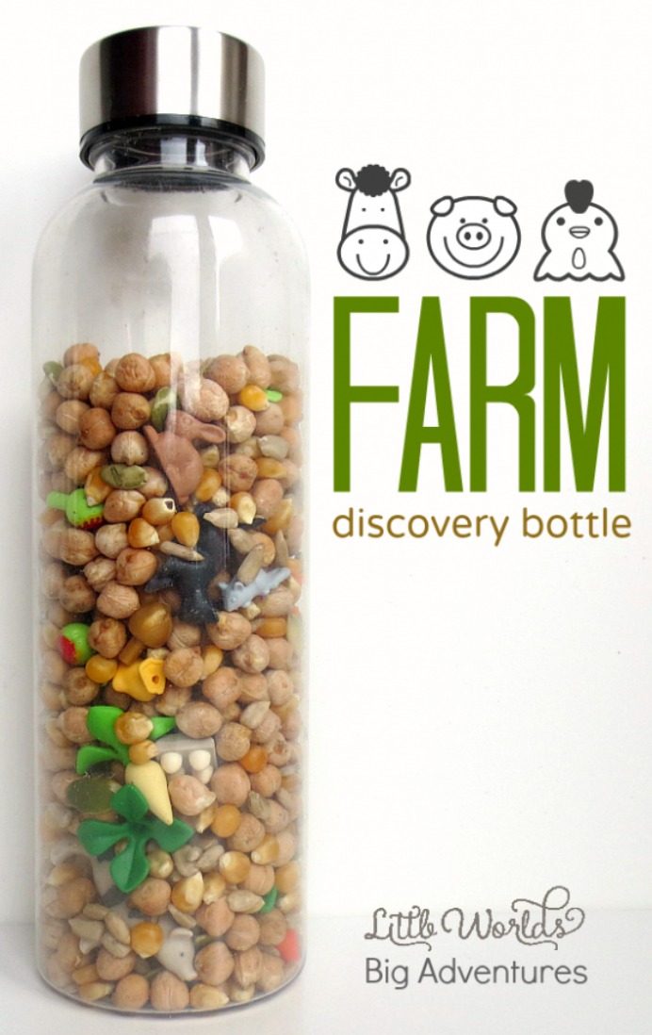 |  | There are lots of ways to learn about maths around the house. Doing puzzles, playing games and exploring house equipment are all great ways to practise maths skills.  This half term, our focus skill is: Object permanence.  The learning intention is:  To develop a wider understanding of the world around us by making links between past learning and immediate experiences.  Activity ideas  - Hide the animals  Try this simple activity of hiding and revealing animals in your child’s favourite sensory materials. This also helps to develop fine motor skills and understanding of cause and effect.  https://busytoddler.com/2016/11/hide-the-animals-quick-sensory-bin/  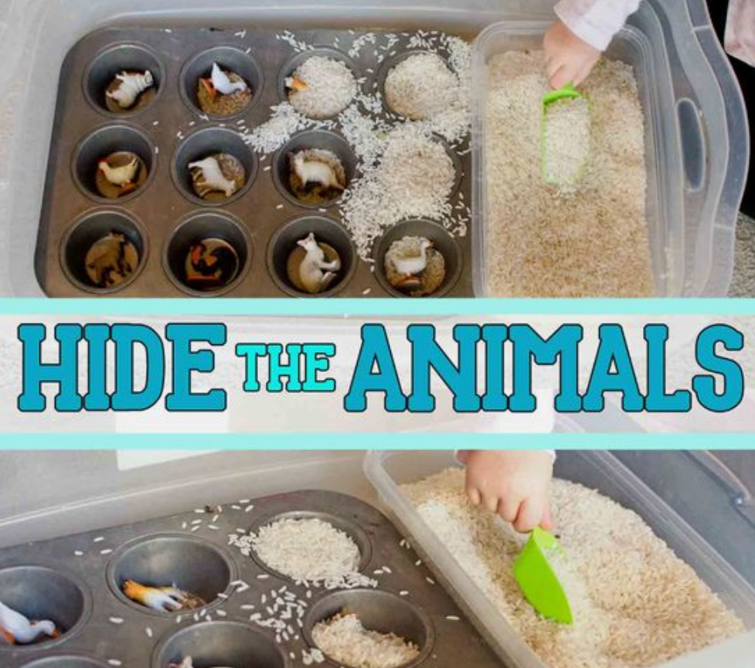  - Art – finding specific colours  Encourage your child to find playdough from a choice of different colours and use this to make farm animals – See ‘Farm Playdough’ resource on the school website. Follow the link below for a recipe to make taste-safe playdough https://www.pinterest.co.uk/pin/5840674504572923/  - Online activities  Find your favourite song or game online. You can use the interactive activities on HelpKidsLearn.com to develop object permanence by teaching your child where to find logos and buttons on a screen, e.g. to press play. It is also a great way to learn about cause and effect and develop attention skills.  There are lots of farm-themed activities under the ‘stories’ tab.  https://www.helpkidzlearn.com/updates/school-closure.html  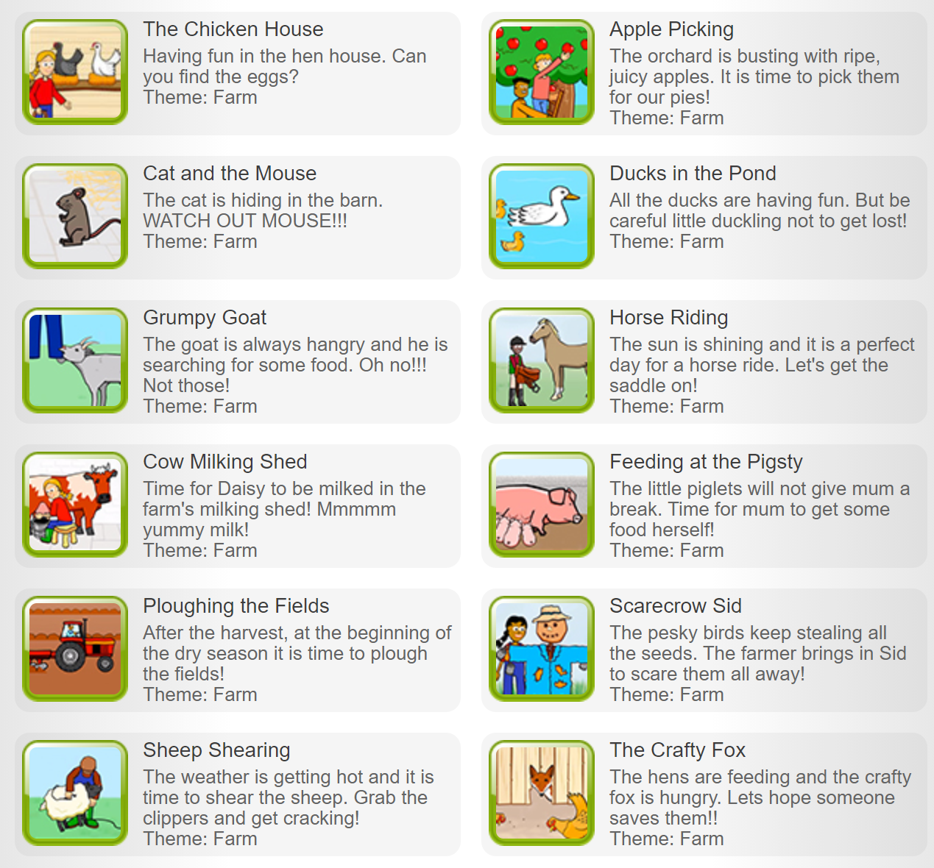
Sensory activities |  | Physical activities
Sensory activities can be extremely motivating, develop attention skills and help your child to self-regulate.  Activity ideas  - Tactile  Skill: Fine motor movements  Make a farm sensory bin and encourage your child to develop their fine motor skills by using their fingers to pick up small object, post and thread. This could include building a pen for the animals out of Duplo, or  cleaning the muddy animals – roll in paint and clean with soapy water.  You can make taste-safe mud by mixing cornflour and water with decaf coffee or gravy granules.  https://learningforlittles.com/how-to-create-a-farm-themed-sensory-table/  See the ‘Milk the Cow’ resource on the school website.  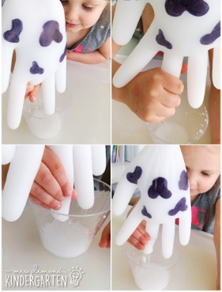  - Music  Skill: Listening and choice making  Listen to songs about the farming! Encourage your child to choose which song to listen to by clicking on the pictures in the ‘Farm Songs’ PowerPoint on the school website, or print off the symbols on the first page to use for PECS.  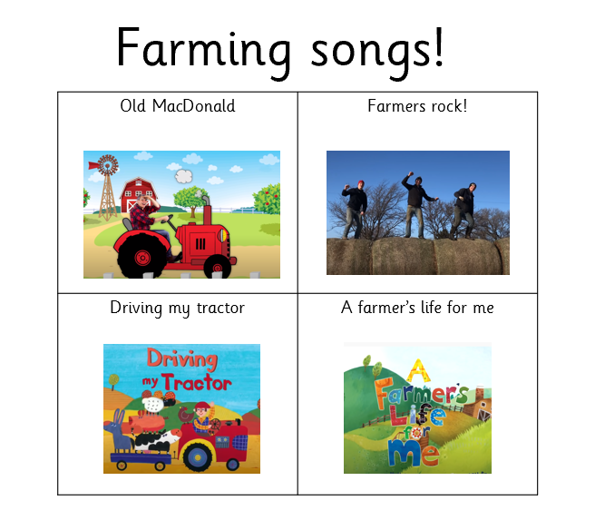  - Farm Craft  Skill: Exploring different art media  Use the ‘Farm Craft’ printable resource on the school website to get creative! Encourage choice-making by offering different art media and colours – whatever you have available to you. Follow the link below for a recipe to make taste-safe paint.  https://rainydaymum.co.uk/baby-play-finger-painting/  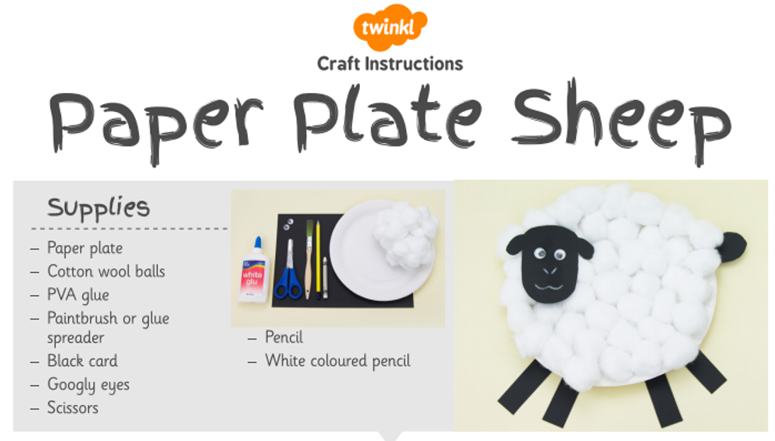 |  | Physical activity is great to keep our minds active and burn lots of energy!  Activity ideas  - Gross motor focus  Skill: Using the big muscles in our bodies in relation to movement and coordination.  Bouncing and balancing – Trampolining is fantastic to help children be aware of their body positions. On a smaller scale, bouncing and balancing on an exercise ball is great for building core strength and developing concentration.  Throwing and rolling – Activities such as knocking down bowling pins and throwing balls or beanbags at a target will work on strength and perception as well as being a great visual to aid understanding of cause and effect.  - Vestibular and proprioceptive  Skill: Developing balance, coordination and body awareness.  Vestibular - This body system controls balance, coordination and movement. People who seek vestibular input will enjoy swinging, spinning, bouncing and rocking motions which help to give lots of movement feedback to the brain. Other people will avoid movement as they find vestibular input over-stimulating, but it can be useful to help them tolerate movement as part of their everyday life. Follow the link below for a range of vestibular activities. https://yourkidstable.com/vestibular-activities-and-input/  Proprioception - This is the awareness of where the body is in space, and pupils who struggle with proprioceptive issues may seek pressure or weight and against their body. ‘Heavy work’ activities give lots of proprioceptive input and are anything that involves pushing, pulling or lifting heavy objects. Follow the link below for a range of heavy work activities https://yourkidstable.com/heavy-work-activities/  - Dance  Skill: Gross motor movements  Encourage your child to copy the actions to the song! Search on YouTube for ‘Bebop Band Fun at the Farm Action Song’  https://www.youtube.com/watch?v=nYZZkHRGv2c  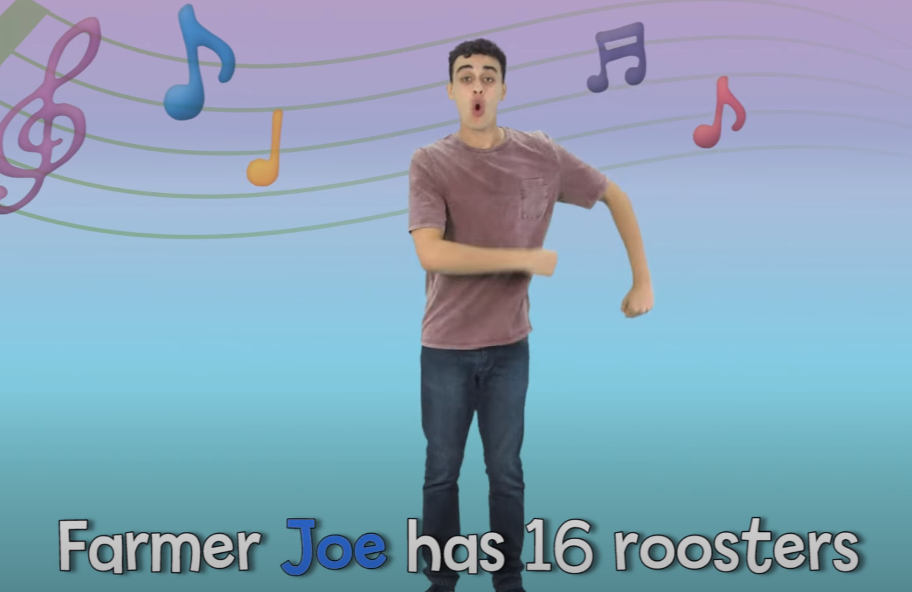
Additional learning links
- Start the day with a ‘Good Morning’ routine – See example PowerPoint on the school website (Click ‘enable content’ when opening the PowerPoint to ensure videos will open)
- Search on YouTube for educational songs, e.g. ‘Barefoot Books’ or ‘The Learning Station’
- Cbeebies.com – games, TV shows and songs. ‘Something Special’ is great for teaching children (and the rest of the family!) Makaton signs.
- TACPAC – See information sheet and example PowerPoint on the school website. Click on the musical notes symbol for links to songs.
- Follow ‘Gina Davies Autism Centre’ on Facebook to find out more about the Attention Autism programme that we use in school and get tips on how you could replicate this at home, either by watching the videos with your child or creating your own session https://www.facebook.com/ginadaviesautism/posts/
- Yoga/relaxation session – See PowerPoint on the school website
Other information
- We have put together an example timetable to help you structure your day – See ‘Footsteps Daily Routine Example’ on the school website. Please adapt this for your child and include as much or as little of the content as you feel appropriate. Symbols can be printed out and used with the ‘Now and next’ board to support your child to understand their routine.
- Please feel free to share any photos or achievements on Dojo or the school Twitter page.
- If you need any further information, or would like a pack of these resources delivered to your home, you can email me at rebecca.adams@westoaksschool.co.uk

