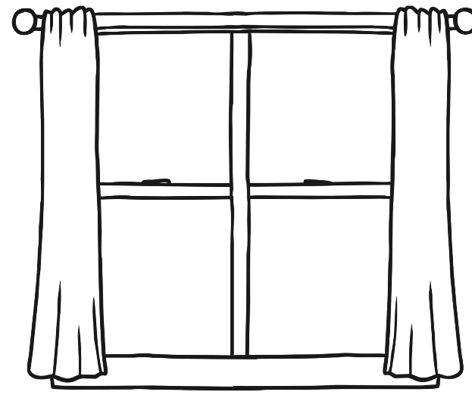

**What are windows for?**

|  |  |  |  |
| --- | --- | --- | --- |
| closing | looking | eating | see the weather |
| hitting |  | let light inside | making dark |
| opening | knocking | talking | fresh air |