 | KS4 Stepping stones  A Day in the Life of…  Week commencing 22.02.2021 |  | 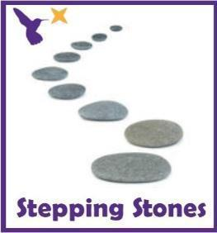
Classes in each pathway-
Woodhouse: Treeswift
Boston Spa: Guillemot
All about our projects this term:
In the ‘A Day in the Life of…’ project we will looking through the lens of different people in the community. We will begin with a postman. Read the ‘Jolly Postman’ and explore the world of letters and post! Each week we learn the class story using the Talk for Writing process and focus on recounts/ letters by posting our work each week.
During Science, we will explore the life of a human body with the focus of ‘Teeth and Eating’ and ‘Health and Growth’. Immerse the pupils into the topic of teeth and what our mouths can do. By the end of term, we would aim for our pupils to be able to show an awareness of the different elements that make a healthy body and diet.
Maths (Length and Height) |  | English activities
This week in Math we will begin to use language to describe length and height, e.g. the tree is tall, the pencil is short. When making direct comparisons, you may initially say something is bigger than something else to model the language.  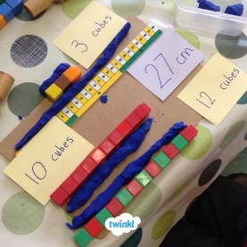  Length and height hunt:  Compare the height or length of objects around e.g. fridge, lamps, rug, bed, tables, chairs etc and make observations about them.  Can you label the objects as long, short, tall, short? Which one is longer, shorter, taller and smaller?  *See ‘Length and Height Symbols’ on the school website*  Can you make a paper ‘footprint’? Can you find items which are longer than their foot, shorter, about the same size?  Can you compare your footprints in size to other people in your family by making direct comparisons? Provide a selection of measuring items to explore. E.g. rulers, tape measures etc.  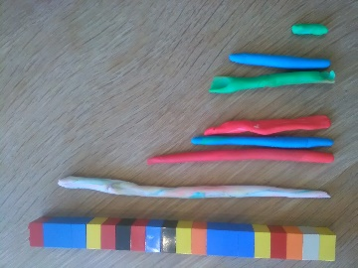  Playdough snakes:  Can you make some playdough and create your own long, short, fat, thin snakes? You could measure them using a tape measure or pieces of strings to make comparisons. Make a snake family and compare the lengths.  *See ‘Snakes’ Worksheet’ on the school website*  Compare family heights in your family:  Can you compare the heights of the people in your family? Stand in height order or order pictures of them from shortest to tallest. Who is taller? Who is shorter?  Maths related stories and songs:  The Giraffe who got a Knot – John Bush  https://www.youtube.com/watch?v=mIVWHQzh0-E  https://go.educationcity.com/content_select/index/1/2/1/1#/s=64869/c=41858 |  | Story focus  Read the ‘Jolly Postman’ book via YouTube link:  https://www.youtube.com/watch?v=gpeo_0yoD0k  Use the symbol mat to find the characters you can see.  *See ‘Jolly Postman ALD’ on the school website*  Recount texts:  This week we are going to write own recount texts in the form of a postcard home and to people in school.  Read through the ‘All about postcards PowerPoint and see all the features of the postcard that you need to include.  *See ‘All about Postcards PowerPoint’ on the school website*  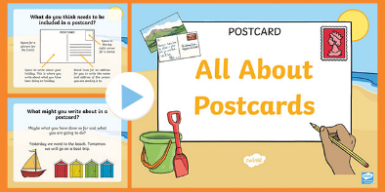  Can you decorate the front of the card using a picture of a holiday, event at home or some school work? On the back, can you write a simple sentence about what you did?  *See ‘Postcard Writing Resources’ on the school website*  Writing and fine motor skills:  Work on your writing skills this week and set some fine motor challenges.  *See ‘Fine Motor  Skills Challenges’ on the school website*
Science |  | Physical activities
This term, we will be learning about what our bodies need to keep healthy. This week we are going to see ‘What we already know?’ with some different activities’ linked to food and exercise.  Healthy eating:  Can you taste, smell or touch some healthy foods linked to the Eatwell plate? What does it taste like? What does it feel like?  What does it smell like? Complete a senses research sheet to collate your ideas.  *See ‘Fruit and Senses Research Sheet’ on the school website*  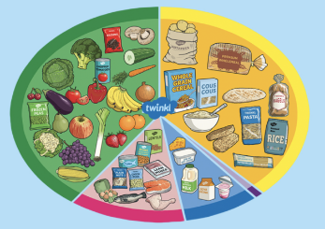  Eatwell plate:  Can you create your own Eatwell plate using the plate and cut out foods?  *See ‘Eatwell Plate’ on the school website*  Exercise and fitness:  Can you complete some healthy fitness challenges and see how you feel after? Use the emotions symbols to communicate how you feel at the end of the activities.  *See ‘Fitness Challenges’ on the school website* |  | Go noodle wake up shake challenges:  Pizza song  https://www.youtube.com/watch?v=4rm0LYLz1Wg  Fitness challenges  https://www.youtube.com/watch?v=K4DnPhR9_mo  Kidz bop dances  https://www.youtube.com/watch?v=sNog54ovi8Q  ‘Down in the Jungle’ finger exercises- (YouTube)  You might want to do some finger warm up exercises before you start your English work. Get some playdough and join along with the exercises.  https://www.youtube.com/watch?v=o9D5lfqZF3oh  PE bingo card challenges:  Can you choose a few challenges on the bingo cards for each day and see if you can complete them all by the end of the week?  *See ‘PE Bingo Cards’ on the school website*  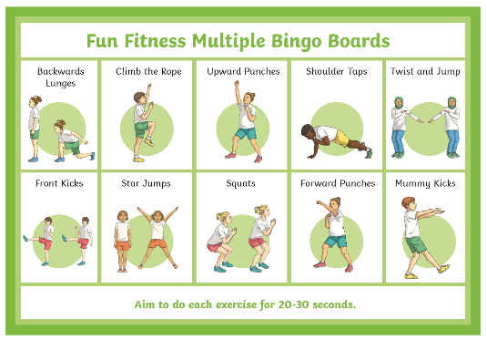
RE
In RE we will continue looking at symbols.
This week, we will begin to recognise a different symbol linked to Judaism e.g. the Menorah.
Can you do some sorting tasks with a variety of signs and symbols and see if pupils can recognise different photos and representations of the menorah?
Can you make your own tactile menorah with collage materials or textured playdough?
*See ‘Menorah Sorting’ on the school website*
*See ‘Menorah Collage Template’ on the school website*

PSHE:
This week in PSHE, we will be learning about our emotions.
Watch the different videos about our emotions and see if you can recognise some of the emotions shown in the Storybot songs:
https://www.youtube.com/watch?v=akTRWJZMks0

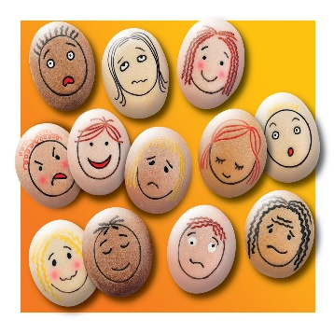
Can you use the feelings photos and explore what emotions they are feeling in the photo? Can you copy the facial expression in the mirror?
*See ‘Feelings Photos’ and ‘Feelings Cards’ on the school website*
Can you use the face template to create your own feelings face using the different face features? Make a sad face, how do you know that it looks sad?
*See ‘Feelings Face’ on the school website*

Enrichment activities:
This half term we will be learning about our immediate environment and what features are visible from our classroom windows. Read or watch to the story ‘Window’ by Jeannie Baker
- Can you collect photos of the window view around the house using a camera or iPad?
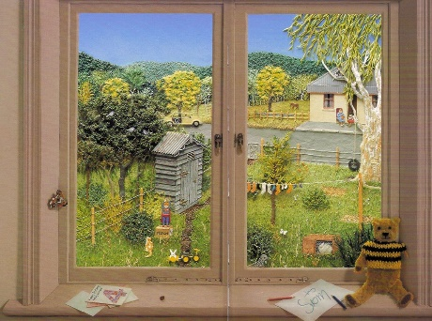
- Can you make observations of what they can see through these windows?
*See ‘Observations Sheet’ on the school website*
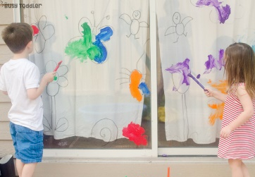
- Can you use a window or window template to create artwork or pictures linked to the objects and features they can see through the window?
*See ‘Window Frame Template’ on the school website*
- Extension: Can you create your own mind map of what windows are for (looking, opening, listening, allowing light in the room, fresh air)
*See ‘Window Mind Map’ on the school website*

In Music, we will be learning about how music can be related to our emotions.
Look at the symbols for each emotion and practise saying and signing that feeling.
Listen to the ‘feeling music’ file and as each song starts exploring the feelings symbol and choose which word describes the music best for you. Encourage the pupils to listen to how it makes a different person feel, try to help them understand that the same piece of music can make different people have different feelings.

Sing and sign challenges:
True colours
https://www.youtube.com/watch?v=r25auE4eC2o

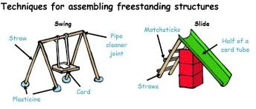
In DT, we are going to learning about freestanding structures. Collect lots of different materials that you can use to create a structure or model with e.g. bricks, playdough, spaghetti, card tubes, lollipop sticks, glue, tape. Explore these and make something that can stand up if whatever way you want to.

Key questions about the materials:
Are they able to join the materials together?
Can they make a structure that stands up?
What technical vocabulary are they able to use or understand? (long, short, strong, weak, heavy, light).
Take photographs of your structures and send them to your teacher to see!

Extra information
-We would recommend a short work session for each area listed above for up to 30 minutes per day or as much as each individual pupil would manage at home.

-Feel free to share photos and achievements via class Dojo and the school Twitter page.

-email me directly with any home learning or curriculum issues or questions: elisha.stokes@westoaksschool.co.uk

- Education city log in:
Username- 383westoaks
Password: 555637

