 | KS2 Stepping stones  Down on the Farm  Week commencing 22.02.2021 |  | 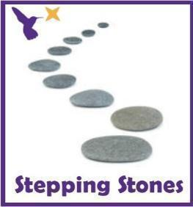
Classes in each pathway-
Woodhouse: Barn Owl, Swan and Starling
Boston Spa: Swift, Finch and Skylark
All about our projects this term:
It’s time to visit the farm! What animals will you see? What sounds will you hear? What does it feel like?
In English, we will explore the farm through the ‘Little Red Hen’. Will you help the Little Red Hen to grow the corn and bake the bread? We will learn the story through the Talk for Writing approach but also develop reading and writing skills through some simple instructions. Continue to focus on our ‘Farm’ topic in art using pencil control and farmyard illustrations and make a farmyard lever books in DT! In Humanities, we will be exploring what we can see from the window and learn how to describe our immediate environment using Geographical language.
Maths (Length and Height) |  | English (Reading)
This week in Math we will begin to use language to describe length and height, e.g. the tree is tall, the pencil is short. When making direct comparisons, you may initially say something is bigger than something else to model the language.  Length and height hunt:  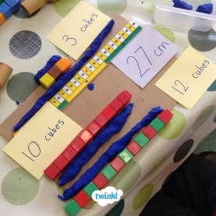  Compare the height or length of objects around e.g. fridge, lamps, rug, bed, tables, chairs etc and make observations about them.  Can you label the objects as long, short, tall, short? Which one is longer, shorter, taller and smaller?  *See ‘Length and Height Symbols’ on the school website*  Can you make a paper ‘footprint’? Can you find items which are longer than their foot, shorter, about the same size?  Can you compare your footprints in size to other people in your family by making direct comparisons? Provide a selection of measuring items to explore. E.g. rulers, tape measures etc.  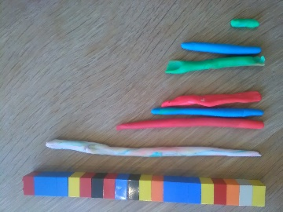  Playdough caterpillar:  Can you make some playdough and create your own long, short, fat, thin caterpillar? You could measure them using a tape measure or pieces of strings to make comparisons. Make a caterpillar family and compare the lengths.  *See ‘Length Caterpillar Worksheet’ on the school website*  Compare family heights in your family:  Can you compare the heights of the people in your family? Stand in height order or order pictures of them from shortest to tallest. Who is taller? Who is shorter?  Maths related stories and songs:  The Giraffe who got a Knot – John Bush  https://www.youtube.com/watch?v=mIVWHQzh0-E  https://go.educationcity.com/content_select/index/1/2/1/1#/s=64869/c=41858 |  | Story of the Term:  ‘The Little Red Hen’  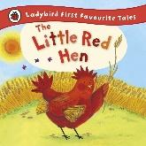  Read through the adapted PowerPoint and practise saying the words or phrases.  You can also watch the story of The Little Red Hen on YouTube or on Twinkl.  Instruction text work:  Can you use the instruction text examples to plant and grow some seeds? Use cress or seeds that will grow quickly for pupils to see fast changes.  *See ‘Instruction Text Examples’ on the school website*  Write your own instruction texts:  Can you use the instruction strips or individual verb symbols to create an instruction list to follow? You can follow your own instructions or give it to someone else to follow? Your instructions could be linked to the planting tasks or to a simple activity at home like making a sandwich or a cup of tea.  *See ‘Plant Instruction Building Sheet’ and ‘How to Make a Jam Sandwich’ on the school website*  Writing and fine motor skills:  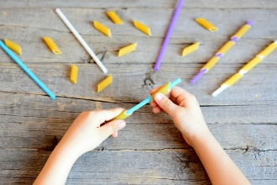  Work on your writing skills this week and set some fine motor challenges.  *See ‘Fine Motor  Skills Challenges’ on the school website*
Science |  | Physical activities
This term, we will be learning about what our bodies need to keep healthy. This week we are going to see ‘What we already know?’ with some different activities’ linked to food and exercise.  Healthy eating:  Can you taste, smell or touch some healthy foods linked to the ‘Eatwell Plate’? What does it taste like? What does it feel like?  What does it smell like?  Complete a senses research sheet to collate your ideas.  *See ‘Healthy Foods Research Sheet’ on the school website*  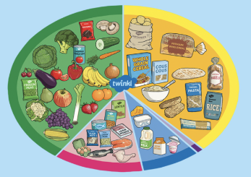  Eatwell plate:  Can you create your own Eatwell plate using the plate and cut out foods?  *See ‘Eatwell Plate’ on the school website*  Exercise and fitness:  Can you complete some healthy fitness challenges and see how you feel after? Use the emotions symbols to communicate how you feel at the end of the activities.  *See ‘Fitness Challenges’ on the school website* |  | Wake up shake up songs:  Wake up song  https://www.youtube.com/watch?v=1gUbdNbu6ak  Lazy town exercises  https://www.youtube.com/watch?v=eD7zbsGjFo4  Dinosaur stomp  https://www.youtube.com/watch?v=Imhi98dHa5w  ‘Down in the Jungle’ finger exercises- (YouTube)  You might want to do some finger warm up exercises before you start your English work. Get some playdough and join along with the exercises.  https://www.youtube.com/watch?v=o9D5lfqZF3oh  PE bingo card challenges:  Can you choose a few challenges on the bingo cards for each day and see if you can complete them all by the end of the week?  *See ‘PE Bingo Cards’ on the school website*  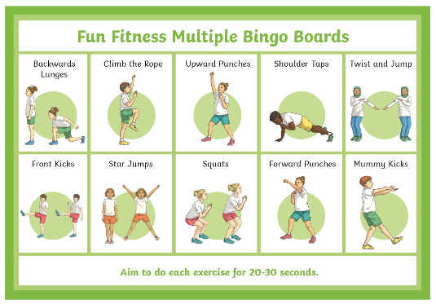
RE
In RE we will continue looking at symbols.
This week, we will begin to recognise a different symbol linked to Christianity e.g. the Ichthys fish.
Can you do some sorting tasks with a variety of signs and symbols and see if pupils can recognise different photos and representations of the fish that look similar?
Can you make your own tactile fish or materials with collage materials?
*See ‘Ichthys Fish Sorting on the school website*
*See ‘Ichthys Fish Collage Template’ on the school website*

PSHE:
This week in PSHE, we will be learning about our emotions.
Watch the different videos about our emotions and see if you can recognise some of the emotions shown in the Storybot songs:
https://www.youtube.com/watch?v=akTRWJZMks0

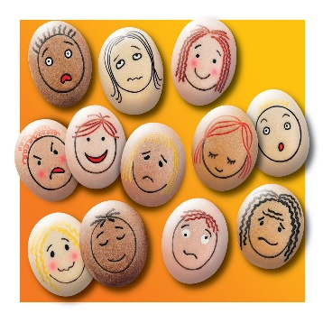
Can you use the feelings photos and explore what emotions they are feeling in the photo? How do you think a person looks when they are feeling happy/ sad/ scared? Can you copy the facial expression in the mirror?
*See ‘Feelings Photos’ on the school website*
Can you use the face template to create your own feelings face using the different face features? Make a sad face, how do you know that it looks sad?
*See ‘Feelings Face’ on the school website*

Creative projects
This half term we will be learning about our immediate environment and what features are visible from our windows. Read or watch to the story ‘Window’ by Jeannie Baker
- Can you collect photos of the window view around the house using a camera or iPad?
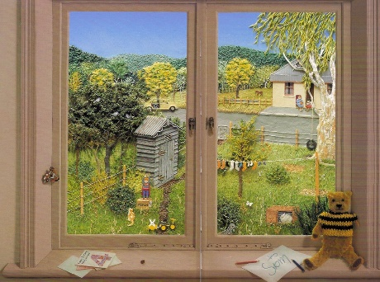
- Can you make observations of what they can see through these windows?
*See ‘Observations Sheet’ on the school website*
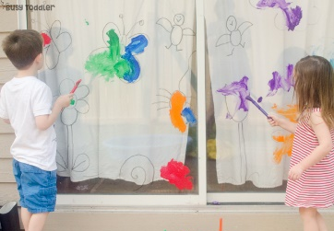
- Can you use a window or window template to create artwork or pictures linked to the objects and features they can see through the window?
*See ‘Window Frame Template’ on the school website*
- Extension: Can you create your own mind map of what windows are for (looking, opening, listening, allowing light in the room, fresh air)
*See ‘Window Mind Map’ on the school website*
In Music start with the animal sounds song linked to our topic. Encourage the pupils to join in with some of the animal sounds..
https://www.youtube.com/watch?v=RmFpOP7Z2ww
or play listening game 4
https://www.youtube.com/watch?v=o3MJ1tFNYE0
Next, play a game of musical statues, asking the pupils to use their bodies to move around the space and ‘freeze’ when the music stops. Choose a wide range of music to play. Try to include a mixture pop, folk, country, classical. Change the length of time the music plays and see how the genre and speed of the music affect the children’s movements.
*See ‘Musical Bumps Symbols’ on the school website*
In DT, we are going to learning about levers and linkages. We will be focusing on creating our own sliding and pop up books over the term. First we will explore real books that have pop up features, sliders or levers. If you don’t have any real ones at home, watch the videos and see how the pictures move during the story?
https://www.youtube.com/watch?v=PsZ-VTk98Ec
https://www.youtube.com/watch?v=x00f-rcsBYk
Can you take photos of your favourite books at home? Which pictures and pages do you like the most? Can you draw some pictures from your favourite books?
*See ‘Drawing Favourite Books’ on the school website*
Over the term, for our DT project you will need:
- Scissors
- Glue
- Card and paper
- Straws or lollipop sticks
- Pens, pencils or paints
Extra information
-We would recommend a short work session for each area listed above for up to 30 minutes per day or as much as each individual pupil would manage at home.
-Please share your express week photos, work and achievements via my email address, class Dojo and the school Twitter page.
-Email me directly with any home learning or curriculum issues or questions: elisha.stokes@westoaksschool.co.uk
-Education city log in:
Username- 383westoaks
Password: 555637

