string

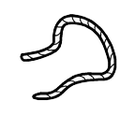

bead



pasta



finished



don’t like



more

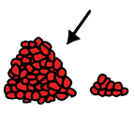

want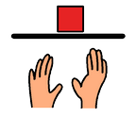

I, me, my

|  |  |  |  |  |  |  |
| --- | --- | --- | --- | --- | --- | --- |
| youC:\Users\LauraThomas\Documents\Resources\PCS Symbols\Core\y\you.png | give  \\wosen-file01\staffhome$\salt\Documents\The Talking House\PECS\PCS Symbols\Core\g\give 1.png | push |  |  |  |  |
| like  C:\Users\LauraThomas\Documents\Resources\PCS Symbols\Core\l\like.png | thread | pull |  |  |  |  |
|  | help  C:\Users\LauraThomas\Documents\Resources\PCS Symbols\Core\i\I need help.png | caterpillar |  |  |  |  |