 | Week commencing: 22/2/21  Unit theme: How does it Grow?  Story: The Cautious Caterpillar  Weekly theme: Caterpillars |  | 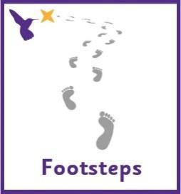
Dove (Boston Spa Learning)
Communication activities |  | Cognition (Maths-based) activities
Help your child to engage with fun stories and musical activities through actions and signs  This half term, our focus skill is: Following instructions.  The learning intention is:  To be able to listen to communicative partners  To be able to process information and respond  Activity ideas  - Reading  Read the story ‘The Cautious Caterpillar’ (See PowerPoint on the website). Encourage your child to follow instructions to turn the page (if printed) or click onto the next slide (if reading on a computer). Support them to point out characters in the story and to copy the Makaton signs – see ‘Cautious Caterpillar Makaton signs’ resource on the school website.  Sign of the week is ‘caterpillar’.  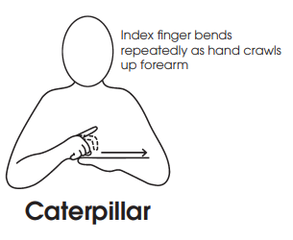  - Patterns  Make a caterpillar necklace by threading beads and pasta onto string. https://buggyandbuddy.com/the-very-hungry-caterpillar-necklace-craft/  Encourage your child to use the ‘Caterpillar ALD’ resource on the school website to comment on the activity. Contact your class lead if you need support on how to use the Aided Language Display with your child.  - Tactile  Grow your own plants at home. Encourage your child to follow the visual instructions on the ‘How to Grow a Plant’ resource on the school website.  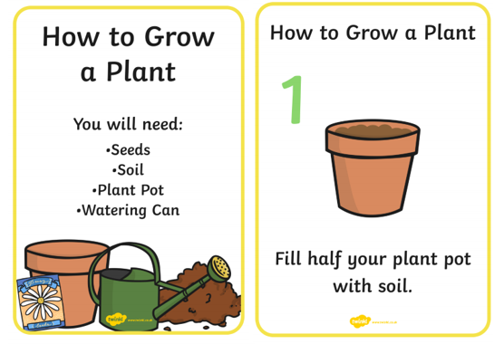 |  | There are lots of ways to learn about maths around the house. Doing puzzles, playing games and exploring house equipment are all great ways to practise early maths skills.  This half term, our focus skill is: Object permanence.  The learning intention is:  To develop a wider understanding of the world around us by making links between past learning and immediate experiences.  Activity ideas  - Art – finding the correct colours  Encourage your child to find the correct colours to decorate the characters from the Hungry Caterpillar story. See ‘Caterpillar Colouring’ resource on the school website.  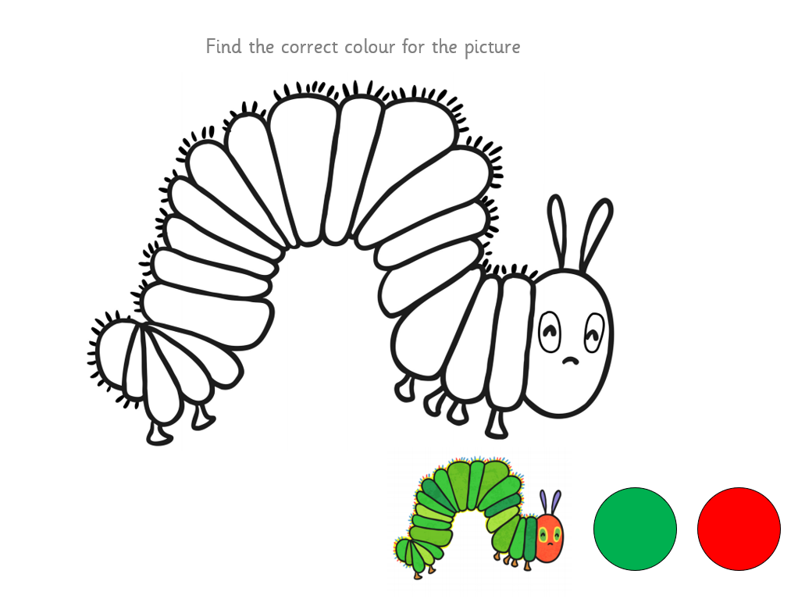  - Number songs – finding the caterpillars  Sing the song ‘5 Little Caterpillars’ (See printable visuals on the website). Encourage your child to find the caterpillars from inside their eggs after each verse.  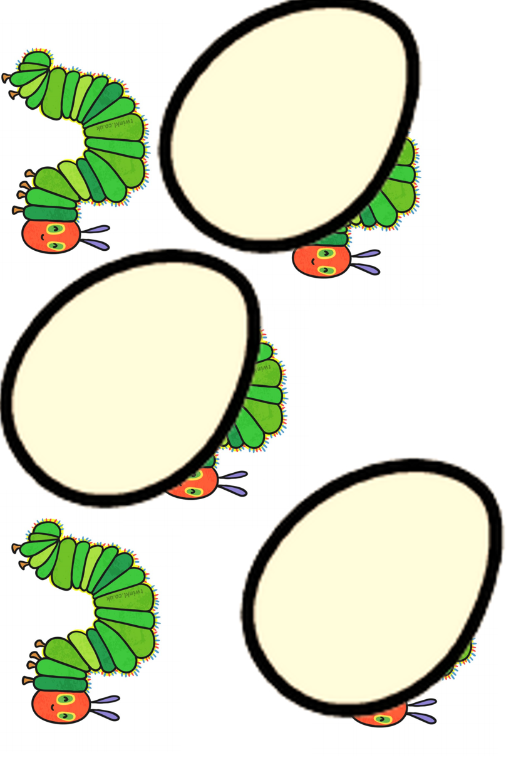  - Food – knowing the location of kitchen equipment  Make a caterpillar face on a rice cake by spreading green icing onto a rice cake and making a face with fruit. Encourage your child to locate equipment in the kitchen, e.g. by getting a knife from the drawer or fruit from the fridge.
Sensory activities |  | Physical activities
Sensory activities can be extremely motivating, develop attention skills and help your child to self-regulate.  - Posting  Skill: Fine motor skills  Using the ‘Caterpillar posting’ resource on the school website, encourage your child to post the food through the caterpillar’s mouth. You could use wooden/plastic role food if you have it to make this activity easier.  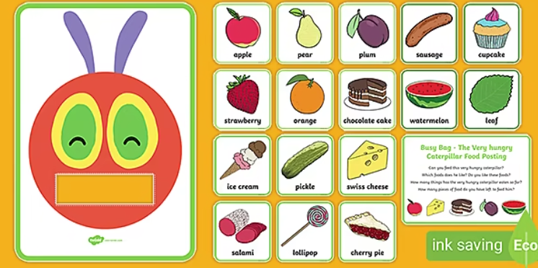  - Art  Skill: Using different art media  Encourage your child to use a balloon to print a caterpillar. Follow the link below for a recipe to make taste-safe paint.  https://rainydaymum.co.uk/baby-play-finger-painting/  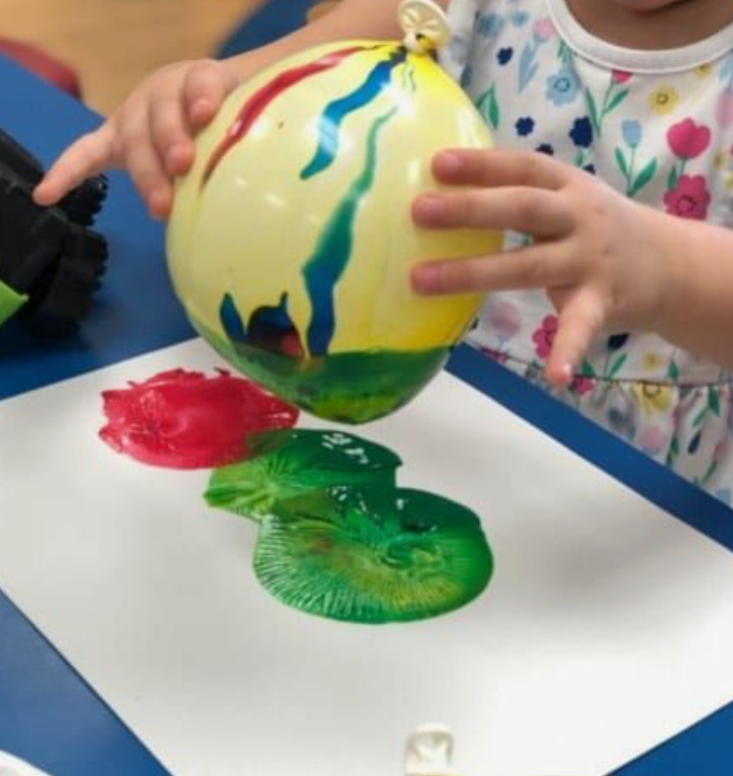  - Tactile  Skill: Fine motor movements  Make your own caterpillar playdough. See ‘Caterpillar Playdough’ and ‘Caterpillar Playdough Mats’ resources on the school website. |  | Physical activity is great to keep our minds active and burn lots of energy!  - Dance  Skill: Gross motor movements  Encourage your child to copy the actions to this fun insect dance! Search on YouTube for ‘Learn to Dance: Bugs and Crawly Things’ https://www.youtube.com/watch?v=hUbYq93cYdE  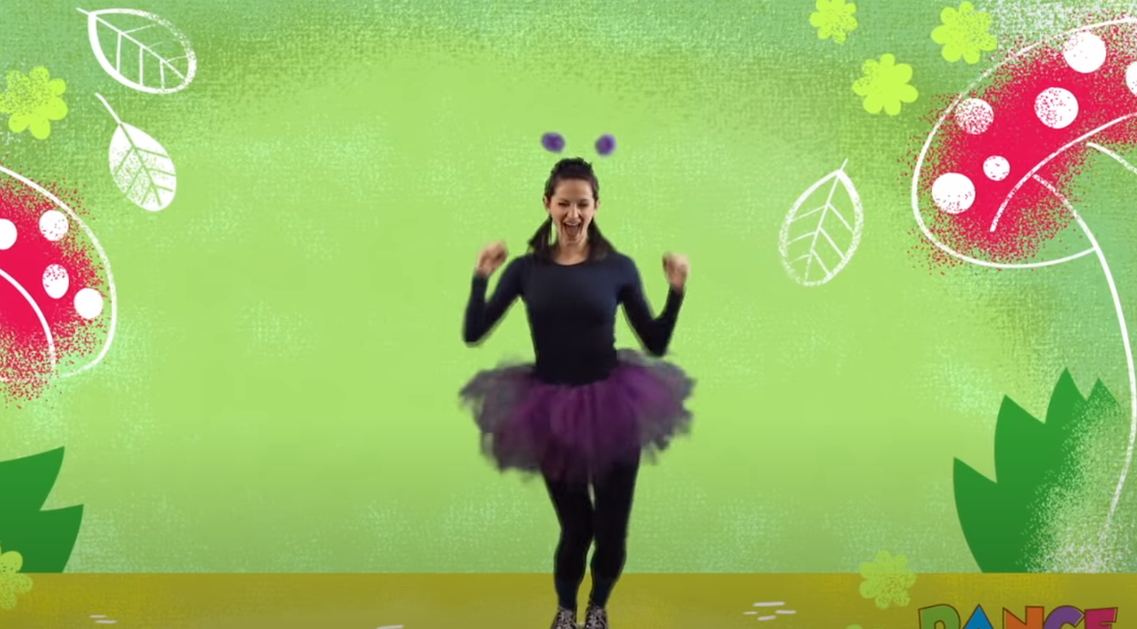  - Ball skills  Skill: Throwing underarm  Encourage your child to throw a ball or beanbag towards you or at a target, e.g. at a wall or into a bucket.  - Jumping  Skill: Body awareness  Encourage your child to jump on the spot, forwards, backwards and sideways! See printable resource ‘Jumping Visuals’ on the website.  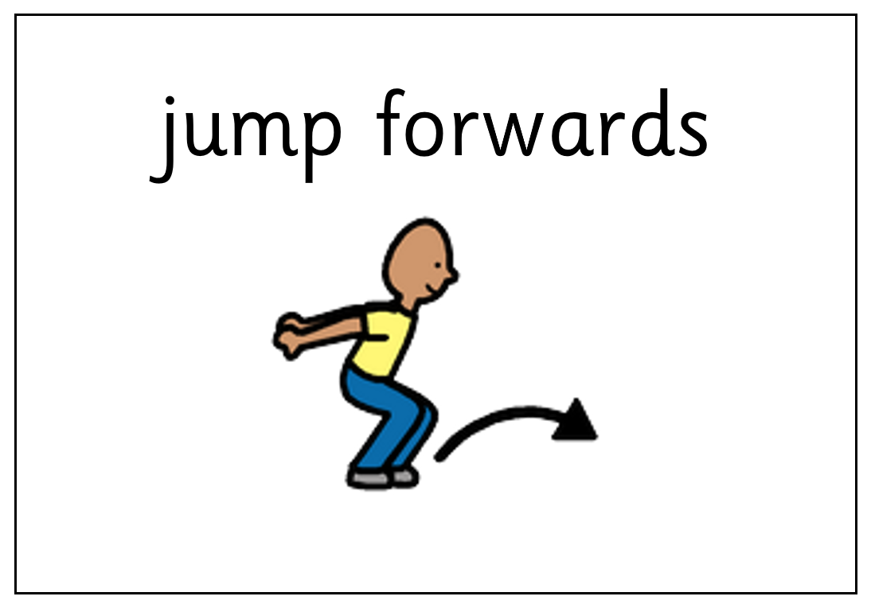
Additional learning links
- Start the day with a ‘Good Morning’ routine – See example PowerPoint on the school website (Click ‘enable content’ when opening the PowerPoint to ensure videos will open)
- Search on YouTube for educational songs, e.g. ‘Barefoot Books’ or ‘The Learning Station’
- Cbeebies.com – games, TV shows and songs. ‘Something Special’ is great for teaching children (and the rest of the family!) Makaton signs.
- TACPAC – See information sheet and example PowerPoint on the school website. Click on the musical notes symbol for links to songs.
- Follow ‘Gina Davies Autism Centre’ on Facebook to find out more about the Attention Autism programme that we use in school and get tips on how you could replicate this at home, either by watching the videos with your child or creating your own session https://www.facebook.com/ginadaviesautism/posts/
- Yoga/relaxation session – See PowerPoint on the school website
Other information
- We have put together an example timetable to help you structure your day – See ‘Footsteps Daily Routine Example’ on the school website. Please adapt this for your child and include as much or as little of the content as you feel appropriate. Symbols can be printed out and used with the ‘Now and next’ board to support your child to understand their routine.
- Please feel free to share any photos or achievements on Dojo or the school Twitter page.
- If you need any further information, or would like a pack of these resources delivered to your home, you can email me at jessica.arnold@westoaksschool.co.uk

