 | Week commencing: 22/2/21  Unit theme: How does it grow?  Story: The Tiny Seed  Weekly theme: Seeds |  | 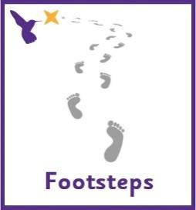
Sandpiper (Woodhouse Learning)
Kingfisher (Boston Spa Learning)
Communication activities |  | Cognition (Maths-based) activities
Help your child to engage with fun stories and musical activities through actions and signs  This half term, our focus skill is: Making choices.  The learning intention is:  To be able to communicate preferences.  Activity ideas  - Reading  Read the story ‘The Tiny Seed’ (See Powerpoint on the school website). Encourage your child to follow instructions to turn the page (if printed) or click onto the next slide (if reading on a computer). Support them to point out characters/objects in the story and to copy the Makaton signs – see ‘Tiny Seed Makaton Signs’ resource on the school website.  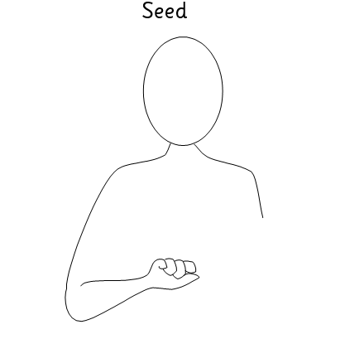  - Cress head  Follow the instructions on the ‘Cress Head’ resource on the school website for a simple planting activity.  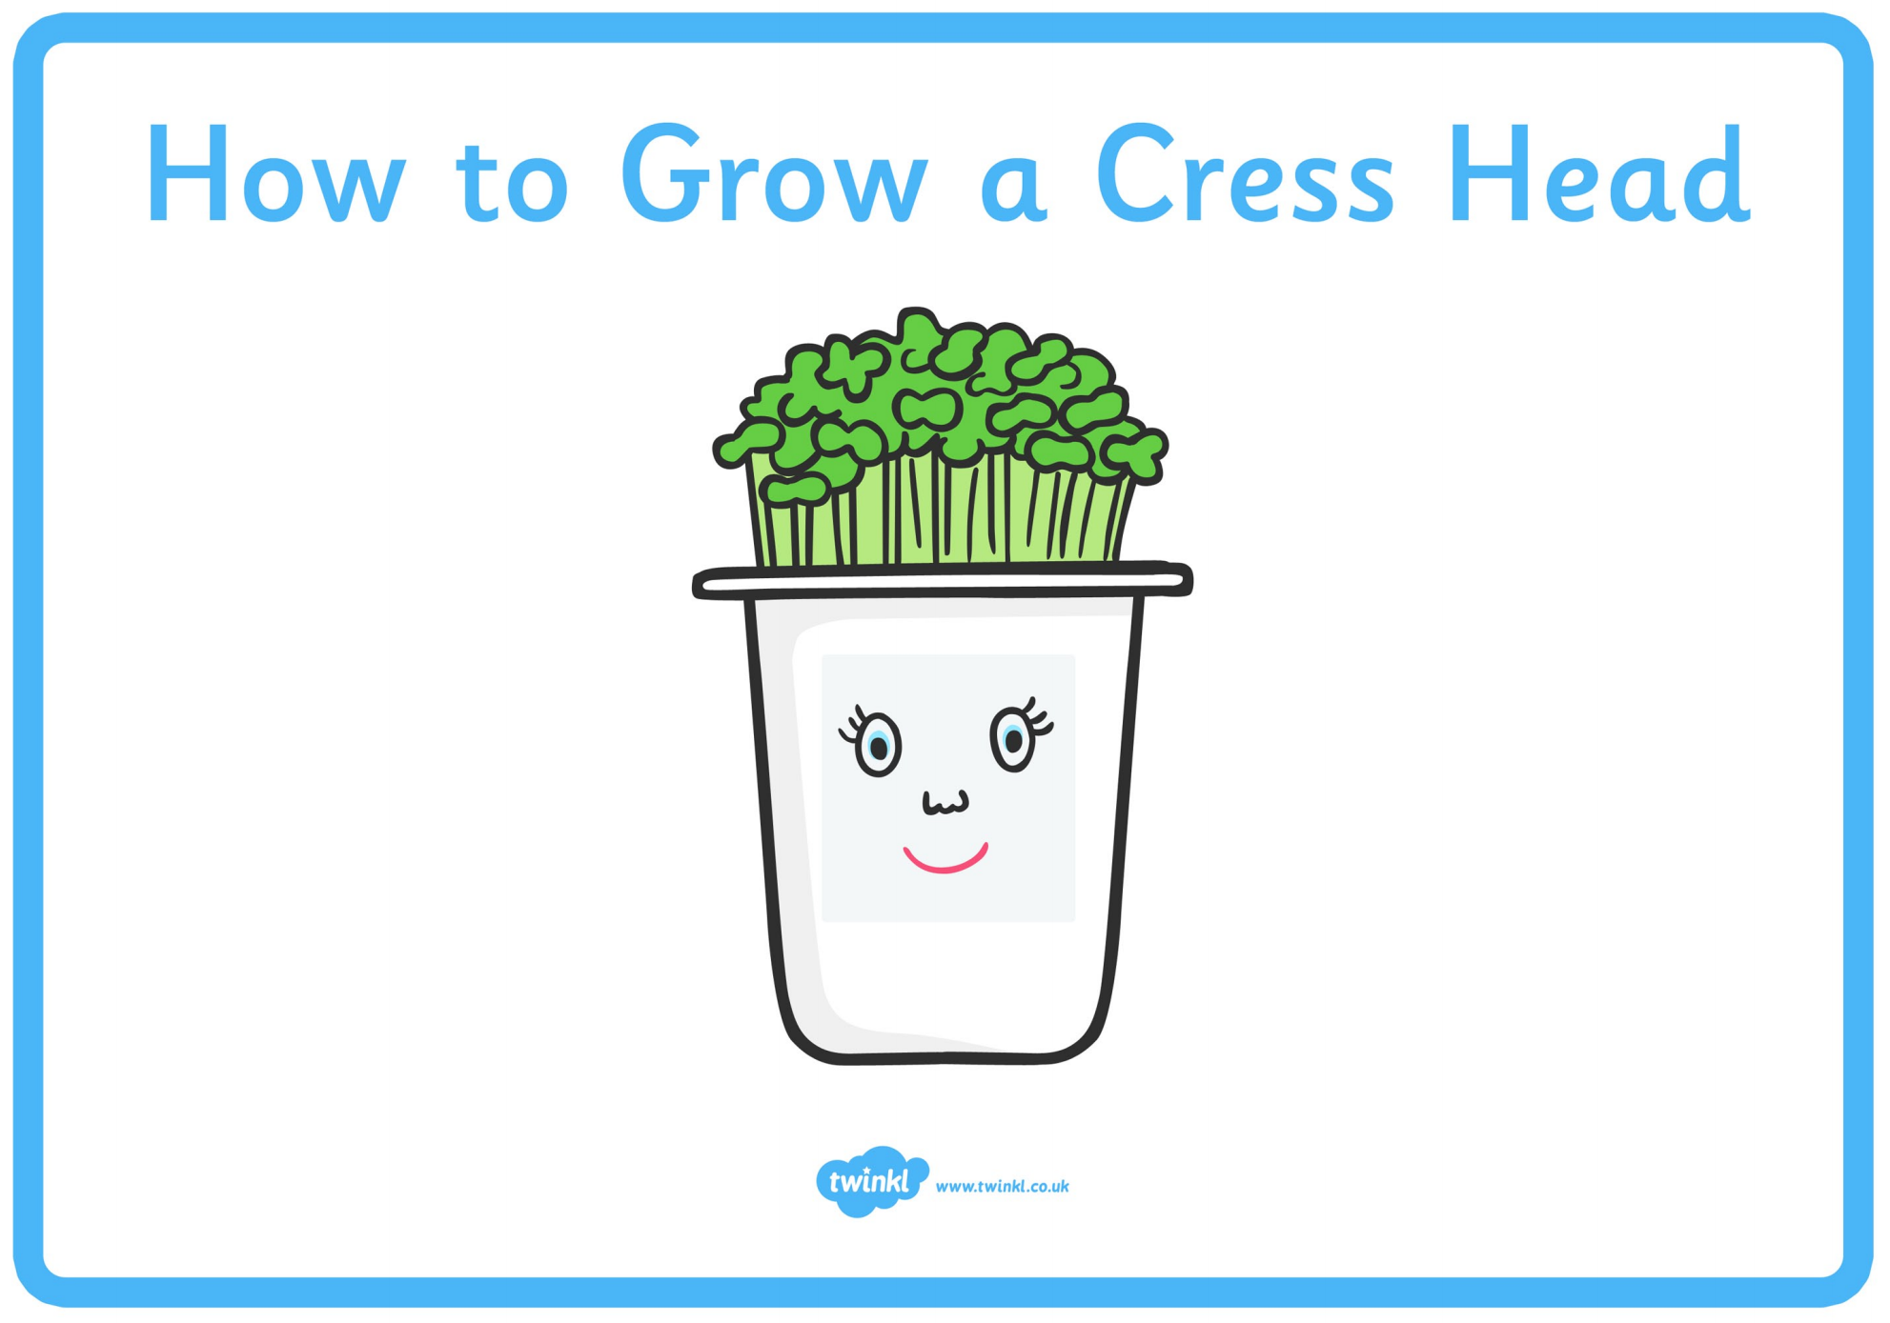  - Music  Make your own musical instruments using seeds – See ‘Rain Stick Craft’ resource on the school website.  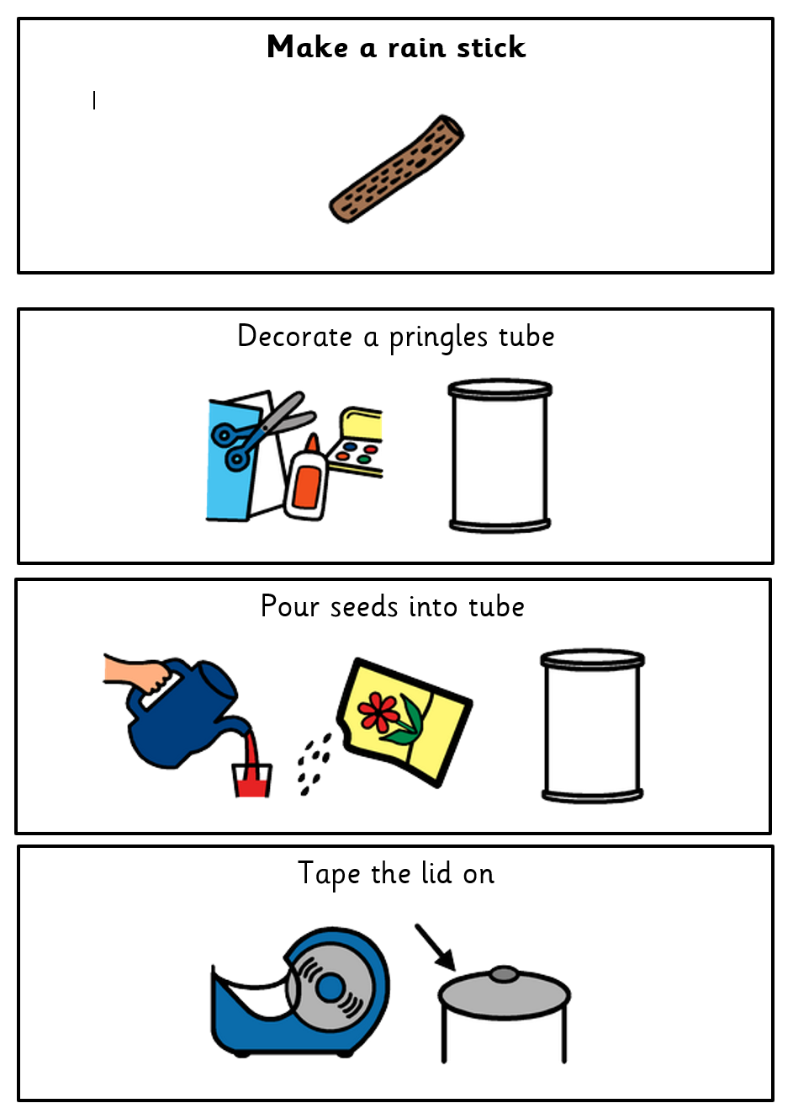 |  | There are lots of ways to learn about maths around the house. Doing puzzles, playing games and exploring house equipment are all great ways to practise maths skills.  This half term, our focus skill is: Measure – Capacity.  The learning intention is:  To be able to make comparisons between objects.  Activity ideas  - Online game  This interactive game helps to develop object permanence by teaching your child where to find logos and buttons on a screen, e.g. to press play. It is also a great way to learn about cause and effect and develop attention skills.  Log into HelpKidzLearn.com:  Go to ‘Stories’ and scroll down to ‘Ploughing the Fields’.  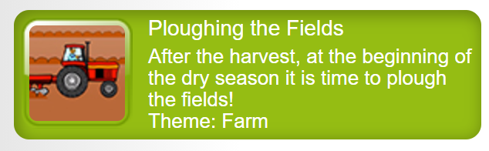  - Water play  Water play can be very motivating for our pupils and great way to support them to explore capacity. While it may be too cold for water play outside at the moment, you could incorporate water play into bath/shower time by having a range of different containers to fill with water. If you have the resources/space to plant some real seeds then this is a great activity to explore different containers, such as watering cans, jugs, cups, bottles, etc.  Key vocabulary to focus on: full, empty, more, less.  - Mud kitchen  Sensory exploration can also be a great way to engage children with exploring objects of different shapes and sizes. Encourage your child to experiment with filling bun cases up with different times up food by pouring or scooping with a spoon (great for developing fine motor skills). Ingredients that tend to be popular for sensory play in school include flour, rice, pasta and lentils. See blog post below for tips on sensory play at home.  https://dayswithgrey.com/blog/one-year-old-for-sensory-play/  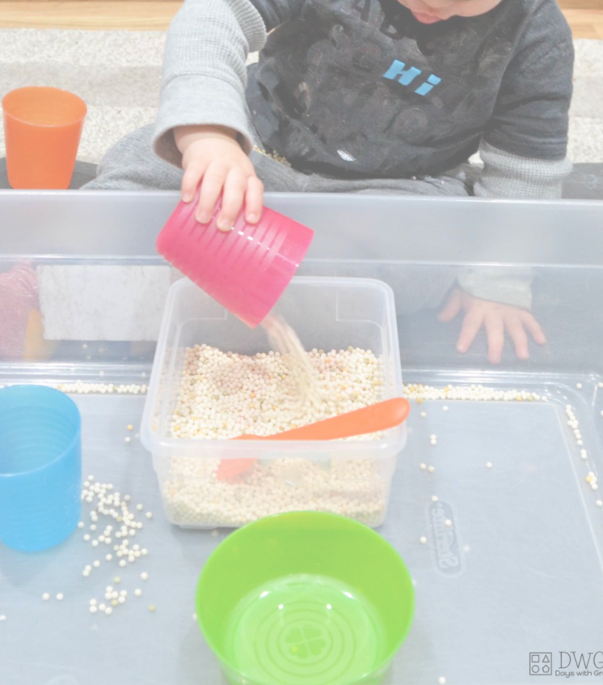
Sensory activities |  | Physical activities
Sensory activities can be extremely motivating, develop attention skills and help your child to self-regulate.  - Art  Skill: Using natural resources  Make flower art containing real seeds, like this sunflower craft. Paint a paper plate, cut petal shapes around the edge and decorate with real sunflower seeds.  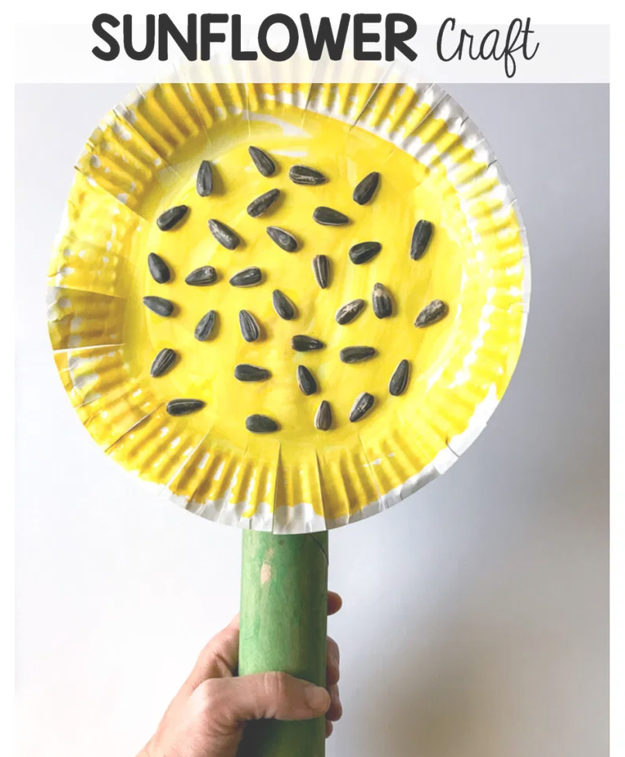  - Food  Skill: Trying new things  Encourage your child to explore different foods that contain seeds. See the blog on the link below for ideas.  https://teachbesideme.com/the-seeds-we-eat-nature-science/  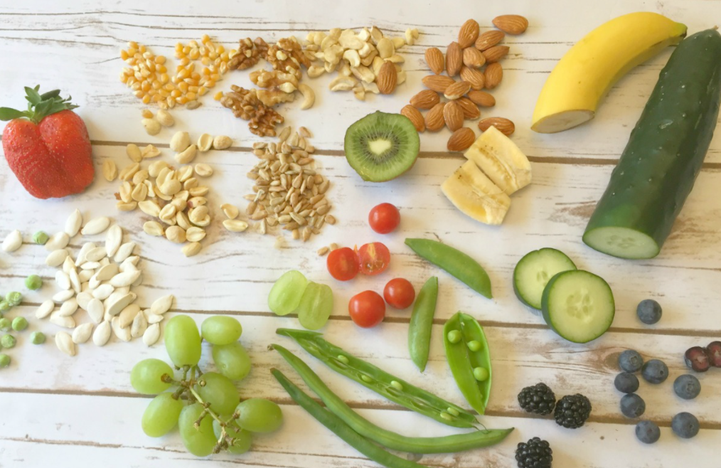  - Sensory walk  Skill: Exploring the environment  Go on a nature walk and see if you can find any of the flowers on the ‘Nature Walk’ resource on the school website. |  | Physical activity is great to keep our minds active and burn lots of energy!  - Dance  Skill: Gross motor movements  Encourage your child to copy the actions to this fun insect dance! Search on YouTube for ‘Learn to dance: Can you plant a bean’ https://www.youtube.com/watch?v=LCKEdDEr82k  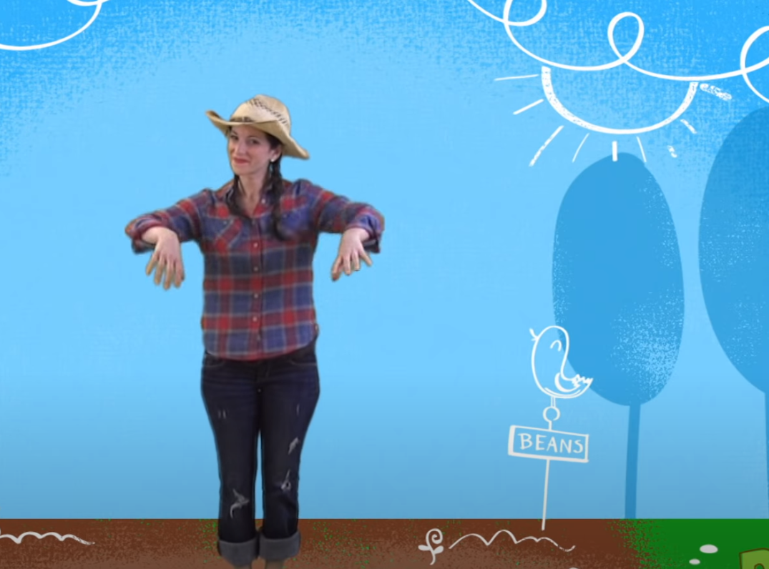  - Jumping  Skill: Body awareness  Encourage your child to jump on the spot, forwards, backwards and sideways! See printable resource ‘Jumping Visuals’ on the website.  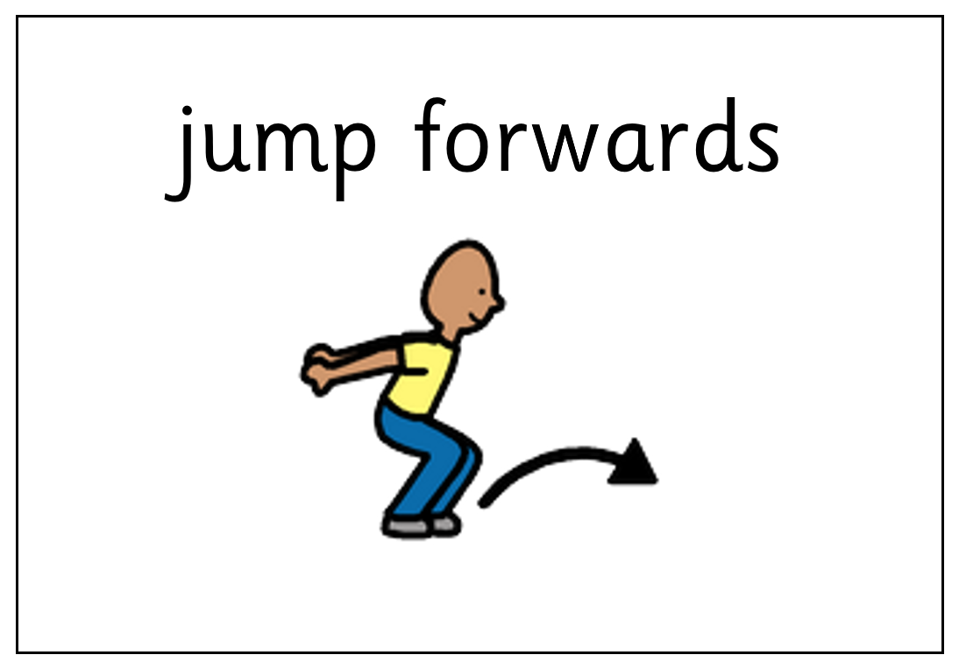  - Gross motor focus  Skill: Using the big muscles in our bodies in relation to movement and coordination.  Bouncing and balancing – Trampolining is fantastic to help children be aware of their body positions. On a smaller scale, bouncing and balancing on an exercise ball is great for building core strength and developing concentration.  Throwing and rolling – Activities such as knocking down bowling pins and throwing balls or beanbags at a target will work on strength and perception as well as being a great visual to aid understanding of cause and effect.
Additional learning links
- Start the day with a ‘Good Morning’ routine – See example PowerPoint on the school website (Click ‘enable content’ when opening the PowerPoint to ensure videos will open)
- Search on YouTube for educational songs, e.g. ‘Barefoot Books’ or ‘The Learning Station’
- Cbeebies.com – games, TV shows and songs. ‘Something Special’ is great for teaching children (and the rest of the family!) Makaton signs.
- TACPAC – See information sheet and example PowerPoint on the school website. Click on the musical notes symbol for links to songs.
- Follow ‘Gina Davies Autism Centre’ on Facebook to find out more about the Attention Autism programme that we use in school and get tips on how you could replicate this at home, either by watching the videos with your child or creating your own session https://www.facebook.com/ginadaviesautism/posts/
- Yoga/relaxation session – See PowerPoint on the school website
Other information
- We have put together an example timetable to help you structure your day – See ‘Footsteps Daily Routine Example’ on the school website. Please adapt this for your child and include as much or as little of the content as you feel appropriate. Symbols can be printed out and used with the ‘Now and next’ board to support your child to understand their routine.
- Please feel free to share any photos or achievements on Dojo or the school Twitter page.
- If you need any further information, or would like a pack of these resources delivered to your home, you can email me at jessica.arnold@westoaksschool.co.uk

