My Werewolf Dad
Homophone poem
Last night the most amazing thing happened to my dad.
We heard a weird noise and saw something mad.
His feet became all furry and his hands turned to paws.
His eyes glowed red and his toes grew claws.
His arms grew long and his back grew hair.
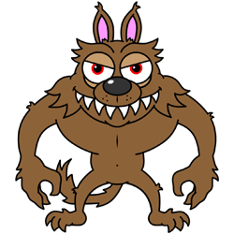
He scared us all with his frightening stare.
He was making noises like a grizzly bear.
We cried ‘help, help’ but no one was there.
Nobody was listening and no one could hear
My dad had gone crazy, he started to cheer.
I cannot believe I’m a grizzly bears son!

Then he decided to run off into the street.
But tripped and tumbled and fell off his feet.
Next he was stung by a large bumble bee.
Until he finally crawled under a tree.
He lay down beside it and fell asleep in the sun.
And dreamed of better days all filled with fun.
He awoke the next morning feeling awfully blue.
But he had an idea, he knew just what to do…

