25.02.21 LO: to spell and use common homophones.
I have used the homophones from this week. | I have written in the form of a poem.
I have included the correct punctuation. | I have formed my letters correctly.  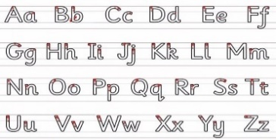
Challenge- I have included rhyming words in my poem.
Greater depth – I have used two homophones in the same line of my poem.
Words of the week – stare wonder mischievous

Example poem

One bee buzzing high up in a tree.
Two blue boats sailing far out in the sea.
Three fluffy clouds are covering the sun.
Four children shouting “come here and have some fun.”
Five sleeping lions sleeping happy as can be
Six parents looking for their mischievous sons
Seven birds tweeting, can you hear them sing?
Eight red balloons just blew right up into the sky.
Nine cute penguins wishing they could fly.
Ten chocolate prizes waiting to be won.

