 |  |  | Monday 22nd |  | Tuesday 23rd |  | Wednesday 24th |  | Thursday 25th | Friday 26th
 | Letters and sounds |  | Listen to:  https://www.youtube.com/watch?v=_s-1sxzjPX8&t=2s – Jolly Phonics Song  https://www.youtube.com/watch?v=e2dx65u59aw - Tricky Word Song  Watch - Miss Dibble teach the sound – ch https://www.youtube.com/watch?v=Qa8OFHlpYYk  Activity – Have a go at the ch diagraph booklet. |  | Listen to:  https://www.youtube.com/watch?v=_s-1sxzjPX8&t=2s Jolly Phonics Song  https://www.youtube.com/watch?v=e2dx65u59aw - Tricky Word Song  Watch - Geraldine the Giraffe teach the sound – th  https://www.youtube.com/watch?v=6U354eD-hgQ&t=102s  Activity – Read and Reveal cards.  Cover the pictures. Ask the children to chop and blend the word. Then reveal the picture to see if they are right. |  | Listen to:  https://www.youtube.com/watch?v=_s-1sxzjPX8&t=2s Jolly Phonics Song  https://www.youtube.com/watch?v=e2dx65u59aw - Tricky Word Song  Watch - Miss Kiely teach the sound – sh https://www.youtube.com/watch?v=XqlM74gvbYg  Activity – ch and sh words. Can you match the words to the pictures? |  | Listen to:  https://www.youtube.com/watch?v=_s-1sxzjPX8&t=2s Jolly Phonics Song  https://www.youtube.com/watch?v=e2dx65u59aw - Tricky Word Song  Watch - Geraldine the Giraffe teach the sound - ng  https://www.youtube.com/watch?v=vQshNmncnBs  Activity – th and ng words. Can you match the words to the pictures? | Listen to:  https://www.youtube.com/watch?v=_s-1sxzjPX8&t=2s Jolly Phonics Song  https://www.youtube.com/watch?v=e2dx65u59aw - Tricky Word Song  Watch - Miss Dibble teach the sound – ai https://www.youtube.com/watch?v=1gGWlFHGK6Q  Activity – ai spelling activity.
 | Reading |  | Please try and read with your child as much as you can. With they reading to you or you can also read stories to them. You need to discuss the features of a book e.g. front cover, blurb, author, what they think the story is going to be about. While your reading a story stop at points and ask questions about what you have already read to check understanding and listening. Also ask children what they think might happen next.  We have recorded a video of us reading a story to the children. It will be on the website weekly for you to watch.  You can also use the following Oxford Owl website (https://www.oxfordowl.co.uk/for-home/find-a-book/library-page/) who are currently offering a free eBook Library for parents to use at home. Please click the join us tab at the top of the page to create a FREE account.
 | PE |  | Join Joe wicks Monday, Wednesday and Friday at 9am for PE with Joe. You will find him on YouTube the Body Coach TV. https://www.youtube.com/user/thebodycoach1
 | Handwriting |  | ‘The benefits of mark making in the early years are clear; a child's physical skills are developed, their creative skills and imagination grows further, children are given a new output to express their feelings and also given a stepping stone into writing.’  Regular name practise is important! Even if your child can write their name they still need practise in making it neater; smaller letters; capital letter at the beginning (not in the middle!); writing their letters round the right way; not writing their names backwards.  They don’t always have to use a pen and paper to write their name or make marks! Why not try writing in flour, shaving foam, sand, oats, paint.
Overview |  | AM  Listen to Miss Dibble and Miss Kiely read Rainbow fish.  https://www.youtube.com/watch?v=IOd8rTdhCp8  PM  To identify different creatures that live under the sea  In this set of lessons we learn about the creatures that lurk deep beneath the sea. In this lesson with Miss Hughes, we identify some of those creatures and the features that allow them to survive in an underwater habitat. At the end of the lesson, we capture the ocean in our very own sensory bottles.  https://classroom.thenational.academy/lessons/to-identify-different-creatures-that-live-under-the-sea-75hkjt |  | AM  Have a look at the Sea Creature Facts PowerPoint and learn some facts and information about the creatures that live under the sea.  PM  Junk modelling sea creatures  In today's lesson, we will create our own sea creature beginning with a j... Can you guess what it might be? The three key areas that today's lesson links to are communication and language, expressive arts and design, and understanding the world.  https://classroom.thenational.academy/lessons/junk-modelling-sea-creatures-74uked |  | AM  Can you guess which under the sea creatures are hiding behind the binoculars?  PM  Build a cave  In today's lesson, we will combine different media in order to create a representation of an underwater cave. The three key areas of development that this lesson links to are expressive arts and design, physical development and understanding the world.  https://classroom.thenational.academy/lessons/build-a-cave-6mw38d |  | AM  Listen to Miss Dibble and Miss Kiely read Starry Eyed Stan.  https://www.youtube.com/watch?v=f9PwX1XXDZU  PM  To understand why our oceans are becoming polluted  In this set of lessons, we learn about ocean pollution. In this lesson with Miss Hughes, we identify things that humans do that pollute the ocean. We then think of things we can do to reduce the pollution in the ocean. At the end of the lesson, we make ocean play dough and practise removing the rubbish from it.  https://classroom.thenational.academy/lessons/to-understand-why-our-oceans-are-becoming-polluted-64u62c |  | AM  To understand what steps can be taken to combat polluting the ocean  In today's lesson, we join Miss Sidenius in learning about the impact that pollution has on our oceans and what we can do to combat ocean pollution. We also use plastic to create a poster to raise awareness of ocean pollution.  https://classroom.thenational.academy/lessons/to-understand-what-steps-can-be-taken-to-combat-polluting-the-ocean-6mrp6t  PM  Sailing on a boat (Music)  It's time to jump on board and come sailing with us! We will be singing a song in French, with movement to mirror the rocking of a boat and making up some rhythmic rhymes in "Ally Ally O".  https://classroom.thenational.academy/lessons/sailing-on-a-boat-6gwkjt

Creative activities | 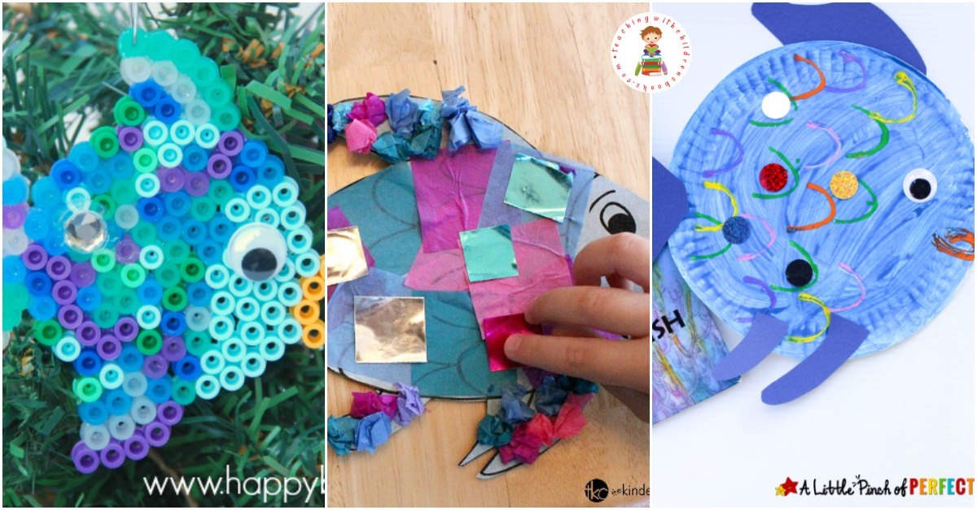  Collage a Rainbow Fish. | 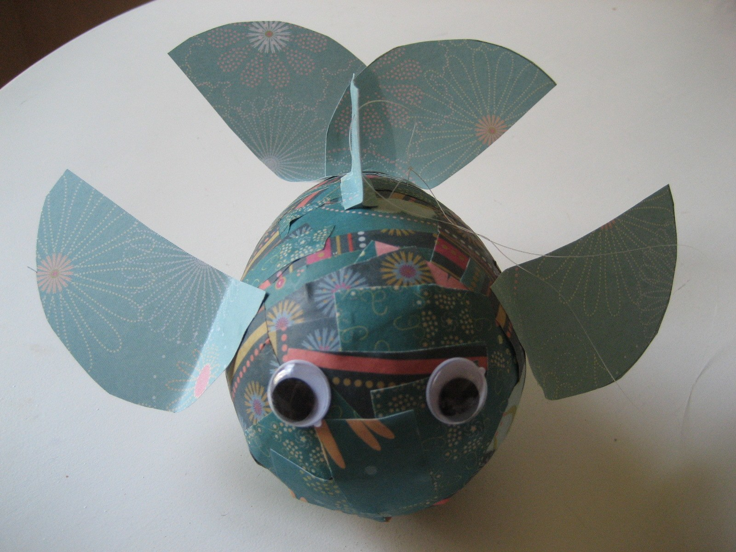  Paper Mache Rainbow fish, using balloons and  different  colour tissue  paper. | 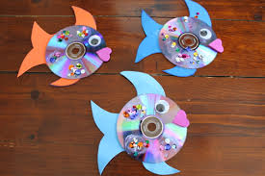  CD rainbow fish. | Make a different rainbow animal. It can be any animal you like. You can colour it in, paint it or even make a collage. | The Rainbow Fish gave away his most prized possession, his scales. What is your most prized possession? Draw a picture of it and write a sentence to say why it is special.
Maths | Can you complete the Rainbow Fish addition sums? | Can you complete the block diagram by colouring in the correct number of boxes for each item you count> | Can you use the number track to help you work out the under the sea subtraction sums? | Exploring one more within 10  In this lesson, children will explore finding one more than a number within 10.  https://classroom.thenational.academy/lessons/exploring-one-more-within-10-74v3cc | Exploring one less within 10  In this lesson, children will explore finding one less than a number within 10.  https://classroom.thenational.academy/lessons/exploring-one-less-within-10-cgtk0c
Literacy | Can you retell the story of The Rainbow Fish using the story sequencing cards to help you. | Can you use the Under The Sea Writing Activity to write a sentence about the picture? Use the word bank to help you. | Use the Under the Sea Rhyming activity to think of words that rhyme. Use your sounds to try and write the rhyming words you think of. | Discuss what a submarine is.  Now imagine you are going on a journey inside a submarine - What might you see on this journey under the sea – might you see Rainbow Fish? Can you use adjectives to describe what you might see? e.g. ‘deep, blue sea’ and ‘dazzling, shimmering scales.’  Can you draw a picture to show what you are describing? | Hot seat characters from the story. Take it in turns to pretend to be a character from the story. The children can use their knowledge of the story to ask relevant questions of the adult. They can also answer questions asked by the adult about the story.
Problem Solving | Can you colour the letters b and d; i and j the correct colour? These letters can be confused with each other. | Play a game like ‘Go Fish’ to encourage turn taking and number recognition. | Play games or activities that provide opportunities to demonstrate and practise sharing e.g. building models together, sharing fruit between a group or taking it in turns with a favourite toy. Praise children for sharing and being kind and link back to the story. | Encourage the children to help you make some Rainbow Fish biscuits! Encourage the children to help you weigh and measure the ingredients. | Visit Monster Island to explore a range of online games for children.  Access this lesson using pin code: SD4136  at Twinkl Go
Physical | Under the Sea Pattern Tracing. | Step by step drawing of under the sea creatures. | Can you use different coloured objects from around the house to make a rainbow? | Play ‘under the sea’ music for the children to create movements to. | Create a Rainbow Fish obstacle course with a tunnel to crawl through for the octopus’ cave, cones to weave through for seaweed and beanbags to throw into hoops when Rainbow Fish is giving out his scales!
UTW | To understand what floating and sinking is  In this set of lessons we learn about things that float and things that sink. In this lesson with Miss Hughes we watch a demonstration and predict what will float and sink. We look at our findings and identify patterns. We use our knowledge to predict what will float or sink in a quiz at the end of the lesson. To extend your knowledge further, test different objects in your home when in the bath or helping to wash up (with your parent or carer’s permission).  https://classroom.thenational.academy/lessons/to-understand-what-floating-and-sinking-is-74w6ct | Float/sink experiment  In today's lesson, we will be scientists and explore whether items we find around our house float or sink and sort them into two piles, depending on whether they float or sink. The three key areas that this lesson links to are understanding the world, communication and language and maths.  https://classroom.thenational.academy/lessons/floatsink-experiment-6dh3gr | Build a boat that floats  In today's lesson, we will construct a boat and then test it in some water to see if it floats. The key areas that this lesson links to are expressive arts and design and understanding the world.  https://classroom.thenational.academy/lessons/build-a-boat-that-floats-cgwk0r | The rainbow fish learnt to be a good friend. Talk to an adult at home about the different ways to be a good friend. Draw a picture of a good friend and a bad friend. | Will the Rainbow Fish Sparkle? Science Experiment.

