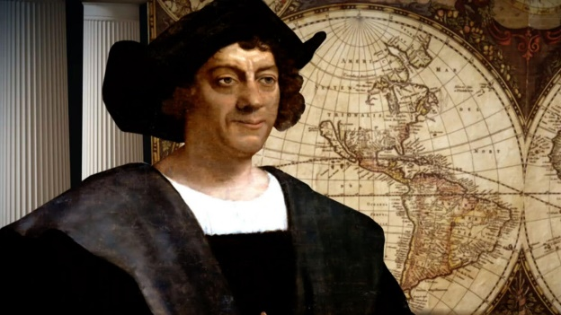
Week beginning 22.2.21 Weekly Timetable for Year 1 (1MW and 1GS)
We are trying to provide a wide range of activities, please do not feel like you have to do all of them.
Some fun extra activities to try at home:

Make a boat - https://www.youtube.com/watch?app=desktop&v=981t1yRjGFc
Make a boat using construction materials.
Dress up as an explorer for the day – see what you can find.
Make a list of all the things you would need if you were to go exploring.
Draw your own map of your local area.
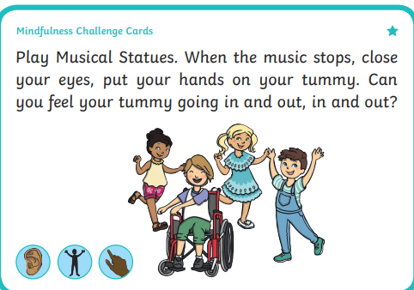
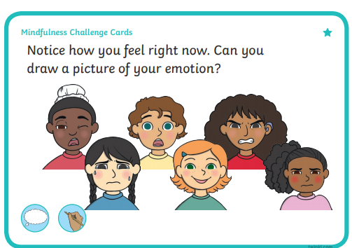
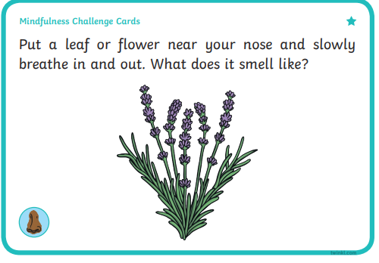
We would love to see some photos of your child’s work, so please email them to us
vanessa.skinner@grahamjamesacademy.co.uk faye.gilmore@grahamjamesacademy.co.uk michelle.walker@grahamjamesacademy.co.uk
Take care and stay safe.
From the Year 1 Team

 | Letters and Sounds  20 mins | Reading time  10/15 mins | Maths Time  25 mins |  | Spellings  10 mins | English/Topic  30 mins | Other subjects or activities  25 mins
M | Phase 5  Today we are learning the sound au (this is a tricky one) like in Paul, launch, August and jaunty.  Children to complete the roll and read.  Phase 3  Recap the sound ai like in rain, hail, Gail and pain. Children could watch Geraldine or alphablocks.  Children to complete the ai spelling activity sheet (page 1) | Reading  This week we are focusing on vocabulary.  Whilst you are reading discuss the meaning of different words e.g. what word means the same as?  Complete the Victor Spots sheets 6 and 7 – the sheets are quite simple but please use them as discussion points for vocabulary. | Maths  White Rose  One more one less first part  Watch the video then complete the sheet.  https://vimeo.com/503093120  Then complete the work sheet. |  | Spellings  This weeks spelling are:  the  a  do  to  today  said  Children to read each word in turn then to spell each word – make sure you let them see the correct spellings so that today they can copy them! | History/English  https://www.bbc.co.uk/bitesize/topics/zhpchbk/articles/znchkmn  Watch video (link above) and read PowerPoint about Christopher Columbus. Who is Christopher Columbus? What is an explorer?  Create a poster about Christopher Columbus to show what you have found out. | Yoga  Cosmic Kids Yoga on YouTube  Kids Yoga About Boats! ⛵ Yoga Club (Week 26) | Cosmic Kids  https://www.youtube.com/watch?v=PCdWB65XXEQ
T | Phase 5  Continue to practice the sound au. Children could watch Geraldine.  Children to complete the real and nonsense word sheet for the sound au.  Phase 3  Children to recap the sound ee like in jeep, deep, see and weep. Children could practice reading and writing the words.  Children to complete the ee sheet (page 2). | Reading Comprehension  Winter Phase 4 Early Reading Comprehension activity sheet | Maths  White Rose  One more one less  Watch the video then complete the activity sheet.  https://vimeo.com/503098045 |  | Spellings  Spelling shapes  Draw one shape for each word. Then write a spelling word in each shape e.g. | History/English  Write a sentence about Christopher Columbus. Then draw a picture to go with it.  For example,  Christopher Columbus began sailing when he was a teenager.  The king and queen of Spain gave Christopher Columbus money to buy the ships.  ** Please make sure children have a capital letter for the start of a sentence and a name, they need to use finger spaces and end with a full stop. | Science  Floating and sinking experiment  National Oak Academy – Key stage 1 – Science – materials – lesson 4 Which materials float and sink.  https://classroom.thenational.academy/lessons/which-materials-float-and-sink-cdj66c  There is a sheet available if you would like to perform the test at home.  Number formation power point – children to practice writing numbers 0-10.
W | Phase 5  Children to complete the phase 5 picture and caption matching sheets. Complete some today and some tomorrow.  They are some sounds we have not covered yet, so please try your best.  Phase 3  Recap the trigraph igh like in fight, night, might and bright. Children to watch Geraldine or practice reading and writing the words.  Children to complete the igh sheet (page 3). | Reading  Use a dictionary or google to find the meanings to these words:  Explorer  Travel  Voyage  Navigate  You will need an adult to help you. | Maths  White rose  Compare objects within 50  Watch the maths video and then compete the activity sheet.  https://vimeo.com/503099894 |  | Spellings  Upper and Lower  Write each of your spelling words two times.  First, write each word in upper case letters. Then, write each word in lower case letters. | English/Geography  Use Google Earth to look at the area that you live in. What can you see? Can you recognise things near your house? | Art/Topic  How to draw a globe – Art hub for kids Yotube  https://www.youtube.com/watch?v=hDAQGJCFYrM  PSHE  Please see wellbeing craft idea sheet.
TH | Phase 5  Children to carry on completing the phase 5 picture and caption matching sheets.  They are some sounds we have not covered yet, so please try your best.  Phase 3  Recap the sound oa like in goat, boat, moat and float.  Children could watch Geraldine or practice reading and writing the words.  Children to complete the oa sheet (page 4) | Reading  Reading Comprehension  Zoom to the Moon | Maths  White rose  Compare numbers within 50  Watch the video and then complete the activity sheet.  https://vimeo.com/503102857 |  | Spellings  Three times  Write each of your spelling words three times using a different coloured crayon, pen or pencil. | English  Complete the Christopher Columbus cut and stick sheet. Put the different events in order starting with the earliest first. | Wellbeing time  YouTube  Moon and Stars (Peace Out: Guided Meditation for Kids) | Cosmic Kids  https://www.youtube.com/watch?v=QQCnWvwrO8U  PSHE  Use Oak National Academy  Key Stage 1, RHE (PSHE)  forever friends – Who am I? - lesson 1  https://classroom.thenational.academy/units/forever-friends-45e8  Letter formation power point – children to practice writing lower case letters.
F | Practise any sound from the week – either spelling a word with each sound or play a game e.g. sentence substitution, rocket rescue, make a match and sentences – all on phonics play.  Phase 3 – Children to play roll and read. Challenge – Can you use your words to your own sentences? | Reading  Read one of your own books and discuss what different words mean. | Maths Game Day  Complete some or all of the games:  Numbots  Topmarks website – hit the button game  Topmarks – robot addition  Topmarks – the daily 10 (within this game you can choose different maths concepts).  Ict games .com – save the whale – number bonds game  Ict games .com – twilight take away |  | Spellings  Test your child on the spellings for the week!  Make it fun though as some of them are quite tricky. | Grammar and Punctuation lesson  Children may need a little bit of help/reminding with some of the activities.  Please complete Grammar sheet page 1. | Music  Use Oak National Academy Key Stage 1 – Music – Pulse – lesson 6- Identifying tempo: Terminology  https://classroom.thenational.academy/units/pulse-769c

