1 a) 400
b) 750
c) 21000
d) 3300
e) 600
2a) 24
b) 6.8
c) 0.35
d) 0.9
e) 0.009
3a) 1.5
b) 60
c) 100
d) 65.8
4. Correct = 9.5, 95000, 9500,
5. 5400÷1000, 5400÷10, 540÷10, 5.4x1000, 100x540
6. 7x10, 70x1, 700÷10, 7000÷100, 70÷1,
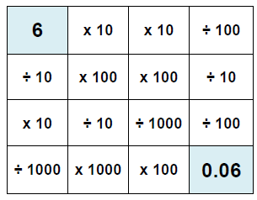
7.
More than one way available

8. = 3
= 100
= 120

9. C ÷B will always give you 100.

