Tuesday
Read the task below: you can draw this or you could use the cut out images to help.
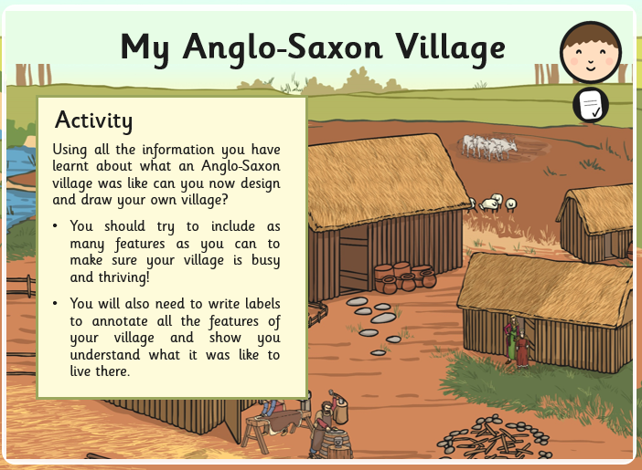
We have provide labels for you to cut an stick next to parts of the village

