**Half Term Activities**

**Big Garden Bird Watch:**

The Big Garden Bird Watch is a great way to find out more about nature. We have included a sheet, which shows you how to identify the birds you might spot! Why not take a walk and see what you find? You could even try identifying some different types of trees. Have a look at the activity sheets we have included to help you with this. There are also instructions to make your own bird feeder.

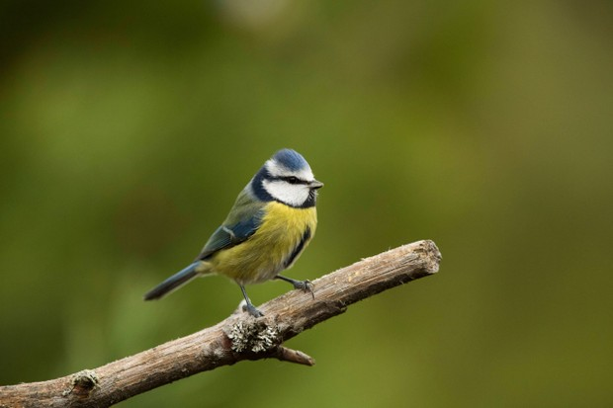 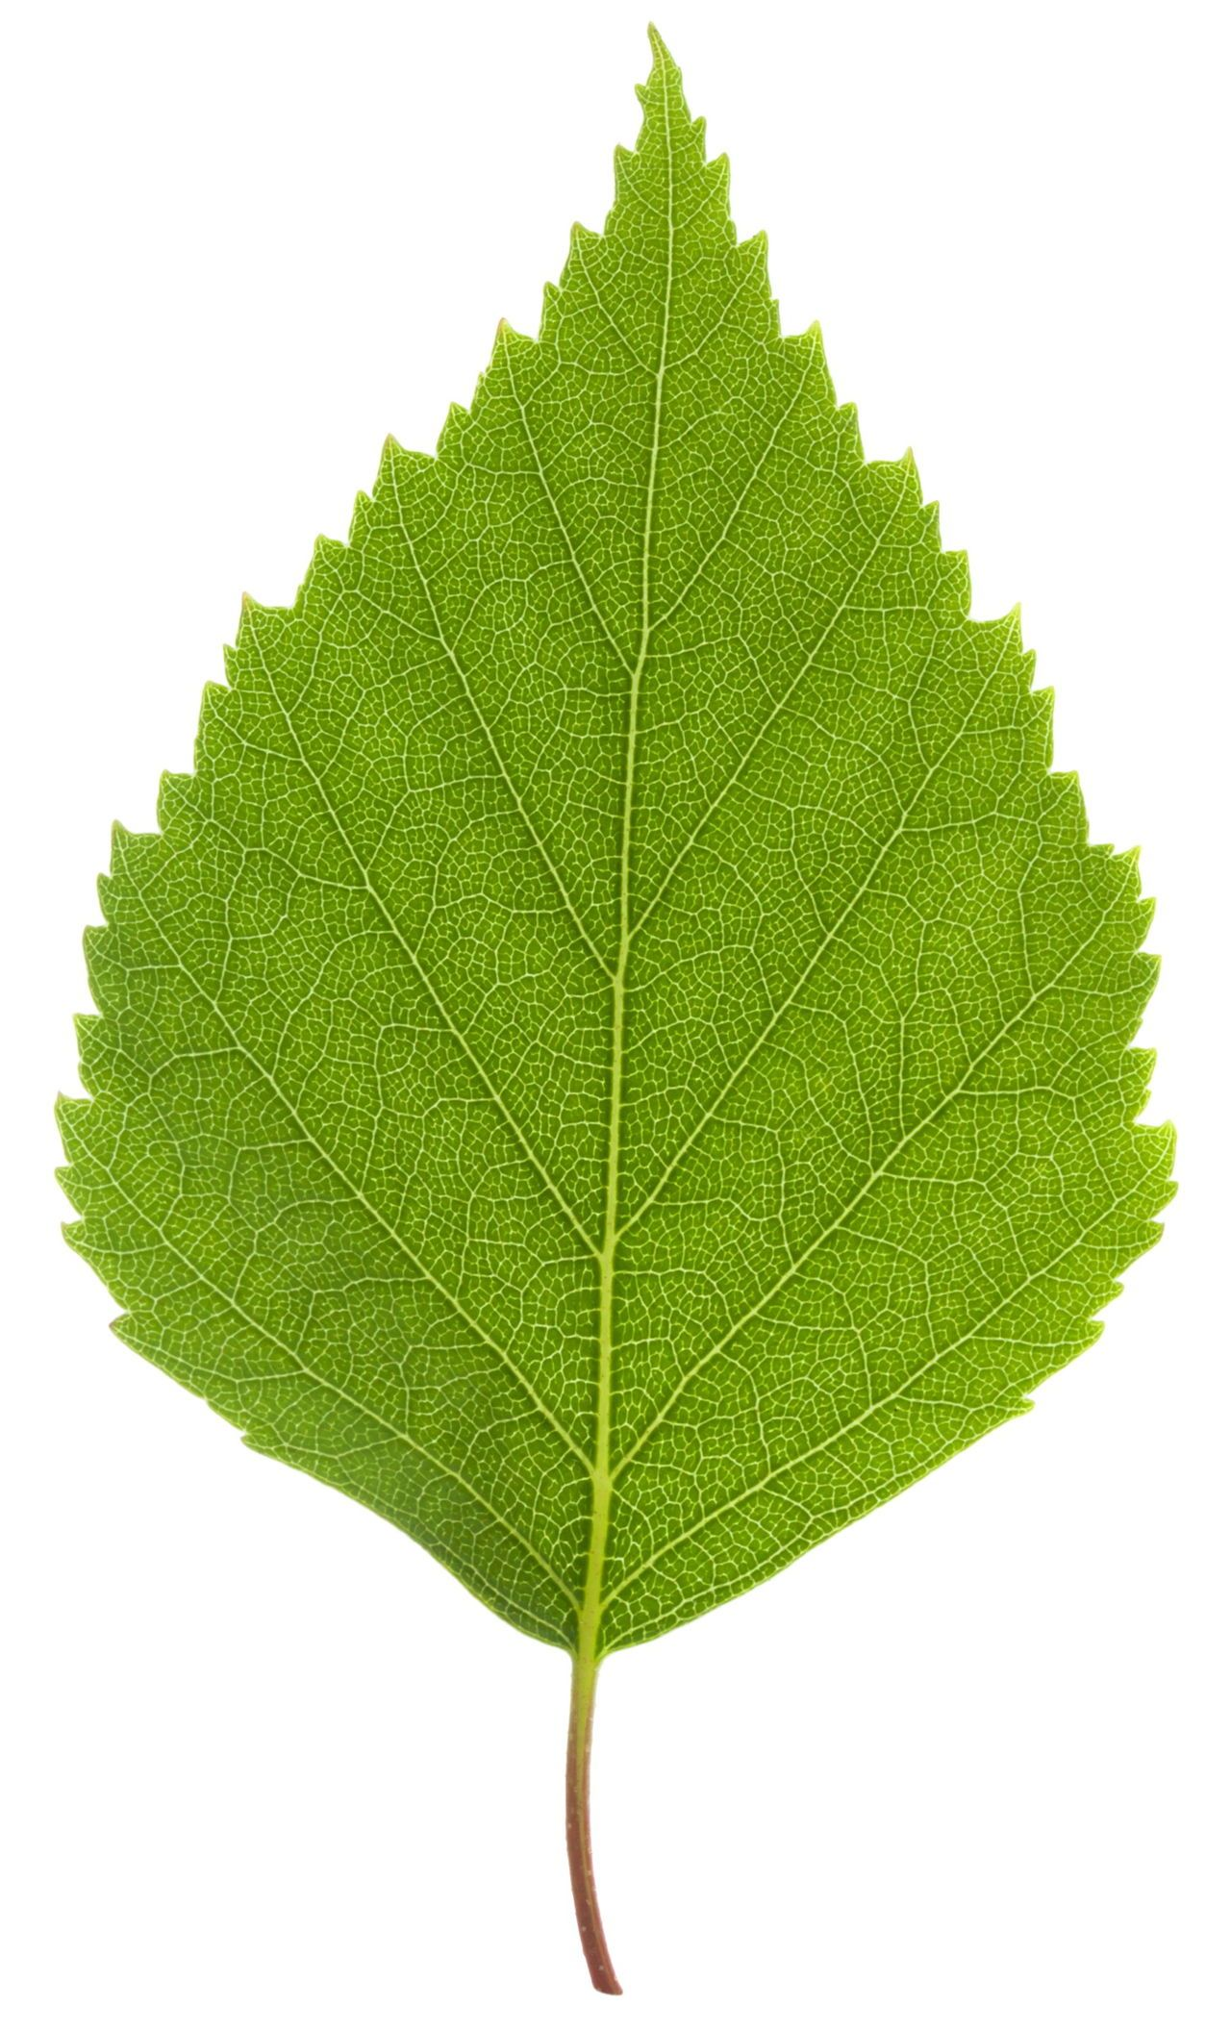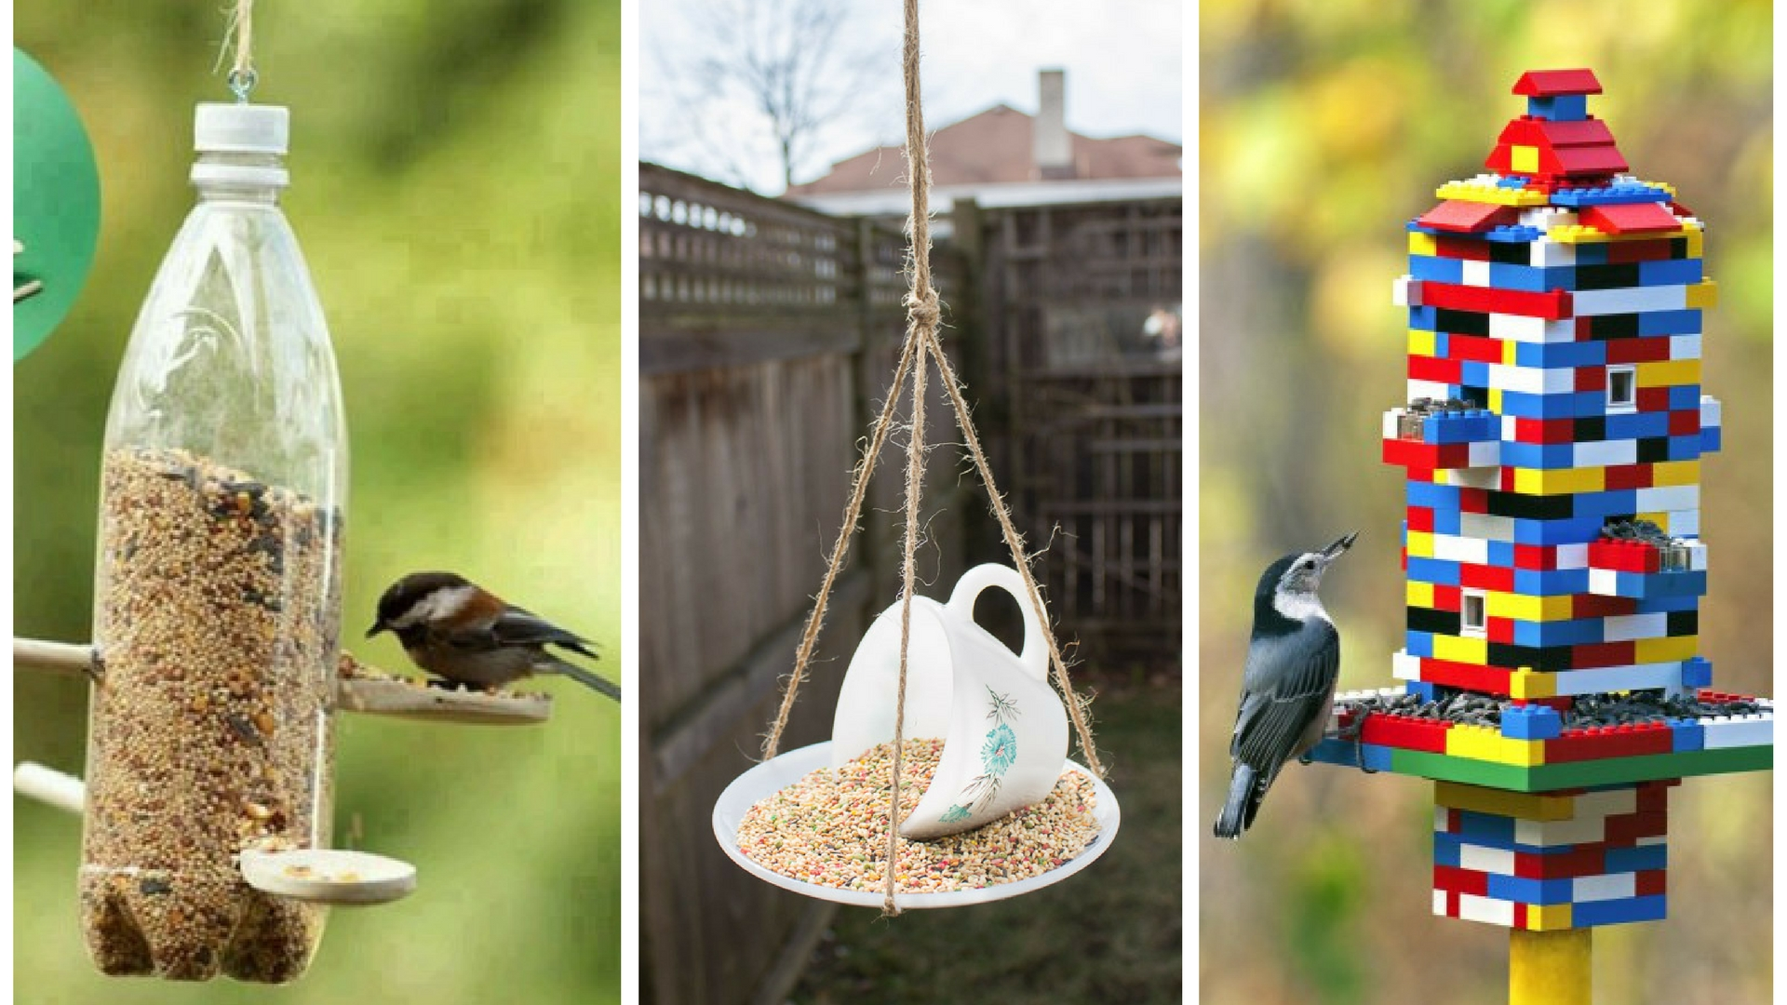

**Pancakes, pancakes and more pancakes!**

Tuesday 16th February is Pancake Day (also known as Shrove Tuesday). Do you know how to make a pancake? Work with an adult to make some tasty pancakes. Use this link if you are not sure how to:

<https://www.bbcgoodfood.com/recipes/easy-pancakes>

Have a look at these ideas for pancake toppings. Can you come up with another topping of your own?



**Research: Do you know why we celebrate Shrove Tuesday? Make a poster showing what you have found out about Pancake Day.**

[**https://www.bbcgoodfood.com/recipes/easy-pancakes**](https://www.bbcgoodfood.com/recipes/easy-pancakes)

Keeping Fit:

It’s very hard to stay fit at the moment but doing some exercise is great for your physical and mental health. Try and get out for a walk when you can, but if not, have a go at these activities:

Online Workouts: Joe Wicks is still providing workout sessions for children (and adults if you fancy it!) on his Youtube channel. Just type: ‘PE with Joe’ into your search engine. He is live on a Monday, Wednesday and Friday at 9am.

Just Dance Kids: If you type ‘Just Dance Kids’ into your search engine, you will find lots of music videos with dances you can learn. Why not challenge a friend and see who can learn it the best?

Running: Ask a parent if you can download a running app like the Nike App. Go out running with a parent/ guardian and chart your progress.

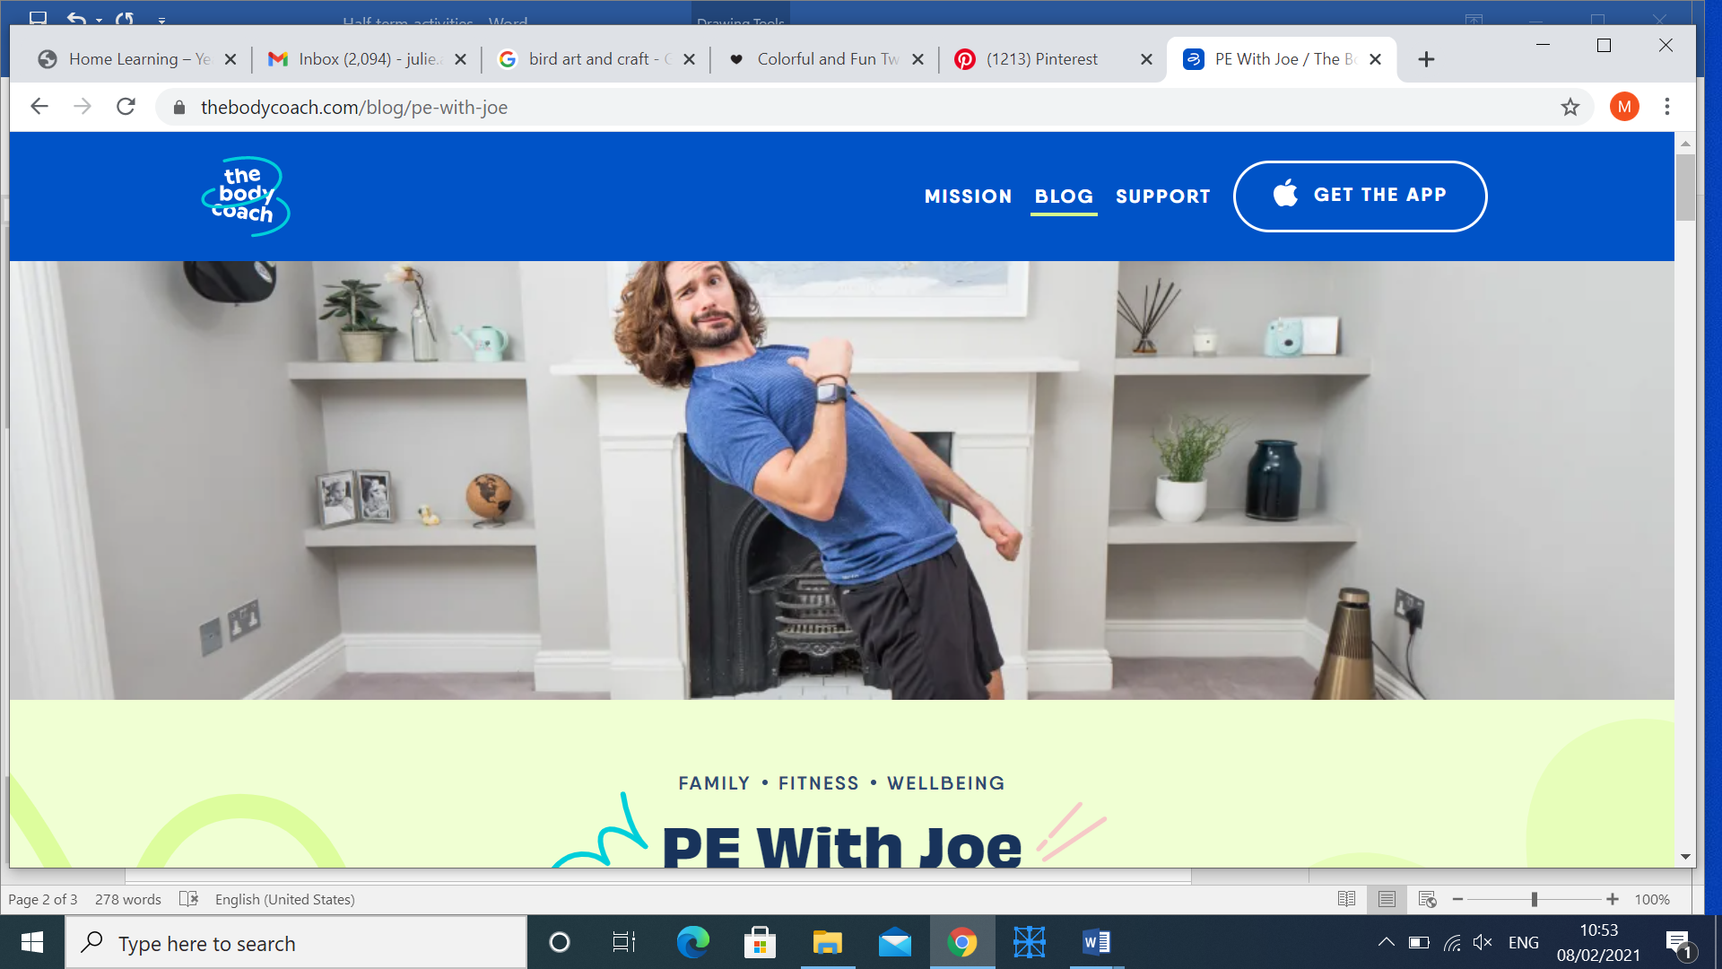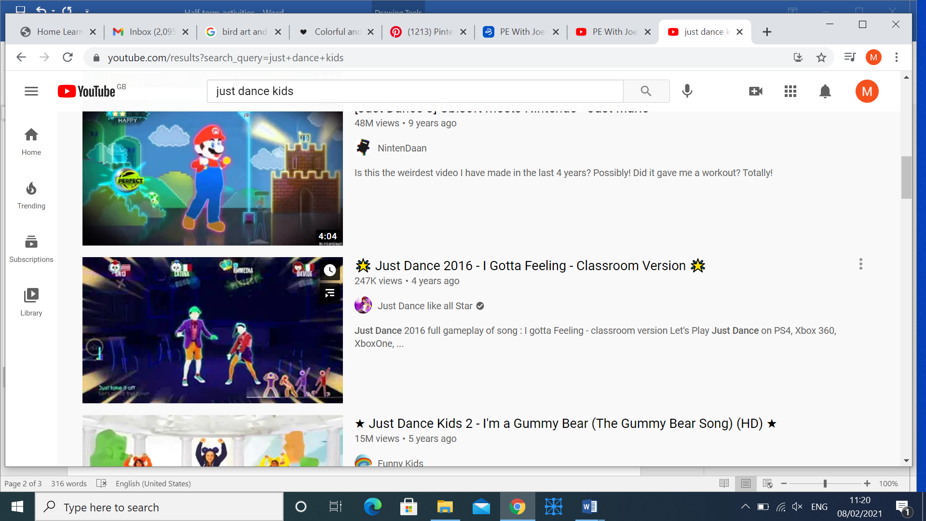

**Art and Craft:**

**If you are feeling arty, have a go and some of these projects!**

**Rock Painting:**

**If you get out for a walk, see if you can collect some stones to paint.**

**You could use them as paperweights or even leave them around the neighbourhood for others to find.**

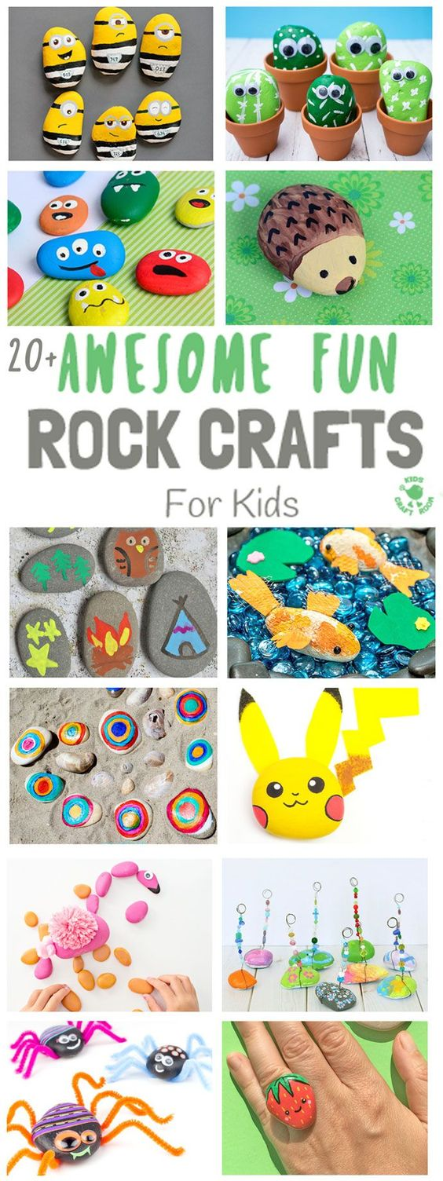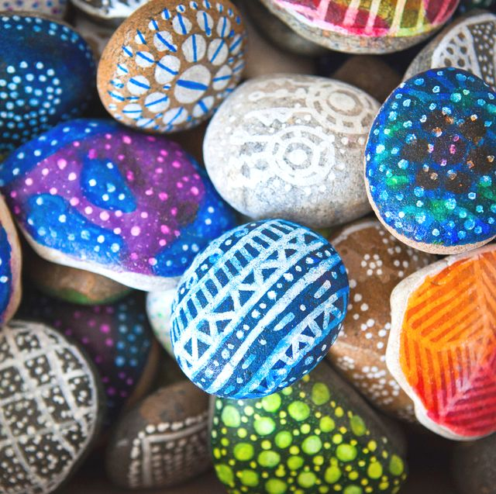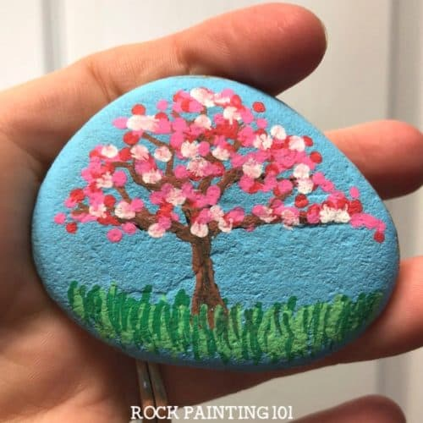

**Origami Bookmarks:**

**Have a go at these origami bookmarks. There are some youtube links to help you.**

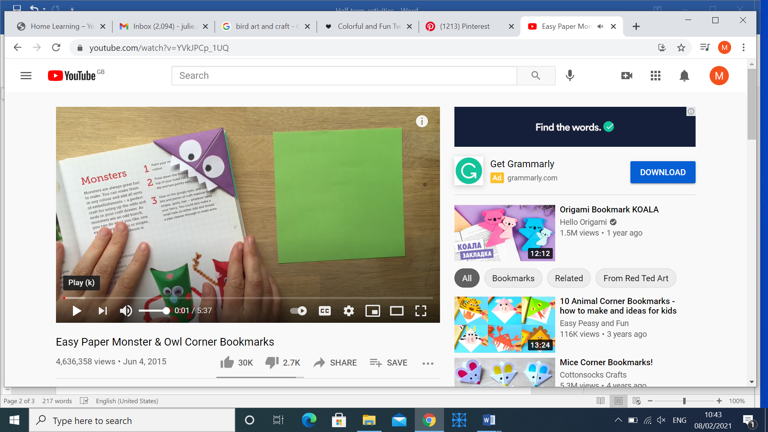**https://www.youtube.com/watch?v=YVkJPCp_1UQ**

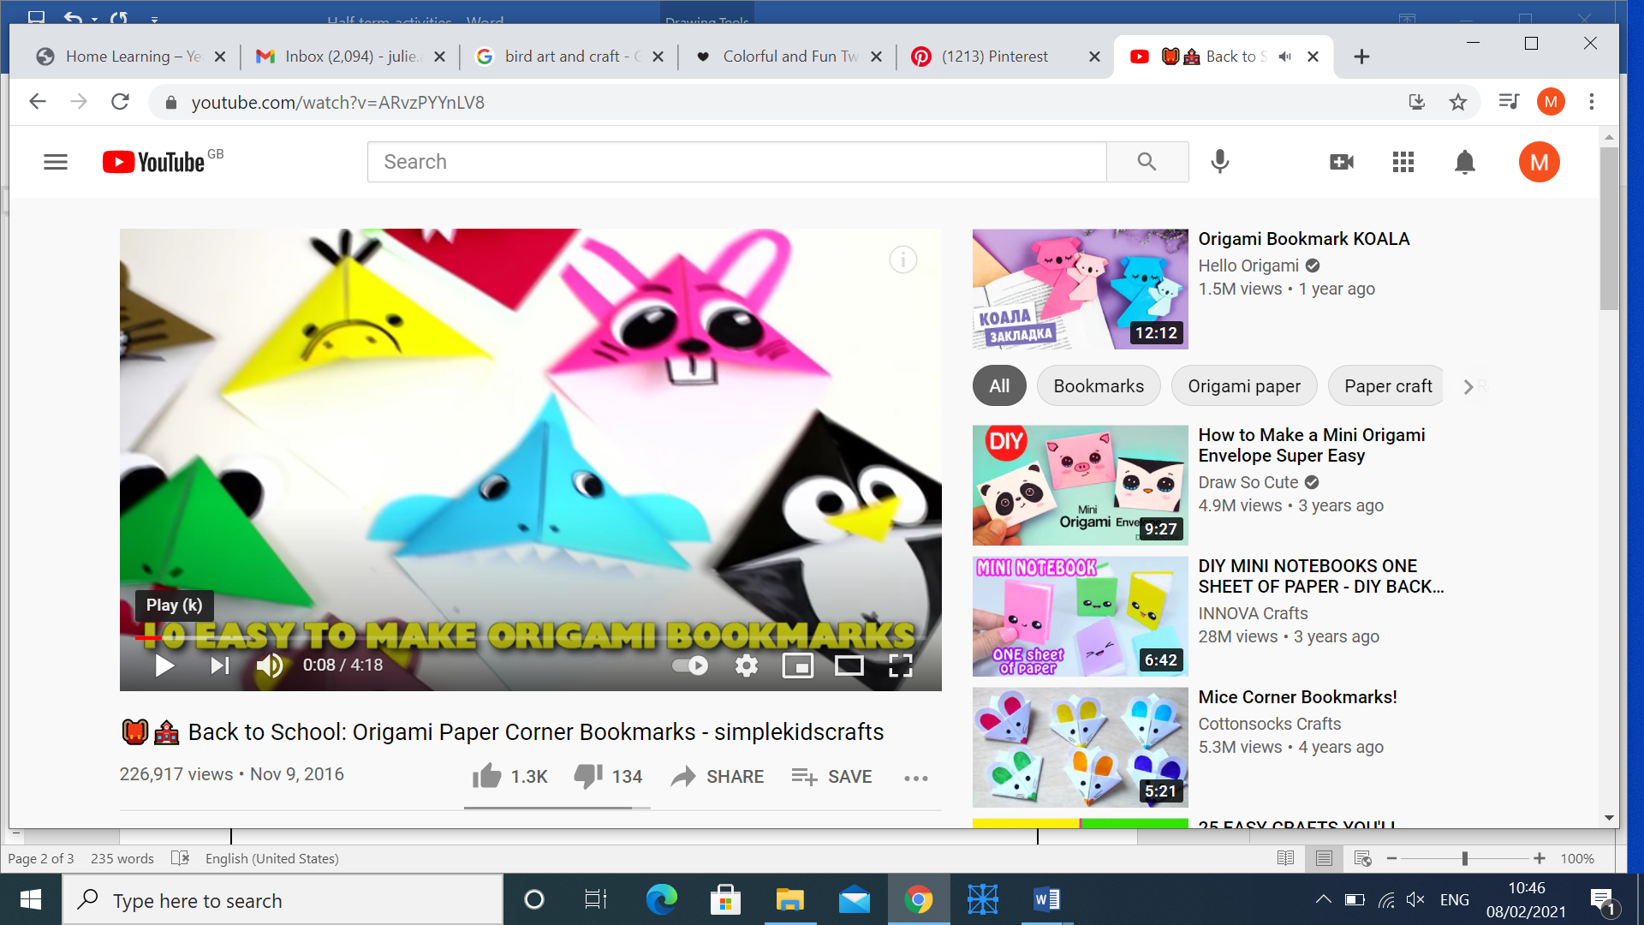**https://www.youtube.com/watch?v=ARvzPYYnLV8**

**There are some other great craft ideas at:** [**https://www.easypeasyandfun.com/crafts-for-kids/**](https://www.easypeasyandfun.com/crafts-for-kids/)**. You could also try making your own exploding volcano by following the instructions on this video:** [**https://www.nhm.ac.uk/discover/how-to-make-a-volcano.html**](https://www.nhm.ac.uk/discover/how-to-make-a-volcano.html)

**Year 6 Half Term Activities Video**

**https://www.youtube.com/watch?v=QwJAWG8-VFs**