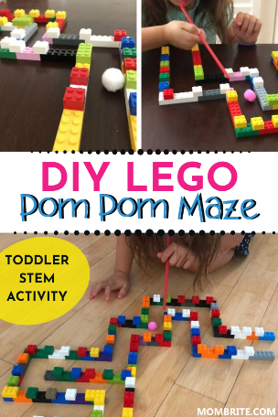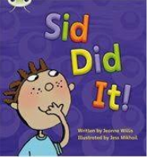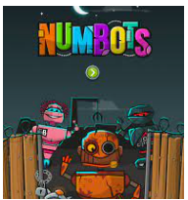

**Lego challenge**

**Use lego or any blocks to make a maze. Use a straw to blow a pom pom or small ball through your maze.**

**Use shaving foam or shaving gel write year 1 common exception words or numbers to 100.**

**Keep your brains active by reading, playing Numbots and practicing your letter and number formation.** 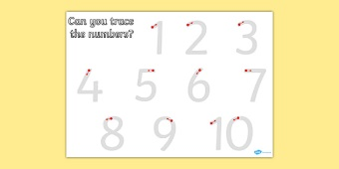

**During the half term you can stay active with cosmic kids’ yoga on YouTube or join Joe Wicks for some fun work outs!**



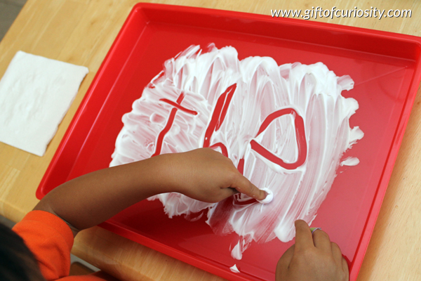

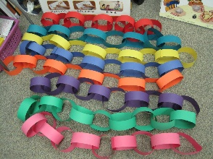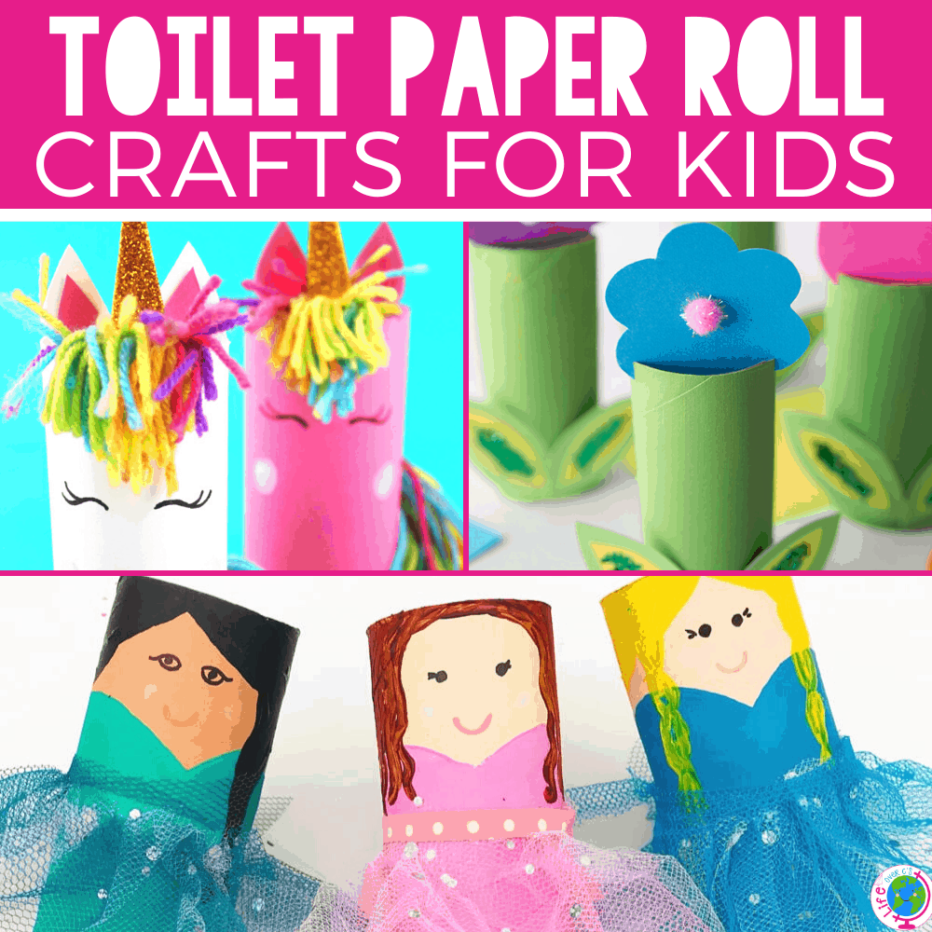

Teach yourself a magic trick using an online tutorial/video and perform it for your family members. Can they guess how it was done? Play board games, card games or complete a big jigsaw puzzle as a family. Charades - act out a TV show, book, film or song for others to identify. Make a simple bird feeder to hang outside. Drawing session - spend family time creating artwork of pets, family members or favourite animals. Create your own art gallery to display your artwork. Look at a map and plan an adventure (either one you might do later or a complete fantasy round the world trip). Research the places you would like to visit. Make invisible ink using lemon juice and a few drops of water. Write a message on paper by dipping a paintbrush in the lemon juice mixture and write a secret message. Place the message on a radiator, near a lightbulb or in the sun to reveal the hidden message.

**Make a paper chain that sequences numbers to 20/50 challenge - 100.**

**Decorate or make something out of a cardboard box.**

**Make a toilet paper roll character – you may need an adult to help you.**