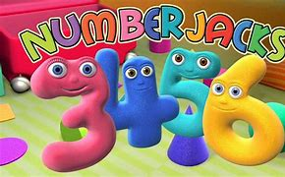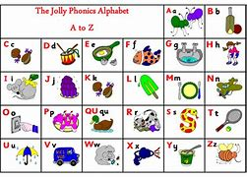u

**Half term fun ideas!**

Thank you for all of your hard work homeschooling over the past 6 weeks. Have a week off and enjoy half term! Enjoy some of these activities if you would like to and remember to have lots of FUN and make memories!

Keep your brains active by practising your sounds with Jolly Phonics and numbers with the Numberjacks on You Tube.

During half term you can stay active with cosmic ‘kids’ yoga on You Tube.

You can also join in with Joe Wicks

for some fun work outs!

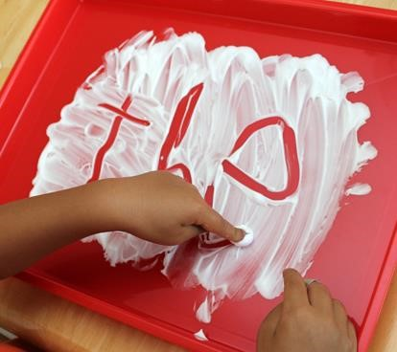

Use shaving foam or shaving gel to

to make different marks.

**Challenge - Can you write letter’s**

**from your name?**



Make a colourful collage. You could use bits of old fabrics, paper, cardboard or even natural materials like petals and leaves to make a lovely picture.

Fruit and vegetables come in lots of different colours. Can you think of a fruit or vegetable for every colour of the rainbow?

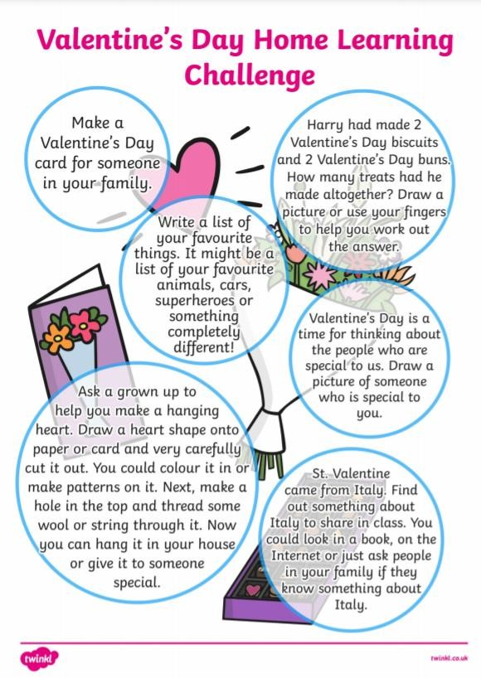



Take a blanket outside and watch the clouds on a cloudy day. See if you can spot any clouds that look like dinosaurs. Do they have spikes or long tails? You could ask a friend or family member to play with you.

Who can spot the most?

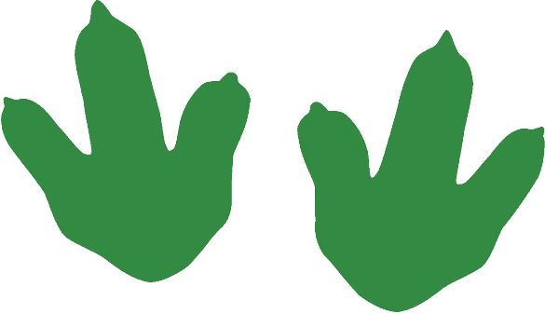

Create your own dinosaur. Draw a picture then write its name underneath. You could ask a grown-up to help you write some adjectives to describe your new dinosaur. Is it scary or friendly? Is it large, long or scaly?

Can you think of some more words that start with the sound ‘d’? Try to name and list of six.

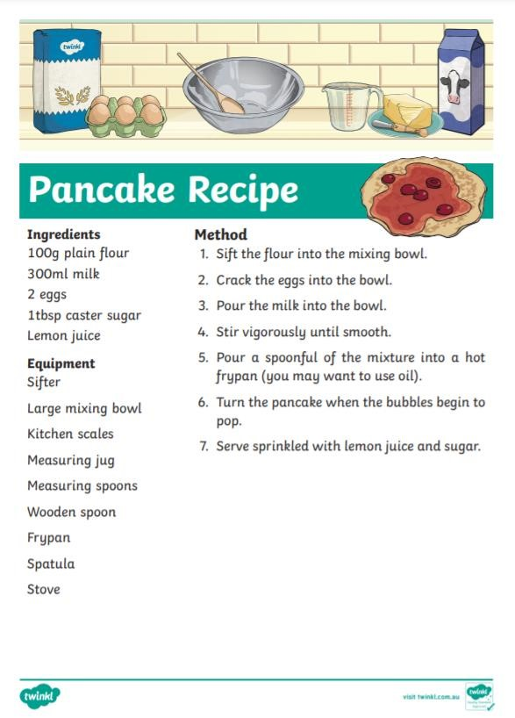 Pancake Day Tuesday 16th February

We would love to see pictures

of your pancakes.

Send them to the school email.