‘Feel Good Friday’
To celebrate all of your hard work this term, today is ‘Feel Good Friday!’ There’s no Maths, English or Phonics work today so why not try some of these fun activities instead?
Please attach any photographs or videos too as we’d love to see what you’ve been doing!
Yoga Time  Join in with ‘Cosmic Kids’ Valentine’s Day yoga. | Fantastic Friendships  Why not video call your friends or relatives and have a little catch up?  I know it’s very hard not being able to go to other people’s houses at the moment but that doesn’t mean that we can’t keep in touch with the people that we love the most.  Don’t forget to tell them why you love them! | Love Bug  Grab an old toilet or kitchen roll holder and decorate it to make your very own ‘Love Bug!’  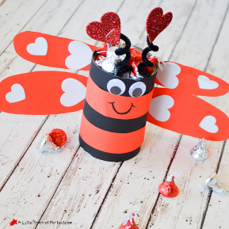
Valentine’s Card  As it’s Valentine’s Day on Sunday, why not make a card to show someone that you love them?  You could make a card for your grown-up, sibling or even your pet! | Positive Affirmations  There are lots of reasons to love yourself! Look in the mirror and tell yourself all of the reasons why you are amazing!  Here is a video to give you some ideas: | Feel Good Friday  Choose an activity that makes you feel good!  You could snuggle up in your PJs and watch a film, dance around the room to your favourite music or maybe even do some delicious baking.  The most important thing is that you have fun!

Valentine’s Day Yoga - https://www.youtube.com/watch?v=cU_T7lmw6Fo
Positive Affirmations - https://www.youtube.com/watch?v=I55jCHTQwCA

