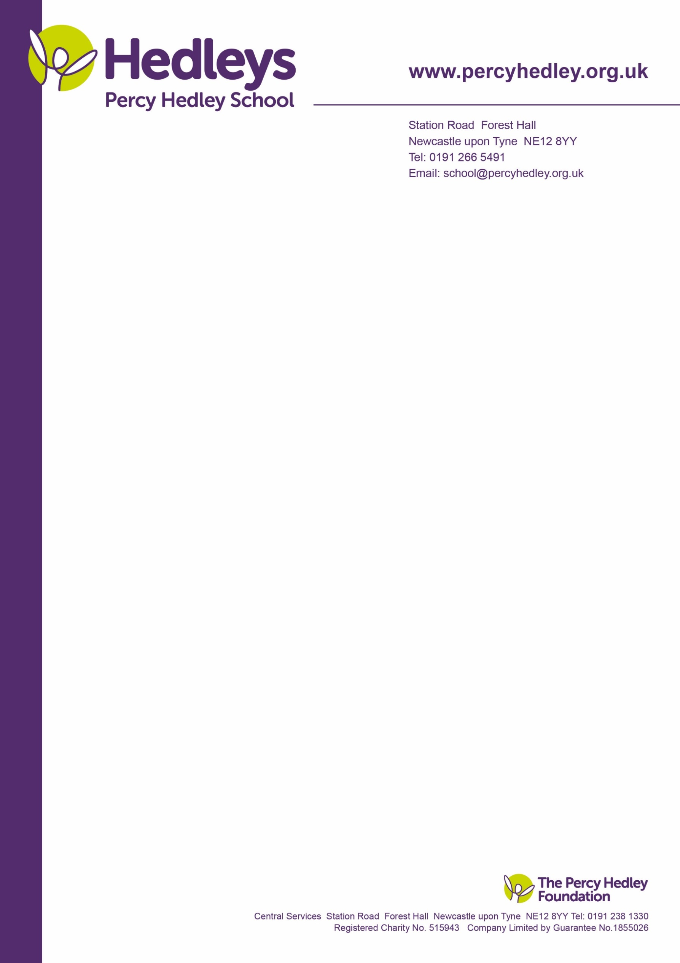
08 February 2021

Dear Parent/Carer,
You are invited to our PTA AGM on Wednesday 10th March 2021 from 10:45-12:00. This will be a virtual AGM on Microsoft Teams. More information on roles is available on the school website under the heading “Parents and Families”. You will need to log in to access.

The PTA main roles are to:
- foster better relationships between school and home
- raise funds for additional resources, toys and support the cost of some school trips which are not covered by school fees. These enhance the learning environment and experience for students.
- facilitate communication links between school and home, providing input to specific policies as requested.

Who are the PTA members?
ALL parents, carers and student linked school staff are automatically members of the PTA. Everyone is encouraged to get involved, supporting fund-raising, joining the 100 Club, attending meetings and sending in suggestions. We understand that distance from school and other commitments may present a barrier to attending meetings in person. This year, due to the COVID-19 pandemic we are moving to virtual, with plans to continue this alongside on site meetings when these can safely resume.
As members of Parentkind, we are required to hold an AGM and elect main committee members once a year. This ensures that the PTA operates in a business like way and that decisions made take into account member views and input. We have adopted their constitution; with appropriate agreed modifications given that Percy Hedley Foundation is already a charity in its own right. (Most PTA’s are charities)

Why is it important to involve parents/carers in the AGM?
The AGM is an important meeting, where the committee is elected and accounts are approved. It provides an opportunity to reflect on the previous year’s activity and plan for the future. With wide and varied attendance the PTA can meet its objectives.
Most of the logistics are carried out by me on behalf of the committee, so Officer roles are not necessarily particularly onerous.

Format for the meeting:
The meeting will commence promptly at 10:45 with a formal set agenda. This will include:
- Treasurer’s report; funds raised and how the school has benefitted from these funds.
- Chair’s report; summary of PTA activity and achievements over the past year.
- Election of Officers: Chair, Vice Chair, Secretary, Treasurer and Student Liaison Officer/s. Other committee posts may be considered, for example Social or Fund-raising, the former a priority this year.
- Outline of plans for the year ahead.

We would really appreciate your involvement, in whatever capacity possible to make the PTA a success.
- Could any parent/carer who would like to be considered for committee roles please advise us using the slip attached, to be emailed if possible to me?
- We will facilitate voting by those who are not in a position to attend meetings; you are required to notify the Chair of your wish to have a postal vote no later than 24th February 2021. This will only be required should we receive notification of more than 1 person being nominated, or expressing an interest in taking on a committee role.
- Once we have collated information above we will advise members of the candidates and results will be announced at the AGM.
- Proxy votes will only be necessary should there be more than 1 person nominated for or putting themselves forward for a specific committee role.
.

Yours sincerely,

Eileen Robinson
On behalf of Chair PTA

Percy Hedley School,
West Lane, Killingworth, Newcastle upon Tyne NE12 7BH
Telephone; 0191 2161811
Email: e.robinson@percyhedley.org.uk

Yours sincerely,

Eileen Robinson
Chair PTA
West Lane, Killingworth,
Newcastle upon Tyne NE12 7BH
Tel: 0191 2161811
Email: e.robinson@percyhedley.org.uk

PTA
West Lane, Killingworth
Newcastle upon Tyne, NE12 7BH
Tel: 0191 216 1811
Email: school@percyhedley.org.uk

Meetings offer the opportunity to meet other parents and staff, share thoughts and ideas and help the school. However, matters relating to individual children/young people should, in the first instance be directed to the class team. With your support we will be able to continue supporting classes.
We very much look forward to seeing as many of you as possible on the 10th March, but in the meantime, please do not hesitate to contact Eileen Robinson if you have any queries or would like additional information about the PTA or indeed what is involved in any of the committee roles. If you prefer to liaise directly with the Chair, please let me know. We are aware of the additional demands on our families, both in terms of distance from school and meeting the needs of their children. Input can be by email, telephone or letter and any suggestions are shared at meetings.

Yours sincerely

Eileen Robinson
On behalf of Sarah Warwick; Chair PTA
Hedleys Percy Hedley School,
West Lane, Killingworth, Newcastle upon Tyne NE12 7BH
Telephone: 0191 2161811 ext: 3258
Email: e.robinson@percyhedley.org.uk
Please return reply slip below FAO Eileen Robinson no later than 24th February 2021. This can be done by email.
-----------------------------------------------------------------------------------------------------------------------------------
I would like to be considered for a Committee role (please specify which role) ___________________________
I would like a postal vote: (please delete as appropriate) Yes/No
I will be attending the AGM (please delete as appropriate) Yes/No
My contact details including name, email address, child’s name and class:
Name: __________________________________ Telephone number:_______________________________
Email address:________________________ Child’s name and Class: _______________________________
Please use comment box below for anything else you would like to share with the committee.

