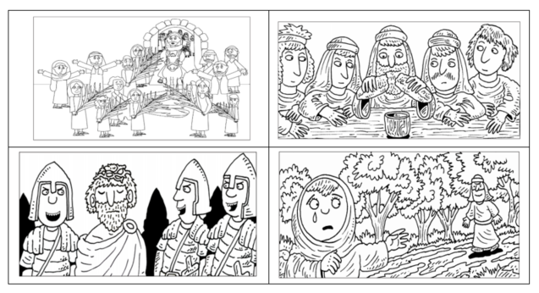

**Why does Easter matter to Christians?**

**What will be explored during this unit?**

This unit aims to answer the question – Why does Easter matter to Christians. During this unit, children will be given the opportunity to explore 5 key stories from the Bible, that explore the last week of Jesus’ life. Christians remember this last week of Lent as a time called Holy week. There are many church services during this time.

|  |  |  |
| --- | --- | --- |
| Lesson focus |  | Summary of the Bible story. |
| Palm Sunday |  | At this time, Christians are reminded of the journey Jesus took to Jerusalem, to celebrate the Jewish festival of Passover (Pesach). Christians are reminded of how the Son of God chose a donkey to travel, to show humility and peace. Palm leaves were waved to welcome Jesus to Jerusalem. |
| Jesus at the temple |  | When Jesus arrived in Jerusalem, he visited the temple. Jesus was outranged that traders were using the temple as a market. He drove the sellers out and taught people that the temple was a place of prayer. Chief priests and teachers of the law were threatened and plotted to end Jesus’ life. |
| The last supper  Maundy Thursday |  | On the night before his death Jesus had a final meal with the disciples. Jesus showed his love for his followers by washing their feet before the meal. Later in the meal Jesus told His disciples that he was going to die, and that the bread and wine should be consumed in remembrance of Him. Jesus also told the disciples that one of them (Judas) would betray him and identify him to the authorities by kissing Jesus on the cheek. Christians remember this through services of Holy Communion or Eucharist. |
| Good Friday |  | On Good Friday, the chief priests and teachers of the law brought Jesus to trial. Jesus was tried by Pilate, where the crowd called for Jesus to be crucified. Pilate didn’t know what crime Jesus had committed but handed Jesus to the soldiers to be crucified. |
| Easter Sunday |  | On the Sunday morning Mary Magdalene, Mary the mother of James, and Salome went to visit Jesus’ body at the tomb. They were shocked to find that Jesus’ body wasn’t there, and the stone that covered the tomb’s entrance had been rolled away. A man in a white robe told them Jesus was alive. Jesus appeared to Mary and later the disciples. He urged them to go and preach the gospel to the whole world. |

|  |  |  |  |  |
| --- | --- | --- | --- | --- |
| Key Words to explore with children | | | Values, behaviours and concepts | |
| Palm Leaves |  | | Respect | |
| Hosanna |  | | Sin | |
| Tomb or cave |  | | Forgiveness | |
| Disciples | Image result for Disciples Clip Art | | New Life | |
| Holy Communion or Eucharist |  |  | Hope |

**How do Christians celebrate Easter?**

**What is so important about Palm Sunday?**

|  |
| --- |
| **Palm Sunday – Jesus Rides into Jerusalem** |

|  |
| --- |
| **A very important person** |

This is a story found in the Bible and tells us about how Jesus rode into Jerusalem, and how different people reacted to His arrival.

Before we look at the first bible story, let us warm up our brains and think about how we welcome people we see as important.

**The Queen is coming to visit your town for an Easter visit.**

Can you imagine that the Queen is coming to visit your town? Can you write a plan of how you would prepare for a visit? You might want to write answers for these questions:

|  |  |  |  |  |  |  |
| --- | --- | --- | --- | --- | --- | --- |
| What would the Queen eat? | Where would she visit? | How would you travel? | How would you decorate the town? | What music would you play? | How would you entertain the Queen? | Where would the Queen sleep? |

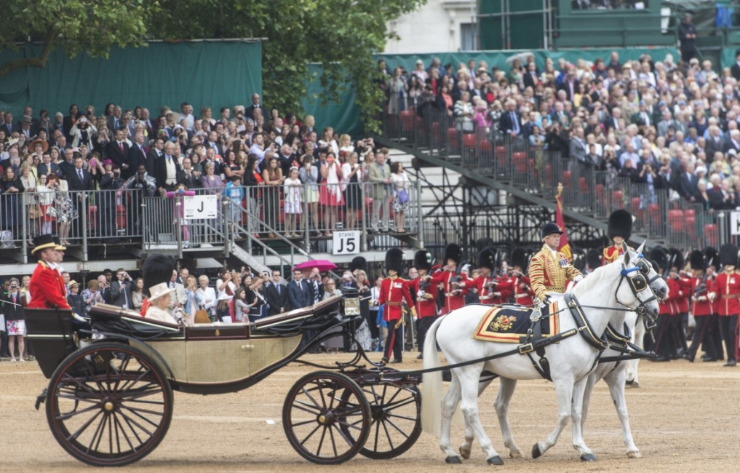

|  |
| --- |
| Jesus enters Jerusalem – Mark 11:1-11 |

|  |  |
| --- | --- |
|  |  |
| One day as Jesus was coming towards Jerusalem. He told two of His disciples to go to a nearby village. ‘You will find a donkey there,’ said Jesus. ‘Untie it and bring it to me. If anyone asks what you are doing you must say the Lord needs it.’ | The two disciples did as they were told and found the donkey tied up outside the house. As they began to lead it away the owners came out and asked what they were doing. ‘The Lord needs it,’ they replied. The owners were happy to let their donkey be used by Jesus. |
| What did Jesus ask his disciples to find?  Why did the owner of the donkey let the disciples use the donkey? | |
|  |  |
| When the disciples returned, they put their coats on the donkey and Jesus sat on it. Then He rode off towards Jerusalem followed by the disciples. | As Jesus travelled towards the city the crowds began to throw their coats and palm branches on to the ground before Him. They shouted loudly, ‘Hosanna! Blessed is He who comes in the name of the Lord.’ |
| Where did Jesus ride to on the donkey?  How did the crowds feel when Jesus rode into the city? | |

|  |  |
| --- | --- |
|  |  |
| As Jesus came near the Mount of Olives His disciples were thankful for all the miracles they had seen Jesus do. They began to praise Him saying, ‘Blessed is the King who comes in the name of the Lord. Peace in heaven and glory in the highest.’ | There were some Pharisees in the crowd who did not like to hear people praising Jesus. ‘Tell your disciples to stop,’ they demanded. But Jesus replied, ‘If they keep silent the very stones would cry out in praise instead.’ |
| Why were Jesus’ disciples so thankful?  What did the Pharisees tell the disciples to stop doing? | |

|  |
| --- |
| **A very important person** |

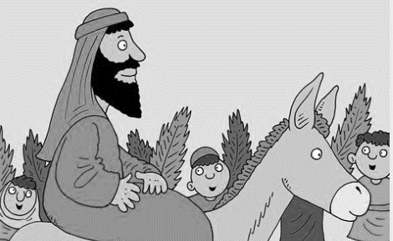

Imagine you are in the crowd to welcome Jesus into Jerusalem. Do you think the people in the crowd were expecting Jesus to ride into Jerusalem on a donkey?

**Use the boxes to write how you think the people in the crowd would react.**

Feel

Think

Say

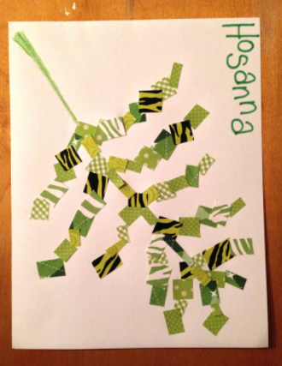



|  |  |  |  |  |  |  |  |  |
| --- | --- | --- | --- | --- | --- | --- | --- | --- |
|  |  |  |  |  |  |  |  |  |
|  |  |  |  |  |  |  |  |  |
|  |  |  |  |  |  |  |  |  |
|  |  |  |  |  |  |  |  |  |
|  |  |  |  |  |  |  |  |  |

**Give thanks**

When Jesus arrived in Jerusalem, the large crowd began to thank God and praise him – Luke 19:37

Using the small squares below, can you write things that you are thankful for?

Can you then cut out each of these squares, and make your own palm leaf?



|  |
| --- |
| **Why was the palm leaf so special?** |

|  |
| --- |
| This activity needs you to use the internet to watch a short clip to explore more about Palm Sunday. In the boxes can you write how the Palm tree was used?  If you are using the internet, please check with the adult you live with that you are able to use the internet safely to watch this BBC bitesize clip.  [The riddle of Palm Sunday - KS1 Religious Education - BBC Bitesize](https://www.bbc.co.uk/bitesize/clips/zy2hyrd) |



Camels eat…

You can eat…

What can you make from it?

In cold nights…

In the hot sun…

|  |
| --- |
| **Who else might have been greeted by waving palm leaves?** |

**How do Christians celebrate Easter?**

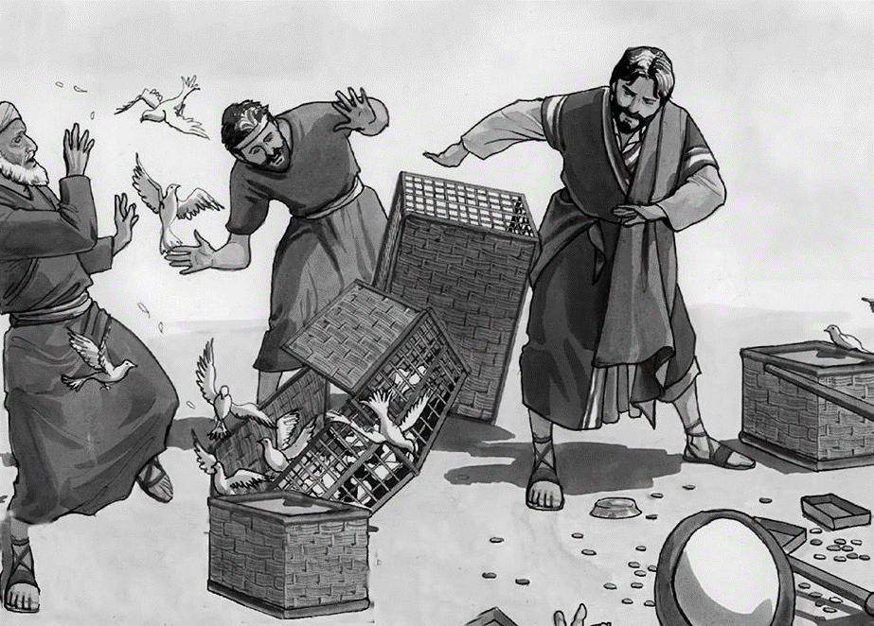

This is a story found in the Bible and tells how Jesus reacted when He found people using a place of prayer like a market to buy and sell goods.

**Why did Jesus become angry?**

|  |
| --- |
| Jesus goes to the temple |

|  |  |
| --- | --- |
|  |  |
| After riding into Jerusalem, Jesus entered the Temple. | He saw that money changers had set up tables in the Temple. There were also traders buying and selling. Jesus exclaimed. ‘Is it not written, “My house will be called a house of prayer? ‘But you have turned it into a den of robbers.”’ |
| Where did Jesus go, after riding into Jerusalem?    Why did Jesus say that the people in the temple were like robbers?  What did Jesus say the temple should be used for? | |

|  |  |
| --- | --- |
|  |  |
| Jesus overturned the tables of the corrupt money changers. He overturned the benches of those selling doves. | Jesus drove out all who were buying or selling and stopped anyone carrying goods through the Temple. He then taught the people that God said, ‘My temple will be a house of prayer for all nations.’ |
| Why do you think Jesus was so angry?  What did Jesus do, to show how upset he was? | |

|  |  |
| --- | --- |
|  |  |
| The chief priests and the teachers of the law and the leaders plotted how they could get rid of Jesus. They were afraid of Jesus, because the whole crowd was amazed at his teaching. | Jesus then left the Temple and returned to Bethany. |
| Why did the chief priests and teachers of the law want to get rid of Jesus?  How did people react when Jesus spoke to them and taught them? | |

|  |
| --- |
| Dear diary |

Imagine you were in the temple when Jesus got angry at the people in the temple. Write a diary entry to explain what you saw and how you felt about what Jesus did.

Dear diary…

|  |
| --- |
| **Being respectful** |

When people visit places that they think are important, they may do different things to show respect. People may take off their shoes, or cover their head or turn off their mobile phone and talk in a quiet voice. Outdoors there is a country code to show respect for nature.

|  |  |  |
| --- | --- | --- |
|  |  |  |

**Think carefully about a special place to you and design a poster that explains to visitors the best ways that they can show respect for your special place.**

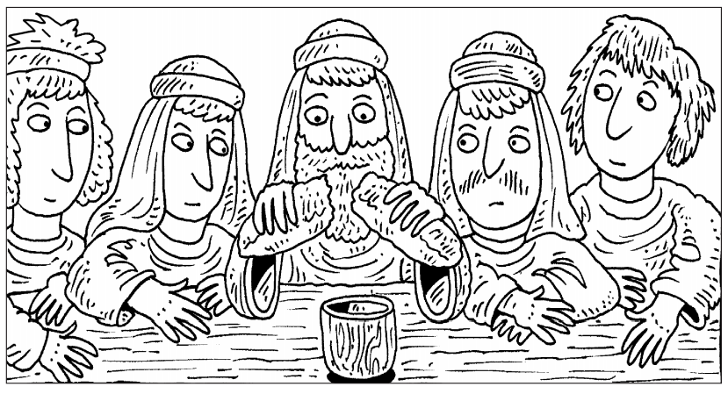

This is a story found in the Bible and tells us about a special meal Jesus had with His friends, the disciples. It is a meal that Christians celebrate today to remember Jesus and how He died and rose again.

**How do Christians celebrate Easter?**

**What is so special about the last supper?**

|  |
| --- |
| The last supper |

|  |  |
| --- | --- |
|  |  |
| Jesus said to His disciples, I want to eat the Passover feast with you before I go away. Go and get it ready for us. | ‘Look for a man carrying a water jar and follow him. He will show you where to go.’ His friends found the man and followed him. |
| What was the name of the feast that Jesus wanted to eat with His disciples?  What did Jesus tell the disciples that they should look for? | |

|  |  |
| --- | --- |
|  |  |
| The man went into a house. This was the house Jesus would be coming to for the meal. Jesus’ friends knocked at the door and waited. | ‘Do you have a room for Jesus?’ they asked. ‘Yes, I have a room upstairs. Everything you will need is ready. I knew Jesus would come,’ said the man. |
| What did the disciples ask the man?  Why do you think the disciples were surprised that the room was ready? | |

|  |  |
| --- | --- |
|  |  |
| He took them upstairs to a big room. They got dinner ready with baskets of flat bread, and wine made from grape juice. | Soon Jesus arrived with His other friends. They went upstairs to have dinner together. |
| What was the food that Jesus and disciples would eat?  What would Jesus and the disciples drink at the meal? | |

|  |  |
| --- | --- |
|  |  |
| Jesus took the flat bread and broke it. They shared it. ‘This bread is my body,’ Jesus said. They shared the wine, too. Jesus said, ‘This wine is my blood. Whenever you do this, remember me.’  Christians hold a special service in Church called Communion. They break bread, and drink a sip of wine, in remembrance of Jesus. | You can watch an animation of the last supper using this link:  [The Last Supper (animation) - KS1 Religious Education - BBC Bitesize](https://www.bbc.co.uk/bitesize/clips/zgsb9j6)  If you are using the internet, please check with the adult you live with that you can use the internet safely to watch this BBC Bitesize clip. |
| Why did Jesus say that the disciples should break bread and drink wine?  What is the special service that Christians take part in to remember Jesus? | |

|  |
| --- |
| The last supper – Understanding what Jesus did. |

Christians take part in a special service that is sometimes called Eucharist, Holy Communion, or the Lord’s supper. Can you match the right pictures and word together in the table below?

|  |  |  |
| --- | --- | --- |
| Drag into the box or draw a line |  | What happened at the last supper… |
|  |  | At the last meal Jesus ate with His disciples before He was crucified Jesus gave thanks took some bread and broke it in pieces. |
|  |  | Jesus said to His disciples, ‘This is my body given for you. Do this to remember me and what I have done for you. |
|  |  | Jesus took a cup of red wine and gave thanks for it. Then He said, ‘This is my blood, poured out for many and for their sins. |
|  |  | Christians continue to eat bread and drink wine together to remind them of the great love of Jesus in making a way to be forgiven. |

|  |
| --- |
| The emotions of the disciples at the last supper. |

|  |
| --- |
| Please look back at the story of the last supper and watch the video again. Can you think about how the disciples might have felt during the last meal they had with Jesus, by drawing an emoji and explaining the feelings in words? |

|  |  |  |  |  |
| --- | --- | --- | --- | --- |
|  |  |  |  |  |
| Jesus tells the disciples they are going to share a meal. | Jesus tells the disciples that he will not be with them much longer. | Jesus breaks the bread and shares the wine. | Jesus tells the disciples that his enemies will capture him and put him on a cross to die. | Jesus tells the disciples that one of them will hand him over to his enemies and betray him. |
| Feelings Emoji to show how the disciples might have felt. | | | | |
|  |  |  |  |  |
| 3 words to describe the way the disciples might have felt. | | | | |
|  |  |  |  |  |

|  |
| --- |
| After the Last Supper |

|  |
| --- |
| When Jesus ate with the disciples, he told them that Judas Iscariot would betray Him. After the meal Jesus went to a place called Gethsemane to pry. This is where Jesus’ enemies came for Him. Can you watch this video from the RE:quest website, and create your own storyboard to explain what happened?  <https://request.org.uk/restart/2017/03/14/holy-week-and-easter/> |

|  |  |  |
| --- | --- | --- |
|  |  |  |
| Jesus went to pray. When here was there… |  | Straight away the guards… |

|  |  |  |
| --- | --- | --- |
|  |  |  |

**How do Christians celebrate Easter?**

**What is so good about Good Friday?**

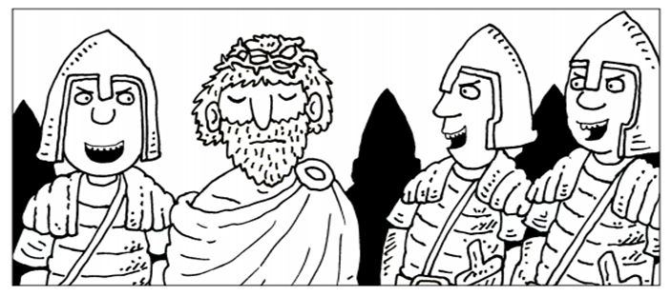

This is a story found in the Bible and tells us about what happened after Jesus was arrested.

|  |
| --- |
| Jesus and Pontius Pilate |

|  |  |
| --- | --- |
|  |  |
| Jesus to sent to be judged by Pontius Pilate, who was the man in charge. He was the Roman Governor in the province of Judea. | Pontius Pilate the Governor asked Jesus, ‘Are you the King of the Jews?’ Jesus agreed, ‘It is just as you say.’ But, when all the crowd laughed at Him He didn’t reply. |
| Who was the man who was to decide what would happen to Jesus?  Why do you think Jesus did not reply when the crowd laughed at Him? | |

|  |  |
| --- | --- |
|  |  |
| Now once a year, Pilate released a Jewish prisoner - anyone the Jews wanted. There was a very bad man called Barabbas in jail. So Pilate asked the crowd, ‘Who shall I release, Barabbas or Jesus?’ | Stirred up by the Jewish leaders who were jealous of Jesus, the angry crowd shouted, ‘Barabbas’. They wanted Pilate to crucify Jesus. |
| Who did Pilate offer to release from prison?  Who did the crowd want to release from prison? | |

|  |  |
| --- | --- |
|  |  |
| Once again, Pilate asked the crowd, ‘What shall I do with Jesus?’ ‘Crucify Him,’ they shouted time and time again. Pilate didn’t want to punish Jesus because he knew that He was an innocent man. He washed his hands in front of everyone, to show that he did not want to be responsible. | The soldiers led Jesus away. They put a scarlet robe on Him and made Him a crown from thorns. ‘Here is the King of the Jews,’ they joked. They led Him away to be crucified. The soldiers hung Jesus on a cross to die on Good Friday. |
| What did Pilate do, to show he did not want to be responsible for what was going to happen to Jesus.  Why did the soldiers make a crown of thorns for Jesus? | |

|  |
| --- |
| Did they really feel good? |

|  |
| --- |
| Now you have read the Good Friday bible story, do you really think it was a good day? Think carefully about how each of the people in this story may have felt at the end of Good Friday. |

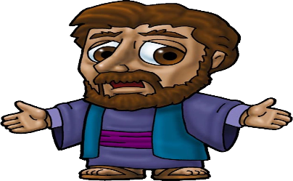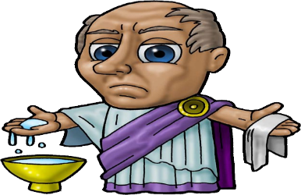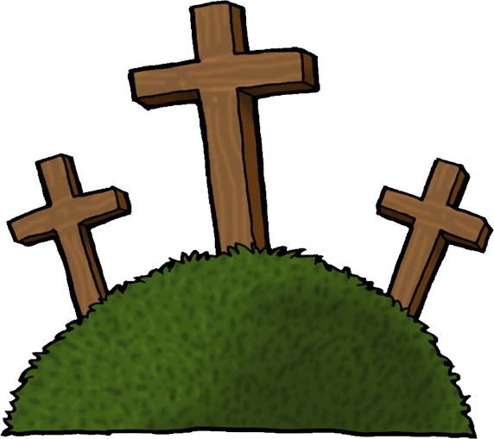

Jesus’ disciples

Pilate

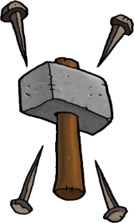



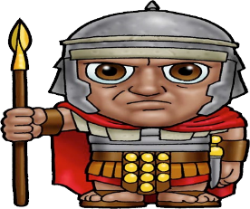

On Good Friday, Jesus died on the cross. His body was then taken down from the cross and buried in a tomb.

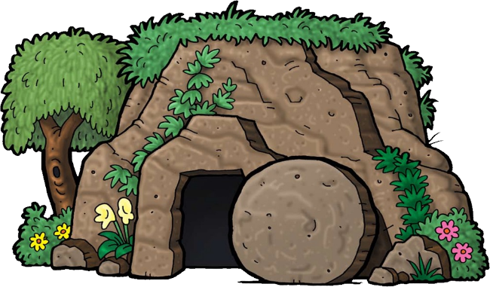

The Roman Soldiers

Judas

|  |
| --- |
| **Saying sorry – Forgiveness** |

Why is it good to say sorry if we do something wrong?

Sometimes, it is difficult to say sorry to someone face to face. We can sometimes say sorry better by writing a letter. If you feel that there is something you want to say sorry for, maybe use this time to write a letter.

You may also feel upset by someone and are hoping that will say sorry to you. Sometimes people do not know they have upset another person, so they need help to see what they did. To have these conversations these three sentence starters can help. Writing this down, can sometimes help you rehearse what you want to say.

|  |
| --- |
| The cross is sometimes described as a bridge that lets Christians say sorry to God for the wrong things that they do and helps them to find their way back to him. Christians believe that God forgives them and gives them a fresh start. |

|  |
| --- |
| So why might it be called Good Friday? |

|  |
| --- |
| Good Friday may seem like an unusual name for the day that Jesus died on a cross. Can you watch this clip about Good Friday and explain one reason why such a sad day was called Good Friday? |

|  |  |
| --- | --- |
| Good Friday and Easter Eggs  [Good Friday and Easter eggs - KS1 Religious Education - BBC Bitesize](https://www.bbc.co.uk/bitesize/clips/zjgkq6f) | If you are using the internet, please check with the adult you live with that you can use the internet safely to watch this BBC Bitesize clip. |
| **Christians call such a sad day Good Friday because…** | |

|  |  |
| --- | --- |
| Image result for easter eggs | How do Easter eggs remind Christians about Jesus coming back to life? |

**How do Christians celebrate Easter?**

**What is so amazing about Easter Sunday?**

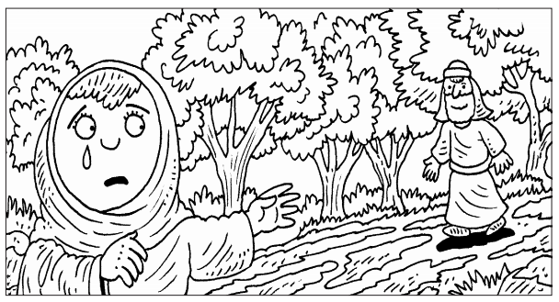

This is one of the most amazing stories in the world – and it is found in the Bible.

|  |  |
| --- | --- |
|  |  |
| Very early on Sunday morning, three days after Jesus died on the cross, Two of His friends, both called Mary, went to the tomb. They took special perfumes and spices to wash Jesus with. They were feeling sad. They loved Jesus. | They had seen where Jesus had been put in a tomb, like a cave, and they knew where it was. But how could they move the big, heavy stone the soldiers had put over the door? |
| What did Mary take with her to the tomb?  What was the problem with the stone that covered the tomb? | |

|  |  |
| --- | --- |
|  |  |
| They got a surprise when they got there. The stone had been rolled away and the soldiers had all gone! They went inside and saw an angel! But where was Jesus? ‘Don't be frightened,’ said the angel. | ‘Jesus isn’t here. He is alive! Go and tell everyone the wonderful news.’ The happy women ran off to share the good news that Jesus is alive. |
| What were they surprised when they got to the tomb?    Who was inside the tomb?  What was the special news that the angel gave to both Marys? | |

|  |  |
| --- | --- |
|  |  |
| When Mary went to Jesus’ tomb, three days after He had died, she had seen the tomb was empty. She went straight away to tell Peter and John. Peter and John had to see for themselves. They both ran to the tomb. They saw the empty clothes, but it was true - Jesus was gone! They went back, puzzled over what had happened. | Mary stayed at the tomb crying. Two angels asked her, ‘Why are you crying?’ ‘They have taken Jesus away,’ she said, ‘and I don’t know where they have put Him.’ Then she heard another voice, ‘Mary, why are you crying?’ Mary thought it was the gardener. ‘Where have you taken Jesus?’ she asked. ‘Mary,’ the Person replied. |
| Who did Mary tell about what they had found in the tomb?  Why was Mary so upset?  Who did Mary think was talking to her when she was upset? | |

|  |  |
| --- | --- |
|  |  |
| That sounded just like Jesus calling her! She dried her eyes and looked up. It really was Jesus! He was alive! Mary was so happy! Jesus was dead, but now He was alive! Jesus told her to go and find His friends and tell them the good news! | Mary ran to find Jesus’ friends. ‘I have seen Jesus! He is alive,’ she told them all. It is at Easter time Christians remember this story and that Jesus is alive! |
| Why did Mary suddenly become happy?  What is the message that Christians remember at Easter time? | |

|  |
| --- |
| **Tweet it!** |

|  |
| --- |
| Imagine that mobile phones had been invented over 2000 years ago and that Mary had a twitter account. Can you watch this video about Easter Sunday and write what Mary might have tweeted about her feelings when she visited Jesus’ tomb |
| If you are using the internet, please check with the adult you live with that you can use the internet safely to watch this RE:Start Easter Video  <https://request.org.uk/restart/2017/03/14/holy-week-and-easter/> |

|  |  |  |  |  |
| --- | --- | --- | --- | --- |
|  |  |  |  |  |
|  |  |  |  |  |



|  |
| --- |
| A sign of hope. |

|  |
| --- |
| At Easter time, Christians look forward to a future with hope, as Jesus came back alive. Can you think carefully about your future and what you are looking forward to doing at Easter time and in the future. Can you choose 4 things that most excite you. You can draw or write about these. |

|  |  |
| --- | --- |
|  |  |
|  |  |

|  |
| --- |
| Making an Easter Garden |

|  |
| --- |
| At the heart of Easter is a really important story. An Easter garden is a great way to show what is understood from the Easter story, by making an Easter garden. This can be done using boxes from home and materials from outside.  This video may help you to remember the events that have been exploring in this Easter pack.  If you are using the internet, please check with the adult you live with that you can use the internet safely to watch this RE:Start Easter Video  <http://request.org.uk/restart/2017/02/23/make-an-easter-garden/> |

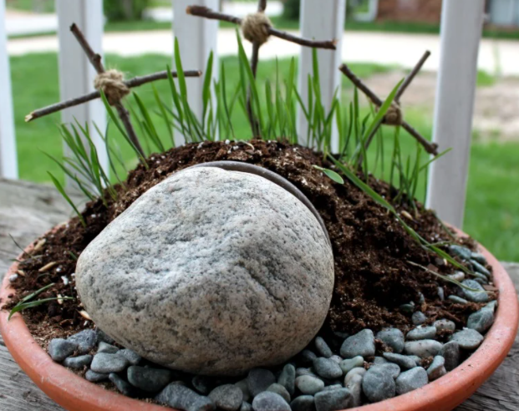 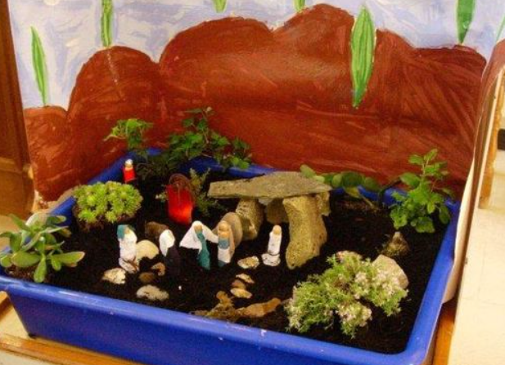

**Can you take a picture of your Easter garden and send it to your teacher?**

|  |
| --- |
| **I know the whole Easter story** |

|  |
| --- |
| **How well do you now know the Easter story? Can you complete the Easter story drag and drop game and order the events to get to stage 4 and complete this activity?**  If you are using the internet, please check with the adult you live with that you can use the internet safely to complete this RE:Start activity  [Easter Story Drag and Drop Game « RE:start (request.org.uk)](https://request.org.uk/restart/2017/02/03/easter-story-drag-and-drop-game/) |

|  |  |  |
| --- | --- | --- |
|  | **New things I learnt in this activity** | |
| **Its time to celebrate Easter. Can you match th pictures together into pairs?**  [The Easter Story Pairs Game « RE:start (request.org.uk)](https://request.org.uk/restart/2016/02/03/the-easter-story-pairs-game/) | |  |