CHRISTIANITY Why is Easter so important to Christians?

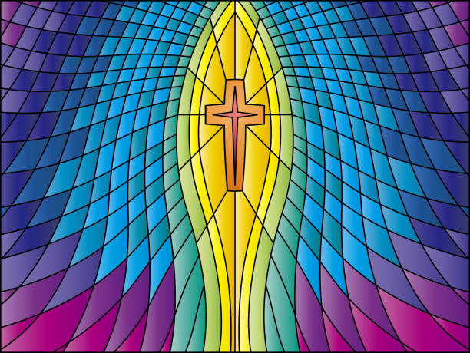

Contents
2. Why is Easter important to Christians?
Background Information

4. Key Words

5. Websites

6. Ideas about Easter

7. Creative Activities

8. Lesson 1: Why do Christians sometimes have palm crosses in their windows?

15. Lesson 2: Why did Jesus get angry in the temple?

21. Lesson 3: What do bread and wine have to do with the Easter story?

28. Lesson 4: Who was responsible for Jesus’ death?

39. Lesson 5: Why does Easter matter to Christians?

46. Lesson 6: What matters most at Easter?

Background Information:
Why is Easter Important to Christians?
Most Christians see the Bible as telling a story about the ongoing relationship between God and Creation, with a particular focus on the bond between God and humanity. The good relationship was damaged very early on in the Bible story, with Adam and Eve eating fruit from the tree of knowledge of good and bad. This action illustrates a human tendency to go their own way — or to ‘sin’. Called ‘the Fall’ by many Christians, this act also signals a separation and division between humans and their Creator: the intended idyllic relationship between God and humans no longer exists. God, however, still loves his creation and seeks to bring all people back into friendship. This is the link with the concept of Salvation — of God ‘saving’ humans (and renewing the whole of creation).
Christians believe that Jesus was God incarnate (God in the flesh) and that he was the messiah, God’s promised rescuer. The death and resurrection of Jesus are the surprising part of the ‘big story’ of the Bible, where the relationship between humans and God begins to be restored. Easter is the holiest day of the year for Christians. It celebrates their belief in the resurrection, or the rising from the dead, of Jesus Christ and the restoration of the damaged relationship between God and His creation.
In many churches, Easter follows a season of prayer and fasting called Lent. Lent is observed in memory of the 40 days Jesus is said to have fasted, or gone without food, in the desert. Just before Lent, many Christians celebrate Shrove Tuesday by making and eating pancakes; this began as a way of using up ingredients before the Lent fast. Lent then begins with Ash Wednesday; this day gets its name from the practice of putting ashes on the foreheads of the faithful as a symbol of the season.
The week before Easter Sunday is known as Holy Week. During this week, Christians remember the events they believe took place at the time of Jesus’ death. Holy Week begins with the day Christians call Palm Sunday. This remembers Jesus’ entry into Jerusalem on a donkey, welcomed by people throwing down their cloaks and palm branches, a traditional way of honouring a worthy person. In churches, palm crosses are often given out and kept by Christians in their homes to show their beliefs.
Christians call the day before Good Friday ‘Maundy Thursday’, remembering the day of the Last Supper. The disciples met with Jesus in an upper room to celebrate a Passover meal together. At services on Maundy Thursday, communion is shared, and in some churches the vicar or priest might wash people’s feet.

Background Information:
Why is Easter Important to Christians?
Good Friday recalls the day on which Jesus was tried by Pontius Pilate and eventually crucified on Golgotha Hill. After his death he was placed in a tomb carved in the rock, and a stone was rolled to block the tomb. The origin of the name ‘Good Friday’ is in the fact that an alternative meaning for good is ‘holy’. However, the name has probably stuck because Christians believe this dark day was necessary to bring about the resurrection — good came from the crucifixion, as part of God’s offering of himself to restore humanity.
Easter Sunday celebrates the resurrection of Jesus. When the women went to the empty tomb, they found that the body of Jesus had disappeared, despite the fact that the tomb had been guarded by Roman soldiers. Later that day Jesus was seen by Mary and the disciples. Over the next 40 days there were many sightings of Jesus. Christians believe this shows that Jesus was resurrected.
Key Word  Key Words | Meaning
incarnation | God in human form; God ‘in the flesh’
salvation | Jesus rescuing people; being saved.
crucifixion | Being killed by being nailed to a cross.
resurrection | Coming back to life.
Easter | A festival where Christians celebrate Jesus’ resurrection.
Palm Sunday | This remembers Jesus’ entry into Jerusalem on a donkey, where he was welcomed by people.
Maundy Thursday | This remembering the day of the Last Supper. The disciples met with Jesus in an upper room to celebrate a Passover meal together.
Passover/Pesach | Holiday commemorating the Exodus from Egypt. The holiday also marks the beginning of the harvest season. It is sometimes called Pesach.
Last Supper | The last Passover/Pesach meal which Jesus hared with his disciples before his death.
Good Friday | The day when Christians remember Jesus’ crucifixion.
blasphemy | Speaking badly about a religion or insulting God.
Sanhedrin | A group of religious leaders/elders who made sure that religious law was followed.
Websites
Easter story videos
https://request.org.uk/restart/2017/03/14/holy-week-and-easter/

Easter Worship Songs (Worship together website can be accessed using a free trial)
https://worshiptogetherkids.ignitermedia.com/collections/53266-king-of-kings
https://worshiptogetherkids.ignitermedia.com/collections/60317-happy-day
https://worshiptogetherkids.ignitermedia.com/collections/60329-like-a-lion-god-s-not-dead
https://worshiptogetherkids.ignitermedia.com/collections/55045-raise-a-hallelujah
https://worshiptogetherkids.ignitermedia.com/collections/53397-mighty-to-save
https://worshiptogetherkids.ignitermedia.com/collections/51601-in-christ-alone

Easter games
https://request.org.uk/restart/2016/02/03/the-easterstory-pairs-game/
https://request.org.uk/restart/2017/02/03/easter-storydrag-and-drop-game/
Miscelleneous Easter
https://content.scriptureunion.org.uk/search?s=easter

Questions I have about Easter.

Easter
What do I already know about Easter?
Write or draw your ideas.

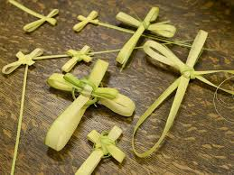
Creative Activities

- Design a cross for the classroom
- Choose one of the events from Holy Weeks and create a piece of art
- Make a sculpture of an event or one of the characters you meet.
- Respond to a song using dance
- Create an Easter themed rap

Be creative and use any ‘junk’ you can find at home in the recycling box – cardboard/milk containers/lids etc.

You could even use materials found outside – twigs, stones, leaves etc.

Lesson 1:
Why do Christians sometimes have palm crosses in their windows?

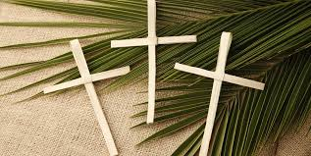
Lesson 1:
Why do some Christians have palm crosses in their windows?

Lesson 1:
Why do Christians sometimes have palm crosses in their windows?

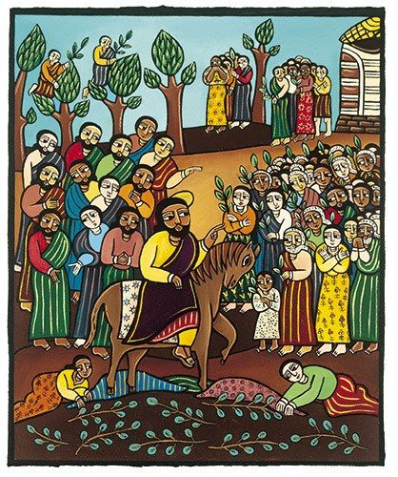

https://request.org.uk/restart/2017/03/14/holy-week-and-easter/

Why do Christians times
How many people can you count in the image?

What do you think is happening in the scene?

Why do you think there are people in the trees?

Have you got any questions about the image?

What do you notice about the eyes in the image?

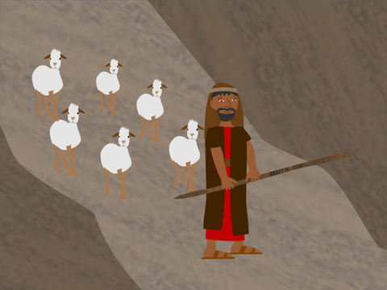
Read or watch the story in the Bible that this piece of art is based on.

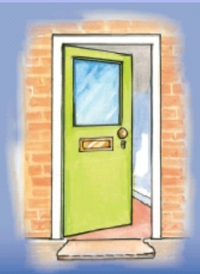
Watch: http://request.org.uk/teachers/teaching-resources/palm-sunday/ (animated)
READ Jesus Enters Jerusalem as a King
²¹ Jesus and his followers were coming closer to Jerusalem. But first they stopped at Bethphage at the hill called the Mount of Olives. From there Jesus sent two of his followers into the town. ² He said to them, “Go to the town you can see there. When you enter it, you will find a donkey tied there with its colt. Untie them and bring them to me. ³ If anyone asks you why you are taking the donkeys, tell him, ‘The Master needs them. He will send them back soon.’” ⁴ This was to make clear the full meaning of what the prophet said:
⁵ “Tell the people of Jerusalem,
‘Your king is coming to you.
He is gentle and riding on a donkey.
He is on the colt of a donkey.’” Isaiah 62:11; Zechariah 9:9
⁶ The followers went and did what Jesus told them to do. ⁷ They brought the donkey and the colt to Jesus. They laid their coats on the donkeys, and Jesus sat on them. ⁸ Many people spread their coats on the road before Jesus. Others cut branches from the trees and spread them on the road. ⁹ Some of the people were walking ahead of Jesus. Others were walking behind him. All the people were shouting,
“Praise to the Son of David!
God bless the One who comes in the name of the Lord! Psalm 118:26
Praise to God in heaven!”
¹⁰ Then Jesus went into Jerusalem. The city was filled with excitement. The people asked, “Who is this man?” ¹¹ The crowd answered, “This man is Jesus. He is the prophet from the town of Nazareth in Galilee.”
Matthew 21: 1 -11

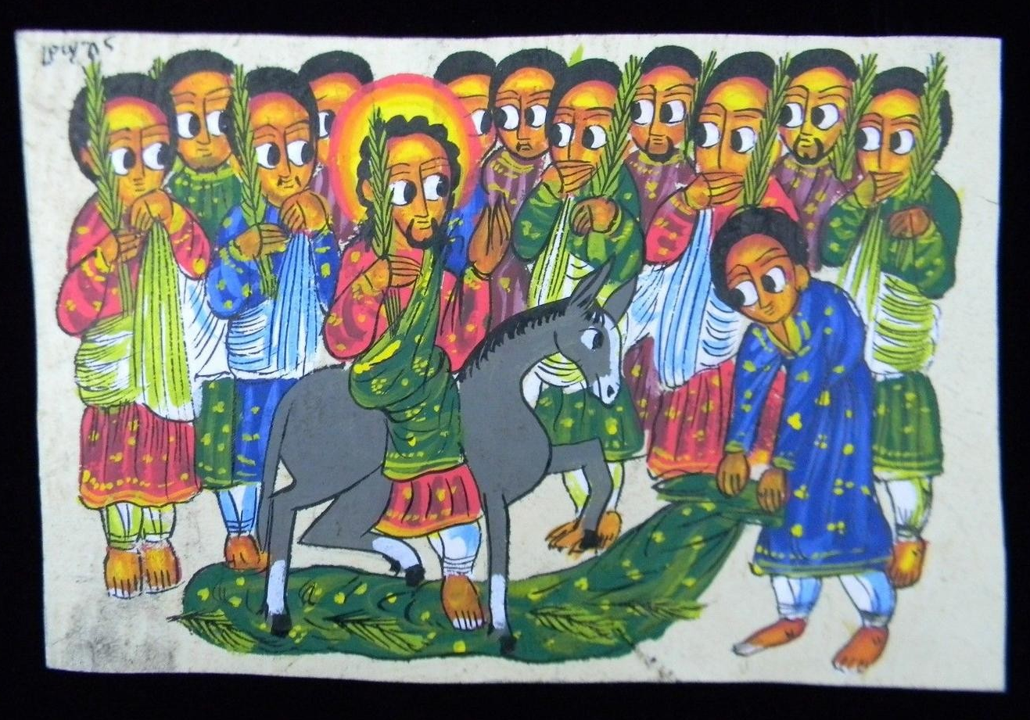
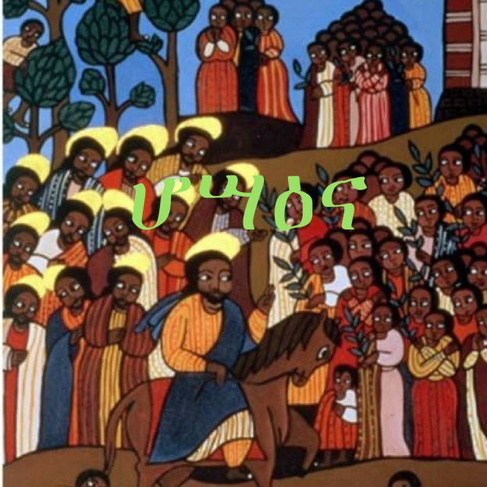
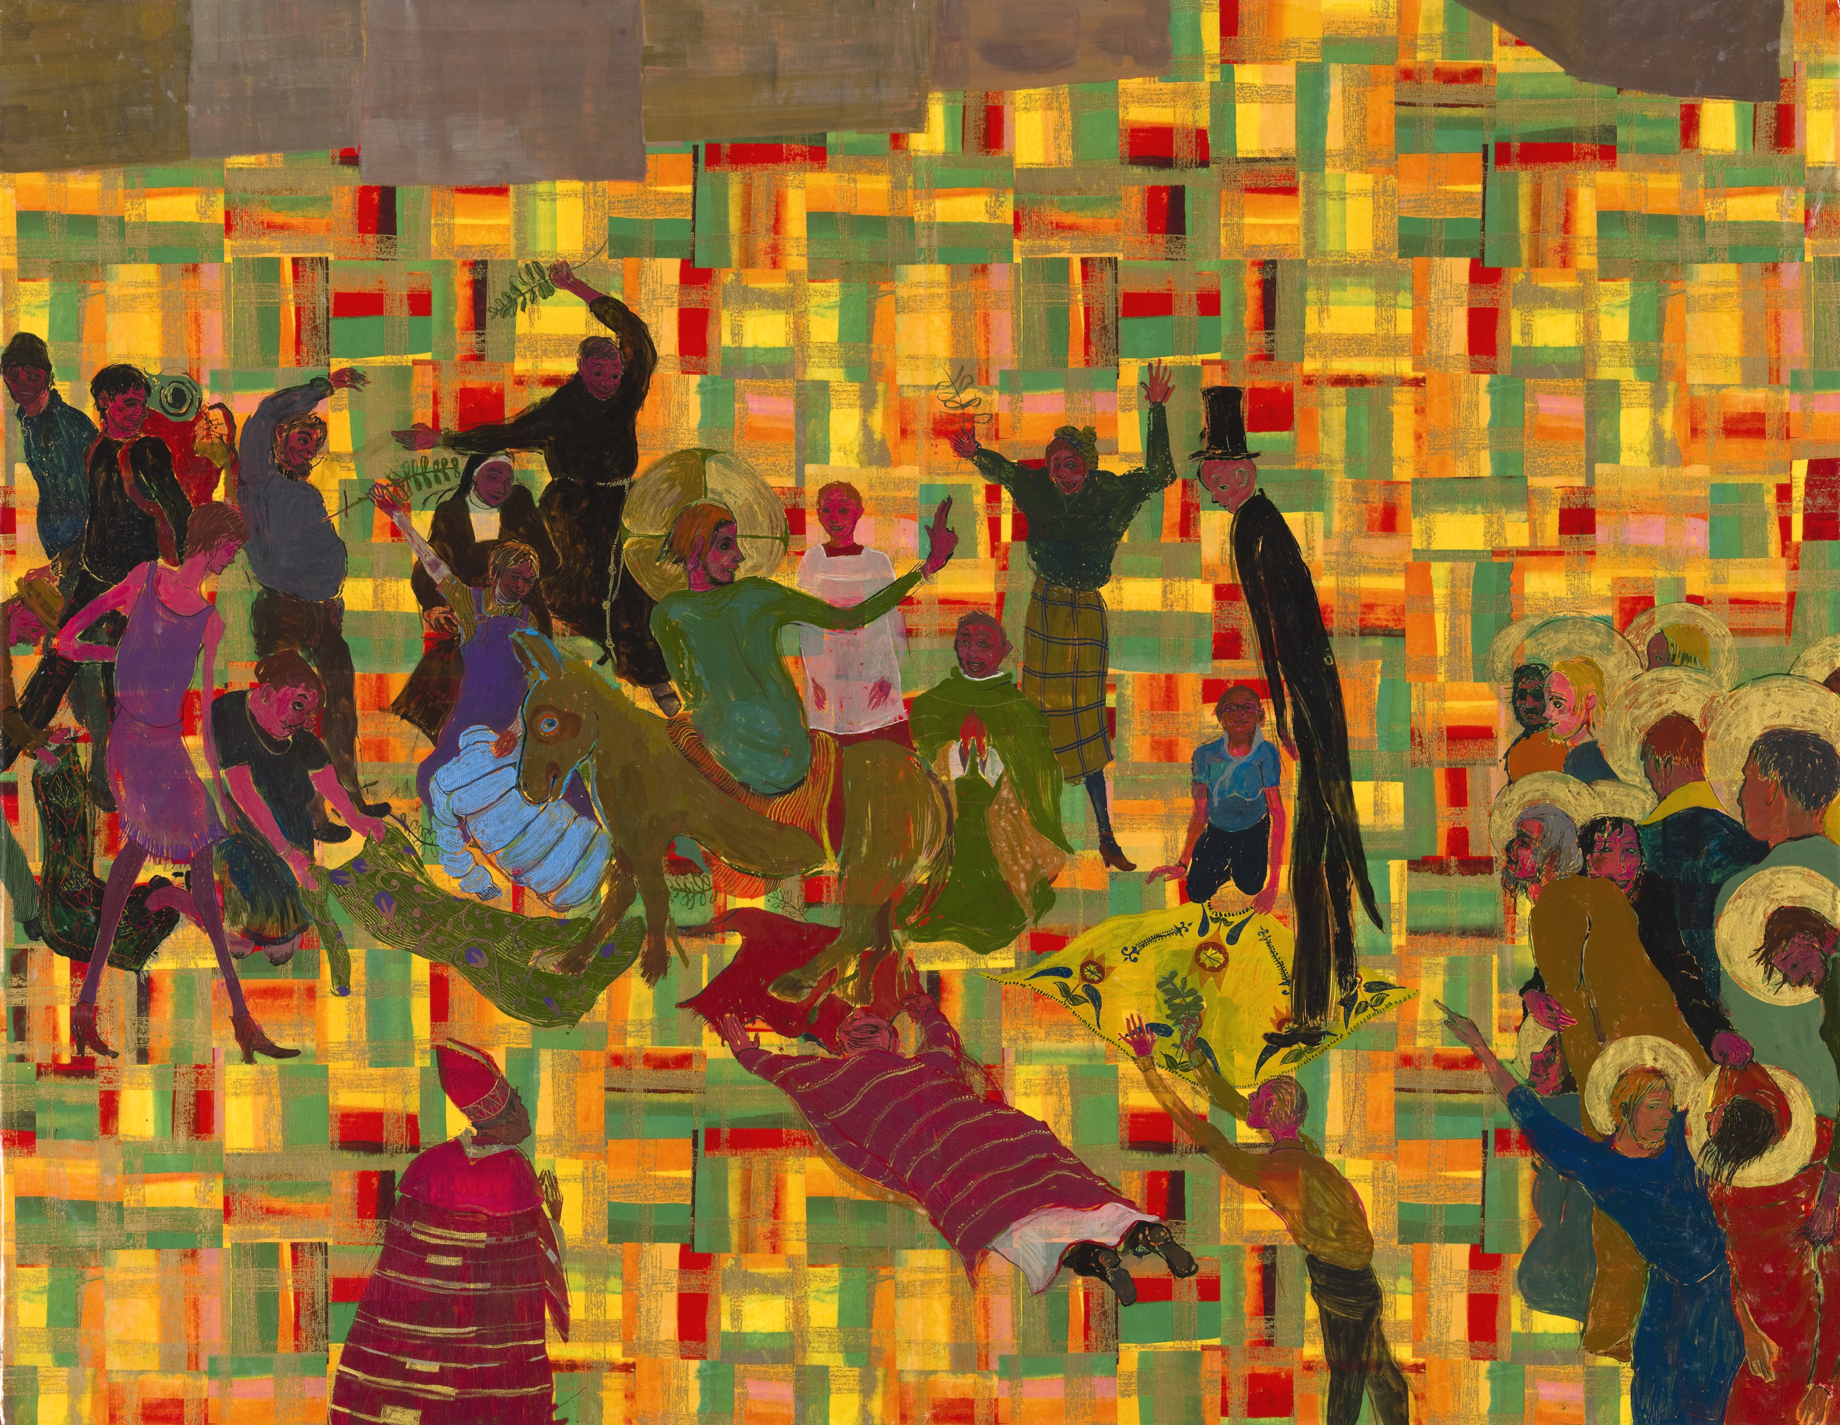
Here are some other paintings showing Jesus entering Jerusalem
Which one do you like best? Why?
How are they different?
How are they similar?
Can you create your own piece of art showing this story?

Why do you think Christians sometimes have palm crosses in their windows?

http://request.org.uk/teachers/teaching-resources/festivals-resources/easter-festival/how-to-make-a-palm-cross/

Have a go at making your own palm cross.

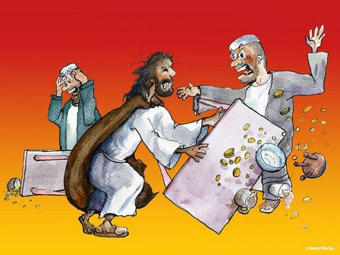
Lesson 2:
Why did Jesus get angry in the temple?

I wonder what the people in these images are thinking?
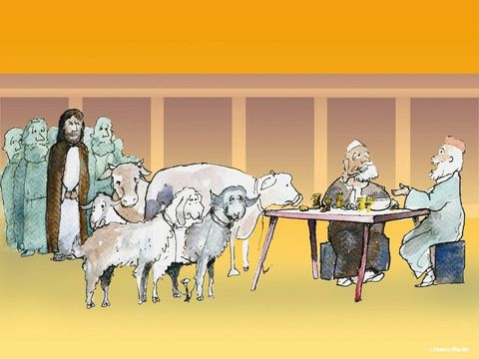

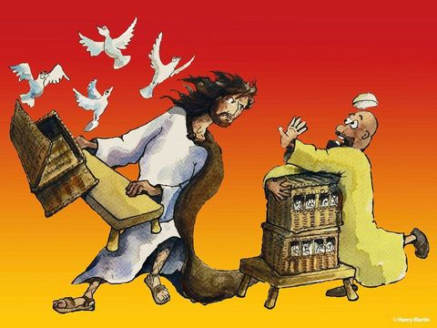

The plagues are: water turning to blood, frogs, lice, flies, livestock pestilence, boils, hail, locusts, darkness and the killing of firstborn children.
Jesus Goes to the Temple
Watch:
or READ
¹⁵ Jesus returned to Jerusalem and went into the Temple. He began to throw out those who were buying and selling things there. He overturned the tables that belonged to the men who were exchanging different kinds of money. And he turned over the benches of the men who were selling doves. ¹⁶ Jesus refused to allow anyone to carry goods through the Temple courts. ¹⁷ Then Jesus taught the people. He said, “It is written in the Scriptures, ‘My Temple will be a house where people from all nations will pray.’ But you are changing God’s house into a ‘hideout for robbers.’”
Mark 11: 15-17

Christians interpret the story of Jesus overturning the moneylenders’ tables in different ways; some of these are below. They are happy for stories to have multiple meanings. Sort these ideas about what the story means from most likely to least likely.

Place the meaning cards onto the diamond nine template on the next page from most likely to least likely.

Worship is more important than sacrifice.
Jesus was an angry man.
The disciples wanted to sell their things in the temple.

People were selling animals for sacrifice to build a relationship with God; because of Jesus, this is no longer needed.
Worshipping God is more important than making money.
The money lenders were in the part of the temple where anyone could pray. Jesus wanted people from all nations to be able to pray in the temple.

Jewish came to the temple to meet God. Now they can come through Jesus.
God wants worship to be about love and justice, rather than following loads of rules.
The moneylenders were cheating people. This needed to be challenged.

Most Likely

Least Likely
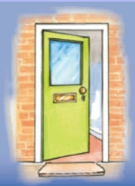
My idea would be to include someone in a game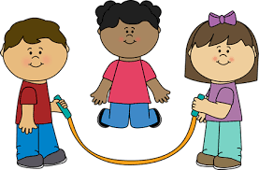
Jesus demonstrated how to include everyone.
Draw how you could learn from this in your life.

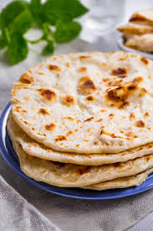
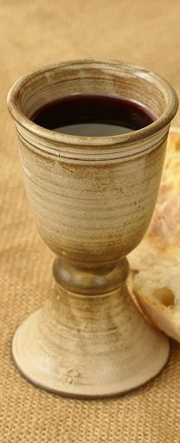
Lesson 3:
What do bread and wine have to do with the Easter story?
What do bread and wine have to do with the Easter story?

Which of these items would you pair together? Why?

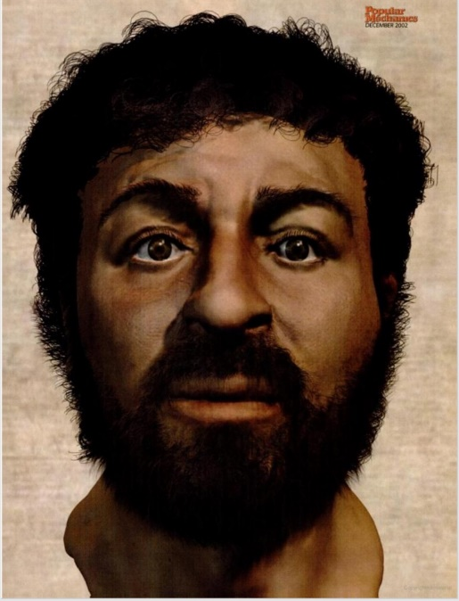

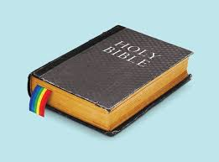

What do bread and wine have to do with the Easter story?

When Jesus entered Jerusalem, everyone celebrated and welcomed him like a King. He told parables and threw out people who were selling things in the temple. Things were going pretty well, and Jesus and his disciples planned to meet together to celebrate Passover. Passover is a special festival every year during which Jewish people remember the terrible things that happened them to when they were captive in Egypt, and how they were set free by God and led out of Egypt by Moses. This Passover meal would be a great celebration.
Read
The Lord’s Supper
²⁶ While they were eating, Jesus took some bread. He thanked God for it and broke it. Then he gave it to his followers and said, “Take this bread and eat it. This bread is my body.”

²⁷ Then Jesus took a cup. He thanked God for it and gave it to the followers. He said, “Every one of you drink this. ²⁸ This is my blood which begins the new agreement that God makes with his people. This blood is poured out for many to forgive their sins. ²⁹ I tell you this: I will not drink of this fruit of the vine again until that day when I drink it new with you in my Father’s kingdom.”

³⁰ They sang a hymn. Then they went out to the Mount of Olives.
Matthew 26:26 - 30

Look again at these items:
What do you think they have to do with the Last Supper?

What might these items help the disciples to remember?

Item | Memory
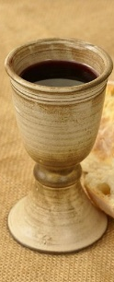

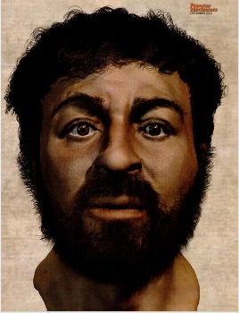

If Jesus came to your home for a special meal, what would you eat?

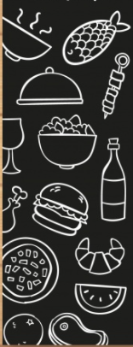
Starter

Main

Dessert

Drinks

Menu

Choose two items from your menu. What would these help you to remember?

Item | Memory

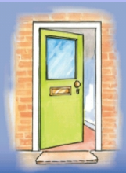
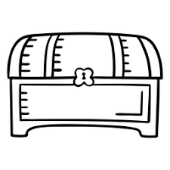
What would you put in these memory boxes? Write or draw your ideas.
A memory box for a special time in your life
A memory box to remember Jesus’ life
A memory box for your school
Lesson 4:
Who was responsible for Jesus’ death?

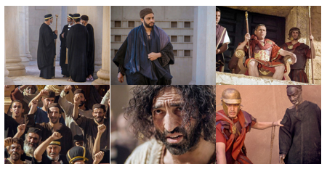

Watch: The Last Supper and Arrest Clip
https://request.org.uk/restart/2017/03/14/holy-week-and-easter/

Who was responsible for Jesus’ death?
Sanhedrin
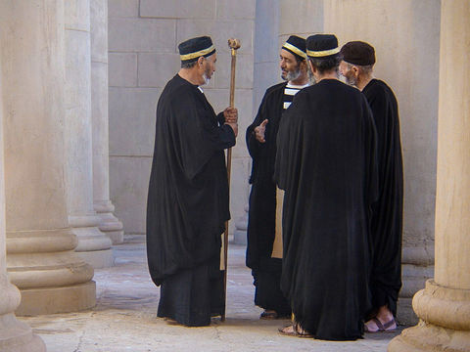

³ Then the leading priests and the Jewish elders had a meeting at the palace of the high priest. The high priest’s name was Caiaphas. ⁴ At the meeting, they planned to set a trap to arrest Jesus and kill him.
Matthew 26: 3 -4

⁵⁹ The leading priests and the Jewish council tried to find something false against Jesus so that they could kill him. ⁶⁰ Many people came and told lies about him. But the council could find no real reason to kill Jesus.
Matthew 26: 59 -60

⁶⁴ Jesus answered, “Yes, I am. But I tell you, in the future you will see the Son of Man sitting at the right hand of God, the Powerful One. And you will see him coming in clouds in the sky.”

⁶⁵ When the high priest heard this, he was very angry. He tore his clothes and said, “This man has said things that are against God! We don’t need any more witnesses. You all heard him say these things against God. ⁶⁶ What do you think?”

The people answered, “He is guilty, and he must die.”
Matthew 26: 65 66

Who was responsible for Jesus’ death?
Judas
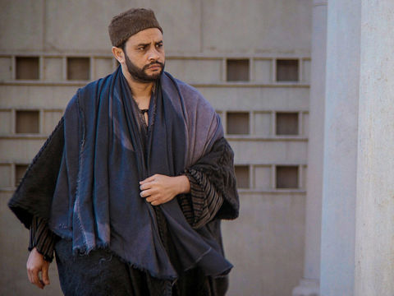

¹⁴ Then 1 of the 12 followers went to talk to the leading priests. This was the follower named Judas Iscariot. ¹⁵ He said, “I will give Jesus to you. What will you pay me for doing this?” The priests gave Judas 30 silver coins. ¹⁶ After that, Judas waited for the best time to give Jesus to the priests.
Matthew 26: 14-16

⁴⁷ While Jesus was still speaking, Judas came up. Judas was 1 of the 12 followers. He had many people with him. They had been sent from the leading priests and the elders of the people. They carried swords and clubs. ⁴⁸ Judas had planned to give them a signal. He had said, “The man I kiss is Jesus. Arrest him.” ⁴⁹ At once Judas went to Jesus and said, “Greetings, Teacher!” Then Judas kissed him.

⁵⁰ Jesus answered, “Friend, do the thing you came to do.”

Then the men came and grabbed Jesus and arrested him.
Matthew 26: 47 -50

Who was responsible for Jesus’ death?
Pontius Pilate
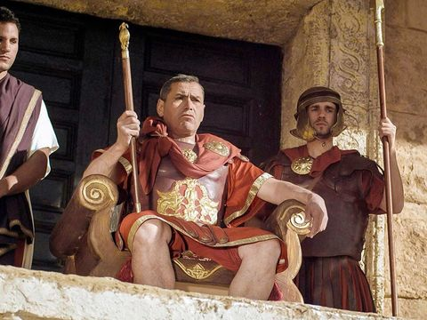
¹¹ Jesus stood before Pilate the governor. Pilate asked him, “Are you the King of the Jews?” Jesus answered, “Yes, I am.”

¹² When the leading priests and the elders accused Jesus, he said nothing. ¹³ So Pilate said to Jesus, “Don’t you hear these people accusing you of all these things?” ¹⁴ But Jesus said nothing in answer to Pilate. Pilate was very surprised at this. ¹⁵ Every year at the time of Passover the governor would free one person from prison. This was always a person the people wanted to be set free. ¹⁶ At that time there was a man in prison who was known to be very bad. His name was Barabbas. ¹⁷ All the people gathered at Pilate’s house. Pilate said, “Which man do you want me to free: Barabbas or Jesus who is called the Christ?” ¹⁸ Pilate knew that they gave Jesus to him because they were jealous.

²⁰ But the leading priests and elders told the crowd to ask for Barabbas to be freed and for Jesus to be killed.

²¹ Pilate said, “I have Barabbas and Jesus. Which do you want me to set free for you?” The people answered, “Barabbas!”

²² Pilate asked, “What should I do with Jesus, the one called the Christ?”
They all answered, “Kill him on a cross!”

²³ Pilate asked, “Why do you want me to kill him? What wrong has he done?” But they shouted louder, “Kill him on a cross!”

²⁴ Pilate saw that he could do nothing about this, and a riot was starting. So he took some water and washed his hands[d] in front of the crowd. Then he said, “I am not guilty of this man’s death. You are the ones who are causing it!”
Matthew 27:11 – 18; 20 -24

25 All the people answered, “We will be responsible. We accept for ourselves and for our children any punishment for his death.”

26 Then Pilate freed Barabbas. Pilate told some of the soldiers to beat Jesus with whips. Then he gave Jesus to the soldiers to be killed on a cross.

Who was responsible for Jesus’ death?
The Crowds
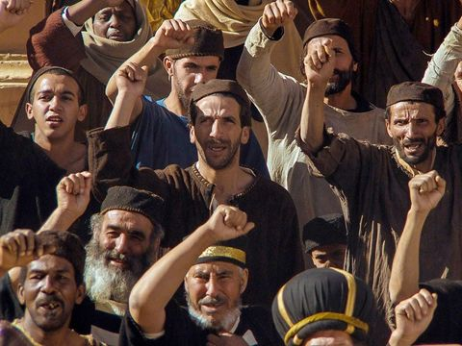

²⁰ But the leading priests and elders told the crowd to ask for Barabbas to be freed and for Jesus to be killed.

²¹ Pilate said, “I have Barabbas and Jesus. Which do you want me to set free for you?” The people answered, “Barabbas!”

²² Pilate asked, “What should I do with Jesus, the one called the Christ?”
They all answered, “Kill him on a cross!”

²³ Pilate asked, “Why do you want me to kill him? What wrong has he done?” But they shouted louder, “Kill him on a cross!”
Matthew 27: 20-23

Who was responsible for Jesus’ death?
Jesus
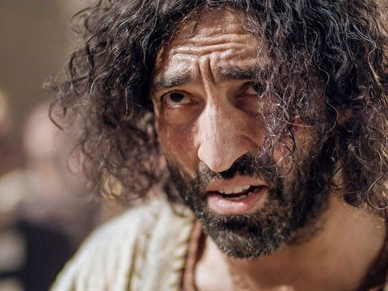

Jesus comes before the Sanhedrin
⁶² Then the high priest stood up and said to Jesus, “Aren’t you going to answer? Don’t you have something to say about their charges against you?” ⁶³ But Jesus said nothing.

Again the high priest said to Jesus, “You must swear to this. I command you by the power of the living God to tell us the truth. Tell us, are you the Christ, the Son of God?”

⁶⁴ Jesus answered, “Yes, I am. But I tell you, in the future you will see the Son of Man sitting at the right hand of God, the Powerful One. And you will see him coming in clouds in the sky.
Matthew 26: 62 -64

Jesus comes before Pontius Pilate
¹¹ Jesus stood before Pilate the governor. Pilate asked him, “Are you the King of the Jews?” Jesus answered, “Yes, I am.”

¹² When the leading priests and the elders accused Jesus, he said nothing. ¹³ So Pilate said to Jesus, “Don’t you hear these people accusing you of all these things?” ¹⁴ But Jesus said nothing in answer to Pilate. Pilate was very surprised at this.
Matthew 27: 11-13
Who was responsible for Jesus’ death?
Soldiers
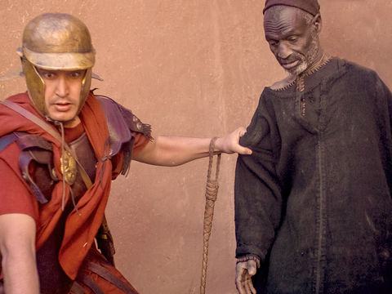

²⁷ Pilate’s soldiers took Jesus into the governor’s palace. All the soldiers gathered around Jesus. ²⁸ They took off his clothes and put a red robe on him. ²⁹ Then the soldiers used thorny branches to make a crown. They put this crown of thorns on Jesus’ head. They put a stick in his right hand. Then the soldiers bowed before Jesus and made fun of him. They said, “Hail, King of the Jews!” ³⁰ They spit on Jesus. Then they took his stick and hit him on the head many times. ³¹ After they finished making fun of Jesus, the soldiers took off the robe and put his own clothes on him again. Then they led Jesus away to be killed on a cross.
Matthew 27: 27-30

³⁵ The soldiers nailed Jesus to a cross. They threw lots to decide who would get his clothes. ³⁶ The soldiers sat there and continued watching him. ³⁷ They put a sign above Jesus’ head with the charge against him written on it. The sign read: “THIS IS JESUS THE KING OF THE JEWS.”
Matthew 27: 35-37

Who was responsible for Jesus’ death?
Judas
- Was paid thirty silver coins by the Sanhedrin to betray Jesus to betray Jesus.
- Kissed Jesus to show the Sanhedrin that this man was Jesus

Pontius Pilate
- Pilate ordered the crucifixion of Jesus after the crowds shouted for Jesus to be convicted.

Sanhedrin
- Accused Jesus of blasphemy.
- Paid Judas Iscariot to betray Jesus.
- Tried to get witnesses to speak out against Jesus.
- Convicted Jesus of blasphemy and sentenced Jesus to die.
The Soldiers
- The soldiers mocked and made fun of Jesus.
- The soldiers nailed Jesus to the cross with a hammer.
- The soldiers crucified Jesus.

The Crowds
- The crowds shouted for Jesus to be crucified.
- They shouted for Barabbas, a murderer, to be released in his place.

Jesus
- Jesus stayed silent and then refused to deny claims of blasphemy when before the Sanhedrin.
- Jesus did not defend himself when standing trial by Pilate.

Who was responsible for Jesus’ death?

Who was most responsible for Jesus’ death?

Put the suspects in order from most responsible to least responsible.
Think about your reasons for this.

Suspect | Reasons | Rank  (Most (1) to least (6) responsible)
Who was responsible for Jesus’ death?

Create a wanted poster for the suspect you think is most responsible.

Lesson 5:
Why does Easter matter to Christians?

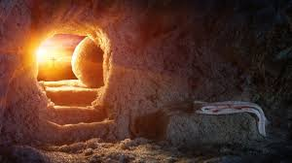

Watch: The Resurrection clip:
https://request.org.uk/restart/2017/03/14/holy-week-and-easter/

Why does Easter matter to Christians?

Read:
28 The day after the Sabbath day was the first day of the week. At dawn on the first day, Mary Magdalene and another woman named Mary went to look at the tomb.
² At that time there was a strong earthquake. An angel of the Lord came down from heaven. The angel went to the tomb and rolled the stone away from the entrance. Then he sat on the stone. ³ He was shining as bright as lightning. His clothes were white as snow. ⁴ The soldiers guarding the tomb were very frightened of the angel. They shook with fear and then became like dead men.
⁵ The angel said to the women, “Don’t be afraid. I know that you are looking for Jesus, the one who was killed on the cross. ⁶ But he is not here. He has risen from death as he said he would. Come and see the place where his body was. ⁷ And go quickly and tell his followers. Say to them: ‘Jesus has risen from death. He is going into Galilee. He will be there before you. You will see him there.’” Then the angel said, “Now I have told you.”
⁸ The women left the tomb quickly. They were afraid, but they were also very happy. They ran to tell Jesus’ followers what had happened. ⁹ Suddenly, Jesus met them and said, “Greetings.” The women came up to Jesus, took hold of his feet, and worshiped him. ¹⁰ Then Jesus said to them, “Don’t be afraid. Go and tell my brothers to go on to Galilee. They will see me there.”
Matthew 28:1-10

Choose words from the word bank to say how the women could have felt at each part of the story.
*Arriving at the tomb/ seeing the angel /seeing the tomb was empty /leaving the tomb/meeting Jesus
Word Bank
happy frightened glad
worried cross crazy
upset angry gloomy
scared amazed nervous
excited wonderful calm
peaceful thrilled bored
pleased thankful joyful
puzzled confused sad
Why does Easter matter to Christians?
Read the story and think about how the women felt.
FEELINGS GRAPH
Example

Feeling worse
Frightened
X
X
X
X
X
Sad
Feeling better
Why does Easter matter to Christians?
Create your own feelings graph. Add words to describe their feelings at different points in the story.
Feeling better
Feeling worse
Hold an Easter egg hunt. If you do not have enough chocolate eggs then cut out eggs from paper and decorate them.
Ask an adult to hide them for you.
As you look for the eggs think of the women going to the tomb to look for Jesus’ body.
Easter is a time to celebrate amazing surprises.
Design a card that explains what Christians believe about Easter. Make it bright and happy.
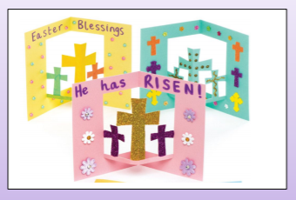
The Resurrection is the most important event in the entire Bible for Christians and is sung about in worship songs all year round. It is because of what happened on Easter Sunday that Christians believe God has promised a way to heaven.

Reflect on the importance of Easter Sunday for Christians as you complete the following activity.
Why does Easter matter to Christians?

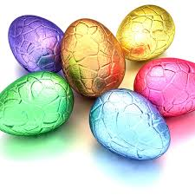

Easter is all about new life and new hope. Write or draw on the egg your hopes and dreams for you and your family.

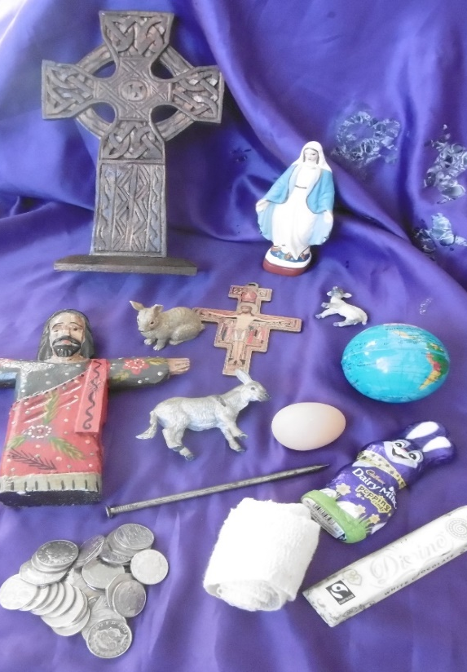
Lesson 6:
What matters most at Easter?

What matters most at Easter?
Look at the items below and have a think.
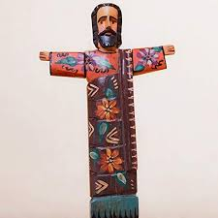
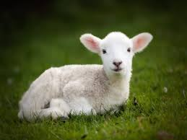
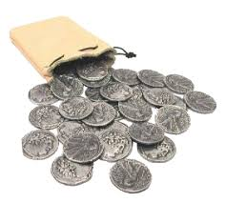
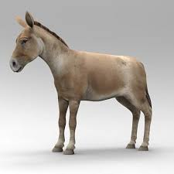
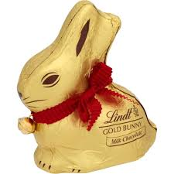
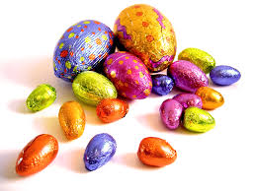
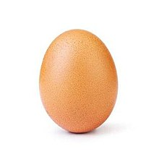
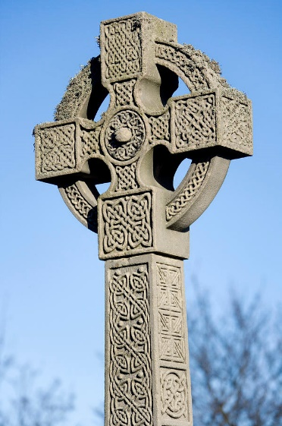
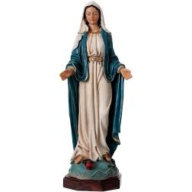
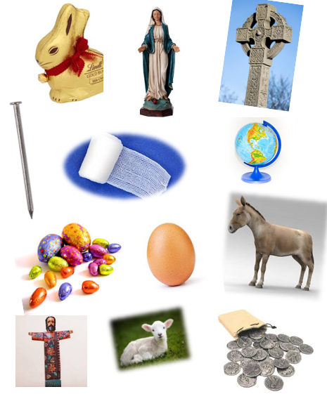
Which matter most? Which matter least at Easter?
Cover them. Can you remember all 12 items?
What matters most at Easter?

What do the objects have to do with Jesus’ last days?
Which ones come from the Bible? Where do the others come from?
Which object would matter most to a Christian?
What matters most at Easter?
What matters most at Easter?

Choose one or more of the following activities:

- Create a forest style sculpture to represent an event from Holy Week
- Create a piece of art (paint, crayons, pastels, collage) to depict one of the events
- Make up an Easter song
- Design a cross for your classroom

