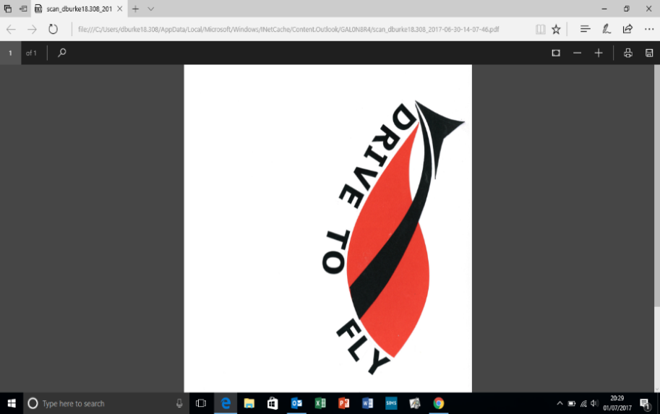

**CPD Schedule Autumn Term**

|  |  |
| --- | --- |
| **26/09/17** | **Engagement session 1:**   * **Flow: the only theory we need for high engagement** * **Strategies modelled: the odd-one-out/ the reading relay/ I went shopping and …./ you say, we pay/ the tear bingo/ the spy card** |
| **17/10/17** | **Engagement session 2:**   * **How does challenge fit into engagement?** * **Strategies modelled: words worth/ shopping basket answers/ the shape of things to come/ my word and your questions** |
| **Half-term** | |
| **07/11/17** | **Engagement session 3:**   * **how does autonomy fit into engagement?** * **Strategies modelled: back to front thinking/ the solution is…what is the problem? / what if…./ is it better or worse?** |
| **28/11/17** | **Engagement session 4: preparing for the Celebration Event** |
| **12/12/17** | **Celebration Event** |