Heartlands High School Student Guide: Google Classroom

- On the Heartlands High School Homepage, when you have logged in, one of the student apps along the app bar is Google Classroom - it looks like this:

↑

- On first opening the app you may need to validate yourself as a user putting in your email address and stating that you are a student.

Your email address is your username followed by @heartlands.haringey.sch.uk
E.g: kiegat17@heartlands.haringey.sch.uk

- Your teachers will have added you to some Google Classrooms (you may have had an email) - if you see something like this - you need to press accept:
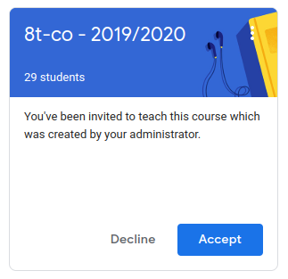

- Your classroom pages will look something like this - this is what is called the stream and will have all your work assignments and useful links your teacher has shared:
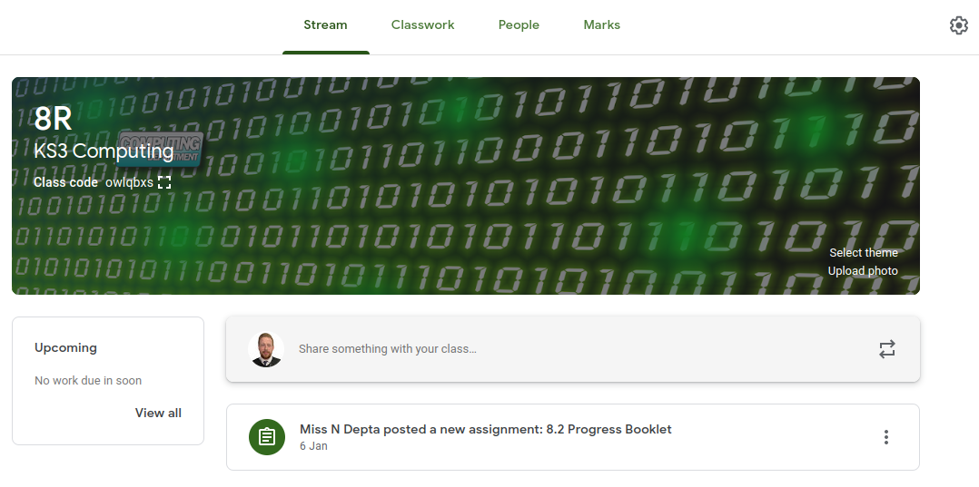

- An example stream might be something like this:

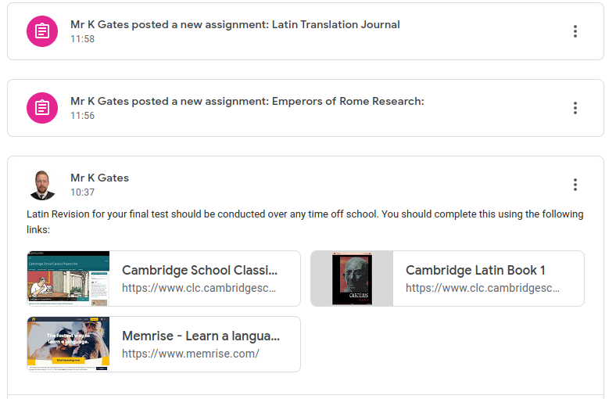

- When you click on an assignment you will see this:

- This is where your actual work is:
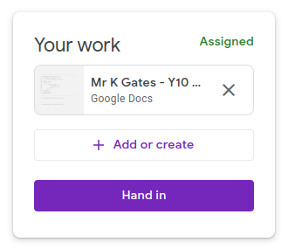
Your work is up here.

This is for you to add any extra work of your own from your drive.

Only press this when work is fully completed.

- You can also leave comments on here to ask your teacher for help - these only go to your teacher. Do Not Comment Anywhere Else:

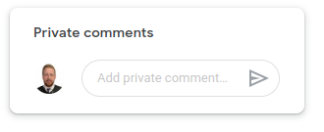

- Your teacher might leave feedback on your work, this will appear as comments on the document. You will be emailed comments too. Click resolve when you have done the feedback tasks, or reply if you are unsure:

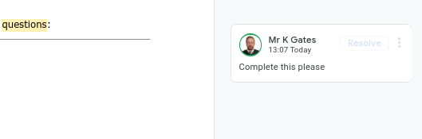

- Some assignments may have marks, some may not - this will be explained on the task information.

- On the classwork tab there are also these useful buttons - the calendar shows you when things are due for this class. The drive folder shows you where things are saved on your Google Drive. DO NOT put any of these items in your bin, as you and your teacher will lose that work and you will have to start again.
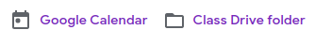
- When you are on classwork you can press this button:
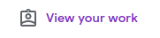
This will show you a screen with all your work to still complete, your work that has been marked and anything that is overdue:

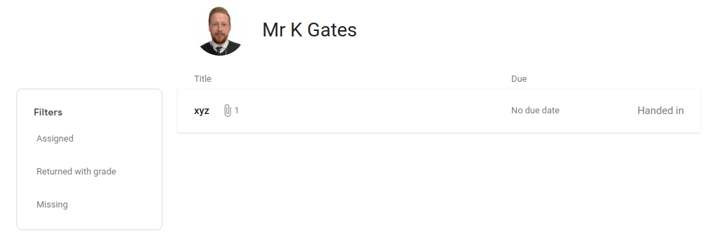

If you do not have access to IT services at home, please let your teacher know as soon as possible and they will share paper resources with you.

Finally if you have any general questions that are not answered in this booklet, please feel free to email your teacher of the classroom you have been added to or Mr Gates on - kieran.gates@heartlands.haringey.sch.uk

