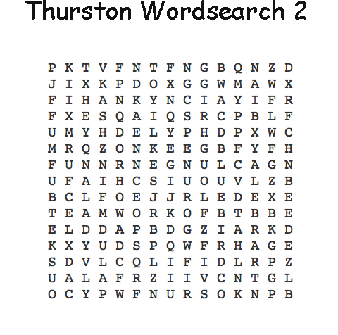
Can you find the following words:

Belay Herdwick
Bluebird Lake
Canoeing Loughrigg
Climb Paddle
Friendship Teamwork
Fun Tiffin

