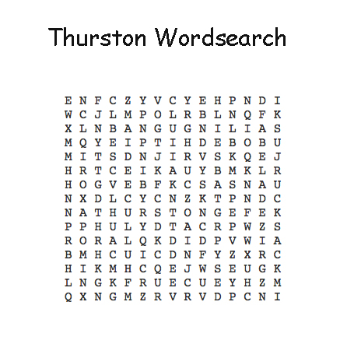
Can you find the following words:

ABSEIL GRIZEDALE
ADVENTURE RUCKSACK
CONFIDENCE SAILING
CONISTON THURSTON
FLAPJACK WETSUIT

