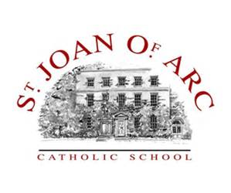
St Joan of Arc
Weekly PE Bulletin
WC: 16th May 2016

FIXTURES THIS WEEK
B  O  Y  S | ACTIVITY | YEAR GROUP | WHEN? | WHERE? | MEET TIME | BACK AT SCHOOL
 | Cricket | 8 | Wednesday | St Joan of Arc | 3.20pm | N/A
 | Cricket | 8 | Thursday | St Joan of Arc | 3.20pm | N/A
G  I  R  L  S | Tennis | 9 & 10 | Tuesday | Away @ SMB | 3.20pm | 5.30pm
 | Tennis | 7 & 8 | Thursday | St Joan of Arc | 3.20pm | N/A

ACTIVITY | YEAR GROUP | WHEN | WHERE? | MEET TIME | BACK AT SCHOOL
B451 Revision Session | Year 11 | Thursday | M4 | 15.30 | N/A
WHAT ELSE IS ON THIS WEEK?

EXTRA-CURRICULAR CLUBS | BOYS | GIRLS
MONDAY | Athletics Training (Years 7-10) | Athletics Training (Years 7-10)
 | West Herts Basketball Training
TUESDAY
WEDNESDAY
THURSDAY |  | Rounders (Year 7-10)

