Christmas Services
TIMES OF CONFESSION  Advent Week of Mercy:  See separate poster and leaflets  SS Mary & John:  Every Friday & Saturday  11.00-11.45  St Teresa:  Every Saturday  16.15-16.45 | SS. Mary & John  23rd December - SUNDAY  IV Sunday of Advent  10.00 & 11.30 am  24th December – MONDAY  5.00 pm:  VIGIL MASS OF THE NATIVITY  7.00 pm: Lithuanian Mass  11.30 pm: Carol Service  25th December – TUESDAY  SOLEMNITY OF THE NATIVITY  OF OUR LORD  00.00 am: MIDNIGHT MASS OF THE NATIVITY  10.00 am: MASS OF THE NATIVITY  11.30 am: MASS OF THE NATIVITY  26th December – Wednesday  Feast of St. Stephen  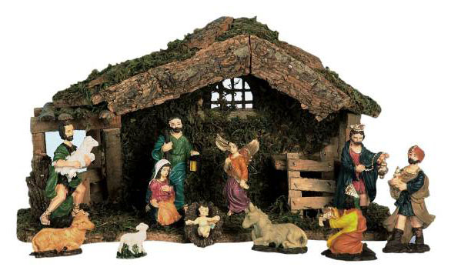  10.30 am: Mass of the Saint  12.00 noon: Mass of the Saint (in Polish) | St Teresa  22nd December – Saturday  5.00 pm:  Vigil Mass of IV Sunday of Advent  24th December – MONDAY  7.00 pm:  VIGIL MASS OF THE NATIVITY  25th December – TUESDAY  NO MASS

