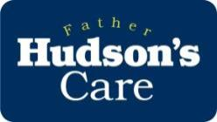
Faith-filled and Hopeful
Learning objectives:
- Describe what is meant by the Catholic virtues faith-filled and hopeful
- Explain how we might practise these virtues
- Identify how others in our Archdiocese are being faith-filled and hopeful

Faith-filled: We are faith-filled when we are living life as God inspires us to live it, putting the Gospel into action through our deeds. Faith gives us belief and trust in God and in other people. We have to build on it every day through prayer, being part of a faith community and living out the gospel values. Faith gives us hope.
Hopeful: We are hopeful when we are optimistic about the future, we trust ourselves and others, and we don’t give up. Our faith teaches us that God is hope – that Christ walks before us and gives us the courage to follow. Hope makes us unafraid to step into the unknown and face challenges. Hope can deepen or restore our faith.

Key stage 1: activity 1
Who can recall the story of Noah’s Ark? After the flood has gone and Noah and his family are safely on land, God promises he will never send another flood to cover the world. He sets a rainbow in the sky as a sign of his promise and a symbol of hope.

Can you think of some of the people we have faith in? For example: God; family; friends; each other.
Draw a rainbow and underneath it write down things that give you hope and remind you that God loves you.

A child’s evening prayer
Thank you, God, for a lovely day,
for sun and rain, for work and play.
For all my family and friends,
and for your love, which never ends.
Amen.
© www.growingupcatholic.com
Key stage 1: Circle time or activity
Who knows what being hopeful means?
If we have faith and love today, it gives us hope for the future. Being hopeful enables us to trust others to do the right thing and make the right choices.
We said that having faith today gives us hope for tomorrow. One project Father Hudson’s works with is called Tabor House. It is a night shelter that helps homeless people to rebuild their lives.
At Tabor House, the staff and volunteers look at the strengths and talents of the people they work with, as well as their hopes and dreams about what their homeless guests want their life to be like. Tabor House helps people build on those talents, so they can work towards achieving their dreams.
Some people who move to Tabor House say they have lost hope. They feel like giving up. But Tabor House has faith in its guests – faith that they want to rebuild their lives. And it has faith in its volunteers – that they will support guests to achieve the best they can. This helps guests to find hope again.
How can we help people to have hope?
For example: donate items to a food bank to remind people that they are cared about; be kind to others; give some toys we don’t use any more to a charity.

Children from Our Lady of the Wayside primary school knitted scarves and donated them to Tabor House
Biblical inspiration

Jeremiah 17:7-8
Blessed is the one who trusts in the Lord,
whose confidence is in him.
They will be like a tree planted by the water
that sends out its roots by the stream.
It does not fear when heat comes;
its leaves are always green.
It has no worries in a year of drought
and never fails to bear fruit.

Isaiah 41:10
Do not fear, for I am with you;
do not be dismayed, for I am your God.
I will strengthen you and help you;
I will uphold you with my righteous right hand.

Key stage 1: Who do we have faith in?
As a class, think of what faith means. For example: trust and belief in others; being sure that other people will do the right thing.
Can we think of some people we put our faith in?
Example answers: We put our faith in families and friends, trusting them to love us and always want the best for us. We put our faith in the community (our school, church, wider society) to work together to make the world a better place. We have faith in ourselves – we understand our strengths and weaknesses. We also have faith in God and Jesus.
Faith also means that we have courage to step into the unknown. Who wants to step into the unknown?
In groups, create a simple course using string. Have one person close their eyes and the others in the group must guide them through the course. This not only shows we are brave enough to step into the unknown, it also shows that we put our faith in our classmates.
Write a prayer thanking God for the people in our lives that we have faith in. Don’t forget to say why we are thankful for them.

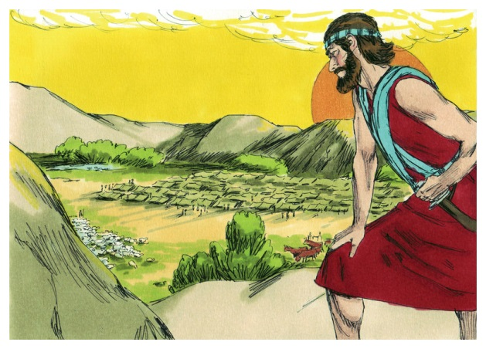
Key stage 2: activity 2
Joshua becomes the leader
“Be strong and courageous. Do not be afraid; do not be discouraged, for the Lord your God will be with you wherever you go.”
When Moses led the Israelites through the desert to the Promised Land, he sent twelve people into the Promised Land to
report back on what they found there. Ten of them said it was filled with giants and that the land would devour them. However two of them, Joshua and Caleb, said that they would be safe as the Lord was with them. The Israelites believed the ten, rather than the two, and ended up wandering the desert for 40 years.
After 40 years had passed, the time came for them to go to the Promised Land. Moses was very old by now so God called Joshua to take the place of Moses and lead his people into the Promised Land. God told Joshua to be strong and brave, because God was walking with him.
It must have been scary to be told to become a leader, and to take your family and friends into a new land. How do you think Joshua felt?
What does this story teach us about faith? Example: it tells us to have faith in God’s word; it teaches us that our faith in God enables us to carry out his commands; it gives us courage to face difficult challenges.
When he was asked to lead his people into an unknown land, Joshua did what God asked of him because he had faith in God. God wants us to live our lives a certain way; to be kind, compassionate and caring, and to live out the Gospel virtues in our actions. Can you think of some ways we can do that?
Example: be nice to our classmates; care for God’s creation; give to charities that help others; pray.
Father Hudson’s Care is a charity that works across our Archdiocese to help others. Their work is based on what God tells us to do: to love others, to welcome the stranger, to look after people in need. One of their projects, Sophia House, provides a home for women who have fled their country and come to England for safety. Sophia House helps them while they make a fresh start in their new home. This can be a scary time, but Sophia House is there to help.
Can you think of a time you had to go somewhere new and were scared?
Think about what helped you and write a prayer thanking God for the help
you received.



Simon, who lives at
St Catherine’s Bungalows, enjoyed indoor skydiving and ‘mud buggying’ with support from Father Hudson’s care staff.

Key stage 2: activity 3
When we love someone, we want the best for them. We hope that their futures will be happy and we do our best to make that happen.
Father Hudson’s Care looks after people who need help with everyday activities that you and I take for granted. Some of the people they work with need a little help to look after themselves and their home. Others need a lot of support. They might need help to wash and dress themselves, to communicate or even to feed themselves. But the carers do a lot more than that – they support people, no matter how complex their disability, to live life to the full. They go to laser quest, concerts, on holiday – two people even went buggy racing and indoor skydiving! This is because the carers focus on how much people can achieve, rather than what
they can’t.
The people they care for have their own hopes and dreams, just like you or I. They have hope for their own futures that they will be able to achieve their goals – they just need help to do so. Father Hudson’s Care also has hope. That hope, together with their faith, enables Father Hudson’s carers to find ways to overcome challenges and help the people they care for to live their best life.

Think about what you hope to achieve in your life – going to college, working in a garage, or travelling, for example. Write a letter to your future self, describing what your hopes are. Feel free to illustrate it however you like.

Biblical inspiration:

Hebrews 11:1 Faith is confidence in what we hope for and assurance about what we do not see.
1 John 5:5 Who is it that overcomes the world? Only the one who believes that Jesus is the Son of God.
Peter 1:21 Through him you believe in God, who raised him from the dead and glorified him, and so your hope and faith are in God.

A Prayer for Hope
Heavenly Father, I am your humble servant,
I come before you today in need of hope.
There are times when I feel helpless,
There are times when I feel weak.
I pray for hope.
I need hope for a better future.
I need hope for a better life.
I need hope for love and kindness.
Some say that the sky is at its
darkest just before the light.
I pray that this is true, for all seems dark.
I need your light, Lord, in every way.
I pray to be filled with your light from
head to toe. To bask in your glory.
To know that all is right in the world,
as you have planned, and as you want it to be.
Help me to walk in your light, and live
my life in faith and glory.
In your name I pray, Amen.


Moses beholding the Promised Land, Walter Rane.
Father Hudson’s Care is your local Catholic charity, supporting people in need across the Archdiocese of Birmingham. Father Hudson’s staff and volunteers give their time and skills to help older people, disabled people, homeless people, refugees, people who are lonely, and children and young people who are experiencing difficulties. Father Hudson’s Care is grateful to everyone who supports them, because it means they can reach out and help more people in need.

