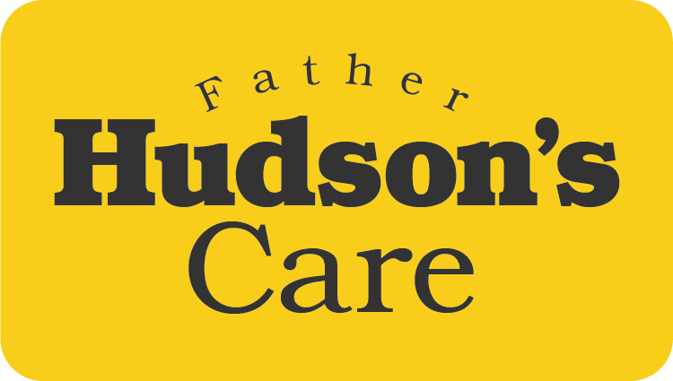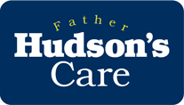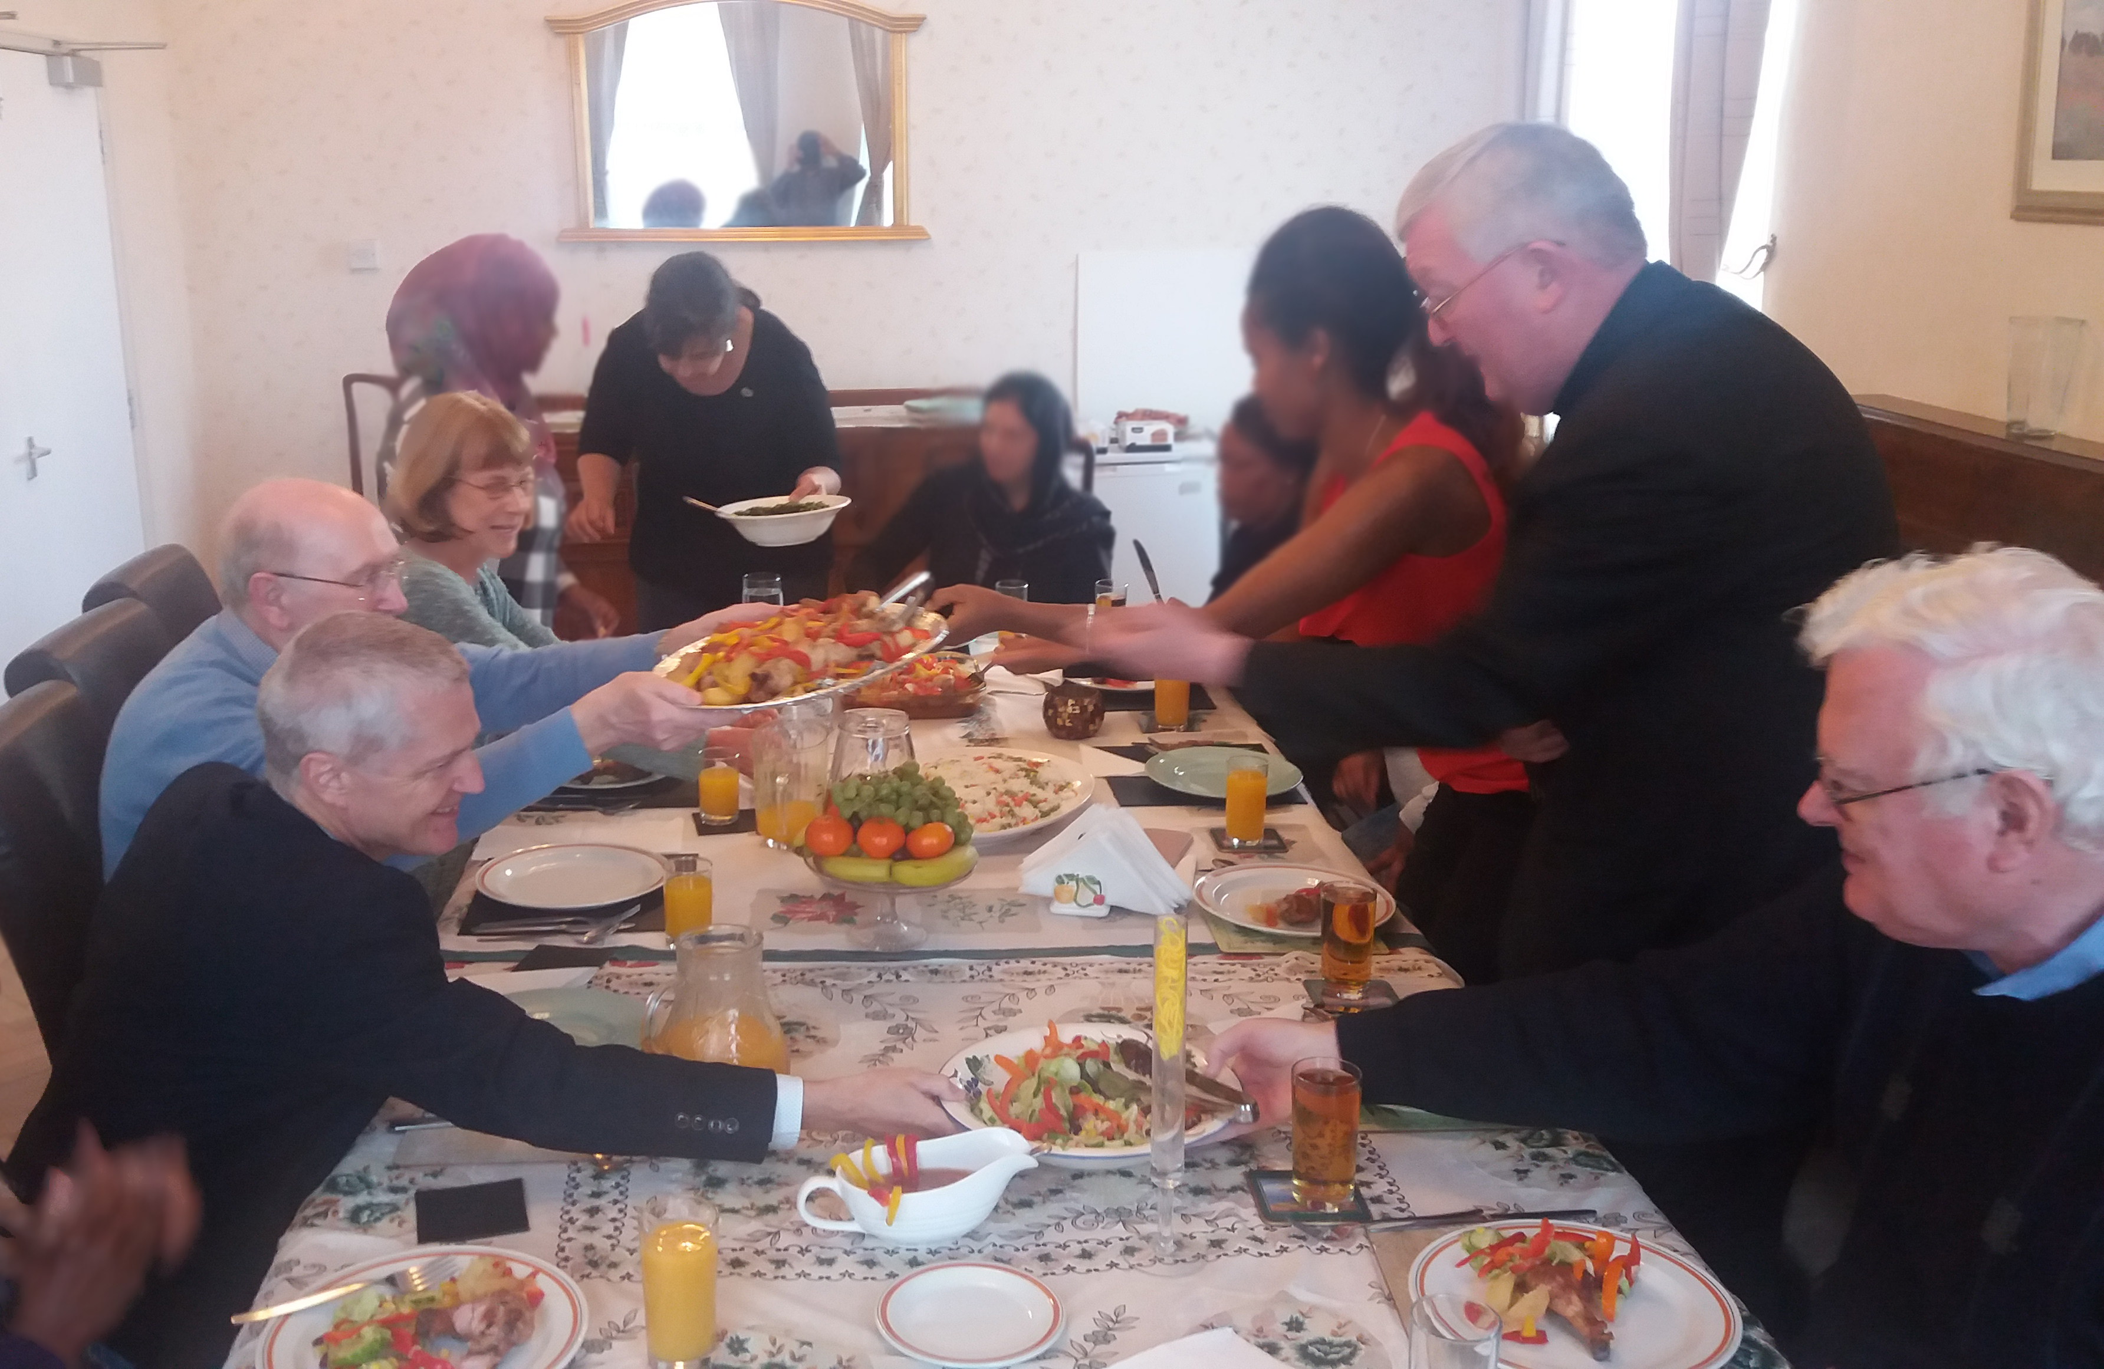
Faith-filled and hopeful
For I know the plans I have for you,” declares the Lord, “plans to prosper you and not to harm you, plans to give you hope and a future.
Jeremiah 29:11
Archbishop Bernard Longley shares dinner with guests, volunteers and partners at Fatima House,
a project that provides safe shelter for female asylum seekers at a time of uncertainty and turmoil.

