Working from Home Timetable

 | 9.00-9:20 | 9:30-10:15 | 10:30-11:15 | 11:30-12:00
M | Mental Maths  Mathletics- Complete a teacher assigned activity.  My user name is  ______________________  My password is  _______________________ | Maths  Complete a page of your choice from the Maths CPG Workout book  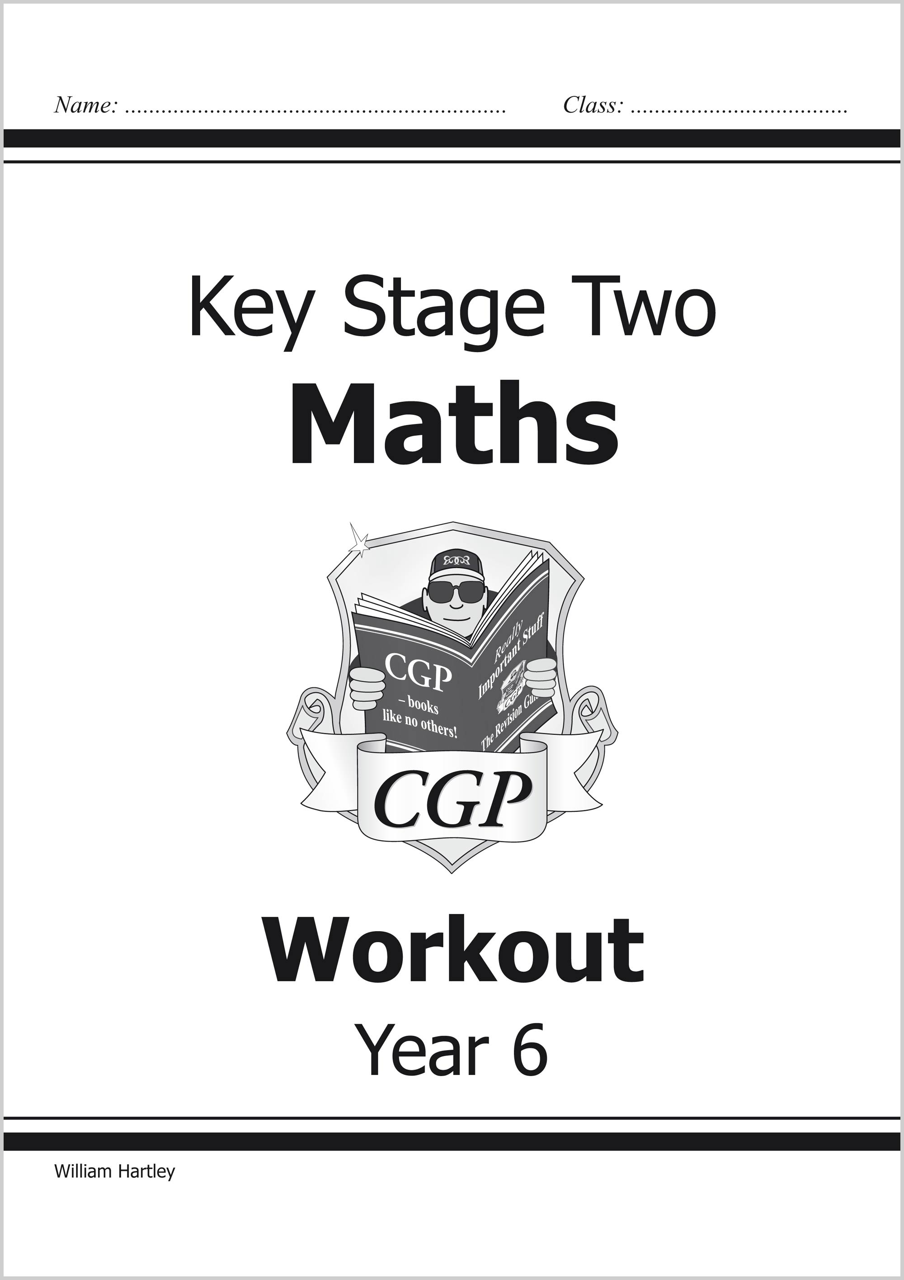 | Comprehension  Choose a comprehension from the Fiction CPG book  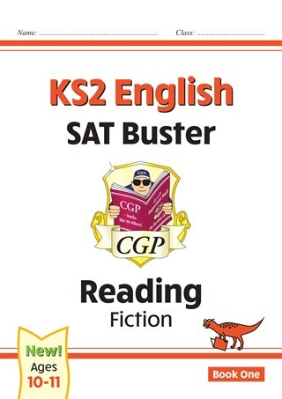 | SPAG  Choose a page from the spelling section of the CPG Spelling and Grammar book  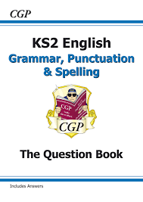
T | Reading Time  Read a book of your choice or one of the AR books provided | Maths  Complete an Arithmetic Quiz from the booklet  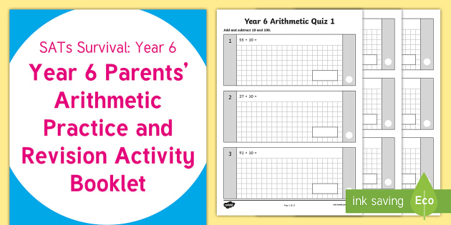 | SPAG  Choose a page from the grammar section of the CPG Spelling and Grammar book | SPAG  Choose a page from the punctuation section of the CPG Spelling and Grammar book
W | Mental Maths  Mathletics- Complete a teacher assigned activity.  My user name is  ______________________  My password is  _______________________ | Maths  Complete a page of your choice from the Maths CPG Workout book | Comprehension  Choose a comprehension from the Non-Fiction CPG book  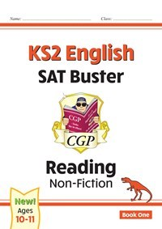 | Reading Time  Read a book of your choice or one of the AR books provided
T | Mental Maths  Mathletics- Complete a teacher assigned activity.  My user name is  ______________________  My password is  _______________________ | Maths  Complete a Reasoning Quiz from the booklet  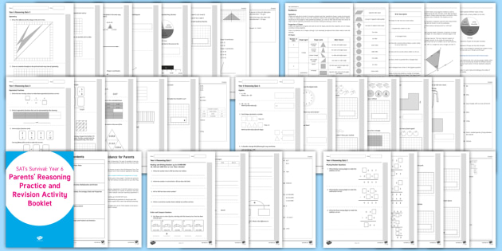 | SPAG  Complete a section from Grammar, Punctuation and Vocabulary booklet  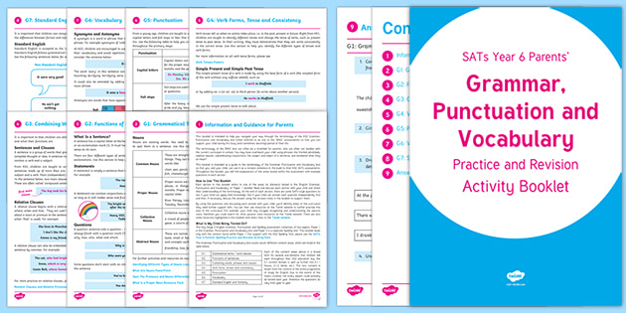 | Complete something of your choice from the Literacy/Numeracy section of Education City  My user name is  ______________________  My password is  ______________________
F | Complete something of your choice from the Literacy/Numeracy section of Education City  My user name is  ______________________  My password is  _______________________ | Maths  Complete a page of your choice from the Maths CPG Workout book | SPAG  Choose a page from ANY section of the book | Reading Time  Read a book of your choice or one of the AR books provided

This ‘timetable guide’ will help you support your child working at home.

If a book becomes full or activities become completed then substitute with an alternative task from a different booklet/online activity

You may want your child to complete more than a page at a time, that is at your discression

Some online educational resources have become made available for parents. A list and further details is on the school website.

If you need our help or support we are available
jcoult@ashley.s-tyneside.sch.uk

khumphrey@ashley.s-tyneside.sch.uk

