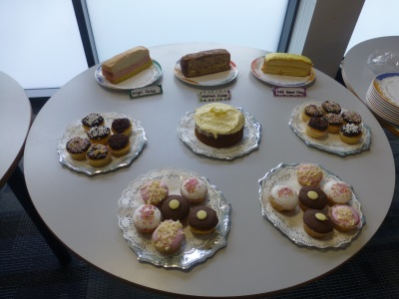

The Beacon Centre
Last year The Beacon Centre
Raised £255 for
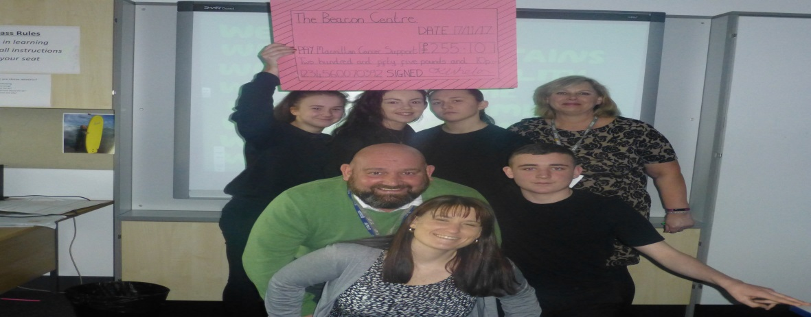
Macmillan Cancer Support

This year, with your help we would like to raise even more
Please join us on Friday 5th October at 11.00am
for the
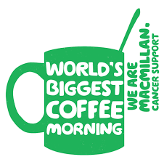
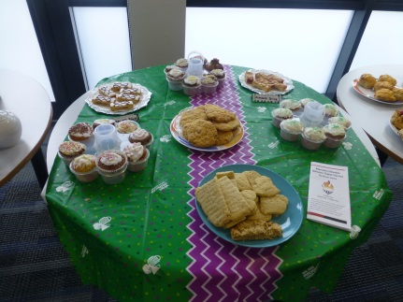
World’s biggest coffee morning’
and help to make a difference

