Brighter Futures, Healthy Families, School Health
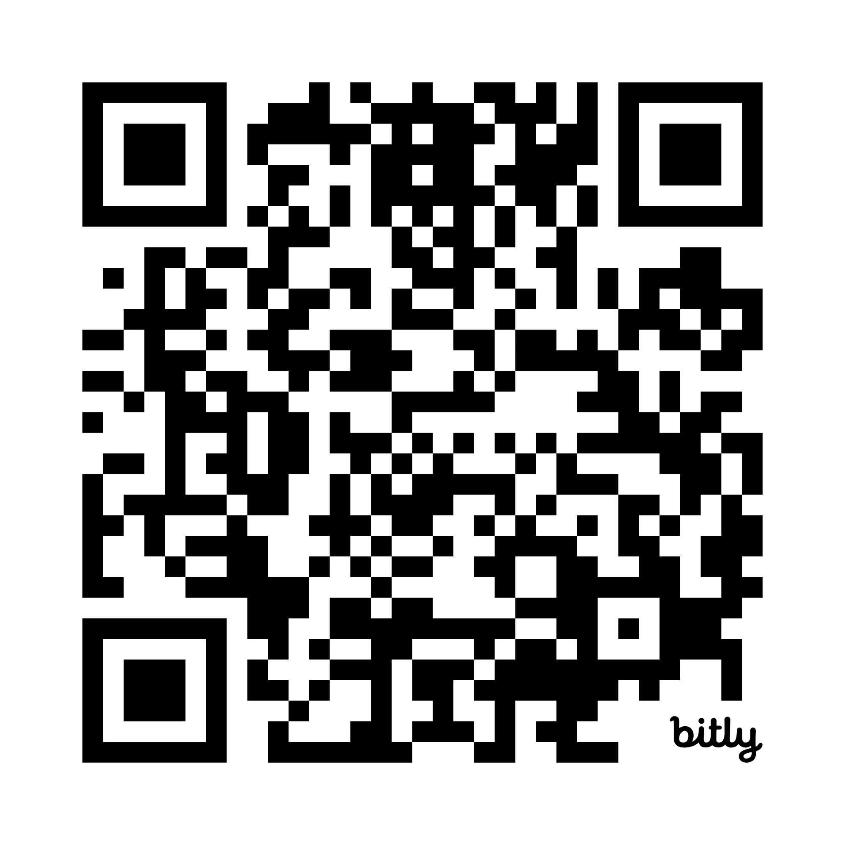

South Ockendon Health Centre
Darenth Lane
South Ockendon
Essex RM15 5LP
0300 300 1999 – Option 2
thurrockschoolhealth@nelft.nhs.uk
@BrighterFuturesHealthyFamilies
@brighterfutureshealthyfamilies

Dear Parent/Carer,

Re: Height and weight checks for children in Year 6
Your child’s height and weight will be measured as part of the National Child Measurement Programme (NCMP). The checks can provide a good understanding of how your child is growing.
The checks are carried out by trained health practitioners, in school or by clinic appointment at your local health centre. The measurements will take place in a private area where the results are secure and cannot be seen or heard by anyone who is not directly involved in taking the measurements. Children are measured fully clothed in normal light, indoor clothing; they will be asked to remove their coats and shoes. The programme will be delivered in line with national and local guidance.
No data will be shared with your child or your child’s school regarding their height and weight.
Registering on the secure online Parent Portal
Register your child/ren via the link below to complete an online health questionnaire which contains helpful information and links for support. Once you have registered you will need to enter the name of your child’s school to complete the health questionnaire.
https://nel031.schoolscreener.com/Portal/#/1234567789/g/Nh364

Accessing your child’s results
After your child has been measured, you can access the results via the Parent Portal. It is your choice whether you share this information with your child and/or school. Depending on your child’s results, we may contact you by telephone.
Opting your child out of National Child Measurement Programme

If you do not want your child to be measured, please opt out via the Parent Portal, or contact the School Health Team within two weeks of receipt of this letter at thurrockschoolhealth@nelft.nhs.uk or 0300 300 1999 – option 2. Children will not be made to take part if they do not want to.
Please do not hesitate to contact us for further information, advice, or support. For assistance with the Parent Portal, please contact parentsupport@schoolscreener.com or call 0203 917 4055.
Yours faithfully,
Healthy Families - School Health

The NCMP information we collect and what it is used for:
- your child’s date of measurement, sex and date of birth are used to calculate your child’s weight category
- your child’s name, date of birth and NHS Number are used to link your child’s measurements in Reception and Year 6. Other data sets held by NHS Digital and Department of Health and Social Care, may also be linked as this would let us add information from health and education records, where lawful to do so, to understand how and why the weight of children is changing, and how this affects children’s health and education and how we can improve the care children receive. This includes your child’s health data relating to:
  - their birth, hospital care (including time in hospital and out-patient appointments and diagnosis of medical conditions)
  - mental health
  - social care
  - primary care - includes all healthcare outside of hospital such as GP and dental appointments,
  - public health - including data relating to preventing ill health such as immunisation records
  - records for when and the reason why people pass away
  - medical conditions such as cancer, diabetes
  - health, lifestyle and wellbeing surveys that your child has participated in
- your child’s ethnicity and address are used to help understand some of the reasons for the difference and changes in child weight across England

All the data collected is also used for improving health, care and services through research and planning.

All this information is treated confidentially and held securely. No individual measurements will be given to your child, school staff or other children.

How the data is used
The information collected from all schools in the area will be gathered and held securely by Healthy Families School Service. We will store your child’s information as part of their local child health record on the NHS’s child health information database which is visible to their GP.

All the information collected about your child will be sent by us to NHS Digital. NHS Digital is responsible for collecting data and information about health and care so that this can be used to monitor and improve the care provided to people across England.

The information collected about your child will also be shared by NHS Digital with the Office for Health Improvement and Disparities (OHID) which is part of the Department of Health and Social Care (DHSC) but in a de-personalised form only. This means OHID will not be able to identify your child. OHID focuses on improving the nation's health so that everyone can expect to live more of life in good health, and on levelling up health disparities to break the link between background and prospects for a healthy life.

Both NHS Digital and the Office for Health Improvement and Disparities (DHSC) will use the information from the National Child Measurement Programme to better understand numbers and trends in child weight and body mass index (BMI). This helps with the planning of services to support healthy lifestyles in your area. No information will ever be published by NHS Digital or the Office for Health Improvement and Disparities (DHSC) that identifies your child.

De-personalised information from the National Child Measurement Programme may also be shared by NHS Digital with other organisations, such as universities. This is to help improve health, care and services through research and planning. This information cannot be used to identify your child, and NHS Digital only ever shares information for research with the approval of an independent group of experts.

