Healthy Snacks
We encourage all children to bring in a healthy snack for morning break,
as well as a water bottle for the day.
See the choices below for suggested healthy snacks.
Snacks not allowed:
- Snacks containing chocolate
- Crisps – or crisp like products
- Sugary fruit alternatives
- Sweets

** PLEASE DO NOT SEND YOUR CHILD WITH NUTS OR FOOD CONTAINING NUTS AS WE HAVE A NUMBER OF CHILDREN WITH ALLERGIES.

Healthy snacks can include:
- Fresh fruit
- Fresh vegetables
- Dried fruit
- Yoghurt
- Cheese with crackers
- Low fat pop corn
- Rice cakes
- Healthy snack bar (with no added sugar)
- Cereal bars (without nuts and not coated in chocolate)

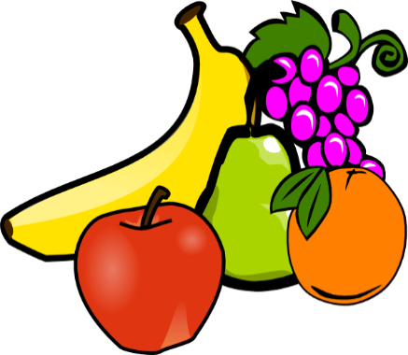

At Graham James Primary Academy we recognise the importance of a healthy lifestyle and diet and understand that establishing a balanced diet in childhood helps to promote healthy eating habits for life. We believe that healthy children are best able to take full advantage of the educational opportunities that the school provides.

