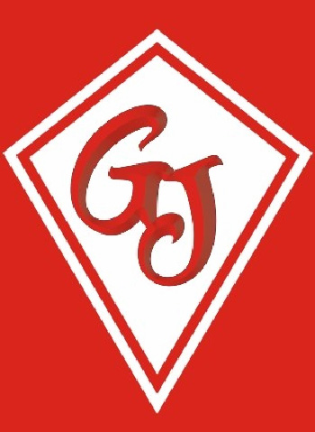

Graham James Primary Academy

The Sorrells

Stanford le Hope

Essex

SS17 7ES

23rd April 2024

Dear Parents,

As you know w/c 12th May is KS2 SATs week. This can be a stressful time for all involved. In our continued attempts to reduce the anxiety of SATs we introduced a breakfast club for the Year 6 children. Studies show that breakfast is the most important meal of the day and it is clear that pupils perform better if they have had breakfast. We have run our breakfast club for many years and it has proved very popular and beneficial to the children.

As in previous years, every day week commencing 12/5 we will be inviting the Year 6 children into school for breakfast at 8.00am. (Breakfast will **not** be available for any child that arrives after 8.20am.) We will provide toast, jam, cereals and fruit juice etc. The children will not have to pay for the breakfast as the school will cover the costs. Unfortunately, we are unable to accommodate siblings.

We hope your child will be able to join the rest of the class at this time. The intention is that this will help to relax the children and make the week a more enjoyable experience. Once they have had breakfast they will be able to have a short break before settling down to take the tests.

Please continue to encourage and praise your child as they have been working extremely hard at both school and at home. Please assure your child that all we can ask is that they do their best, and we are proud of them, whatever the outcome.

Yours sincerely,

Mr Mead, Mrs Gilmore and Mr Chunn