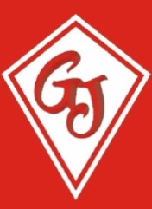Graham James Primary Academy

The Sorrells

Stanford le Hope

Essex SS17 7ES

22nd July 2024

Dear Parent/Guardian

I am writing to remind you that Universal Free School meals are currently only available for Foundation and KS1 children. Therefore, from September you will need to pay for your child’s school dinner. The cost from September will be £2.50 per day.

Payment should be made in advance or on the day. Payments can be made via Parent Pay.

If you haven’t used Parent Pay before you will need your log in details, please contact a member of the office staff for your log in details or if you have any questions.

If you believe that you may qualify for entitlement to free school meals please visit www.thurrock.gov.uk/school-meals/free-school-meals for more details. If you are entitled, then the school will also receive additional funding, this is known as pupil premium.

Yours sincerely

Petra Back

Head Teacher