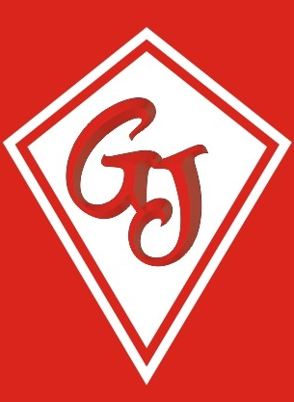Graham James Primary Academy

The Sorrells Stanford-le-Hope Essex SS17 7ES

Head Teacher Petra Back, B.A. Hons.

Telephone (01375) 675889

23rd July 2024

Dear Parents,

Now that your child is moving into Year 1 there will be no need to bring in snack money in September. Graham James has achieved Healthy School Status and therefore if your child requires a snack for playtime please provide a healthy snack. The children will still get a piece of fruit provided by the Government each day.

Thank you for your co-operation.

Mrs Back

Head Teacher